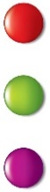
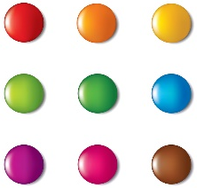
Share the smarties equally between 4 people.
The smarties are split into _____ equal parts.
Each part is worth a ___________.
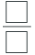
This is the same as

Circle one quarter of the cars.

One quarter of ____ is ____.
____ is ¼ of ____

Fill in the blanks. Use counters to help you if needed.
½ of 12 = ___ | ¼ of 12 = ___
½ of 20 = ___ | ¼ of 20 = ___
½ of 8 = ___ | ¼ of 8 = ___

What do you notice?
_______________________________________________________________________________________________________________
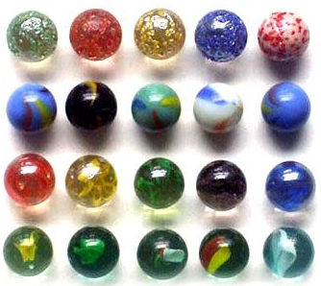

Do you agree? Explain your answer.
“I have ¼ because I have 4 marbles.”

