Lesson 4 – William Morris and Patterns

Aim
To look at the work of William Morris and recreate it using the Patterns template.

Success criteria
I can describe the main features of art that uses repeating patterns.
I can use 2Paint a Picture to create my own art by repeating patterns in a variety of ways. I can combine more than one effect in 2Paint a Picture to enhance my patterns.

Resources

- Examples of work by the textile designer and artist William Morris – you can use the PowerPoint provided or ask a parent to search online for you.

- Examples of other patterns that use repeats: wrapping paper and wallpaper samples are useful for this. See if you can find some at home.

- William Morris fact file from Appendix 4; this is a brief fact file that can be found at the bottom of this lesson plan.

Activities
1. Have a look at some of the work by William Morris (on the PowerPoint presentation) as well as any other pieces you can find with repeating patterns. Spend a few minutes working out what images are repeated and how they are repeated. Can you use words such as these to describe each pattern?

Vertical, horizontal, parallel, diagonal, rotated, symmetry.

2. Talk with an adult about William Morris using the presentation and fact file; you could also use an Internet search engine to find examples of William Morris patterns on the computer and identify the pictures that in it are of – plants, flowers etc. – and how it is repeated.

3. Open the 2Do called ‘William Morris Repeating Patter’ in your 2Dos folder. This will open using 2Paint a Picture. You should then select the pattern template. Draw something simple in the top left square – you will see that it is repeated in the main page like this:

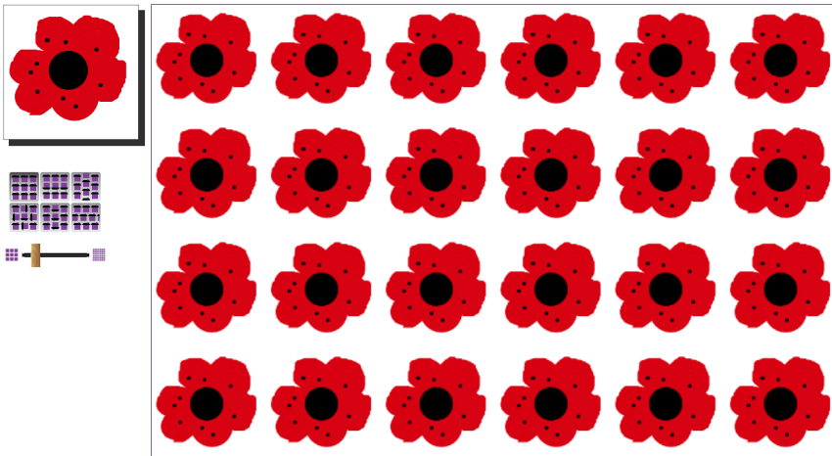

Remember that you can use the Undo button to correct mistakes and that you can alter the thickness of the pen by using the slider at the bottom left underneath all the coloured pens.

Next, you can experiment with varying the way that the pattern repeats by exploring the effect of clicking on the different Repeat Style buttons. A lot of wallpaper designs use what is called a half-drop pattern, giving a diagonal effect.
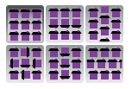
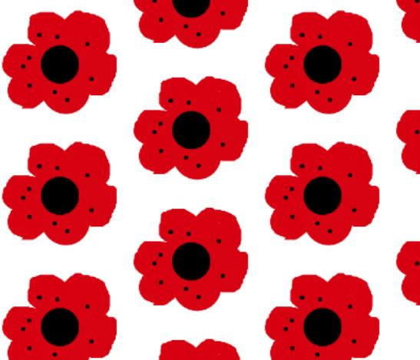

Next explore how different rotations affect the pattern of the same basic shape:

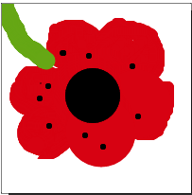

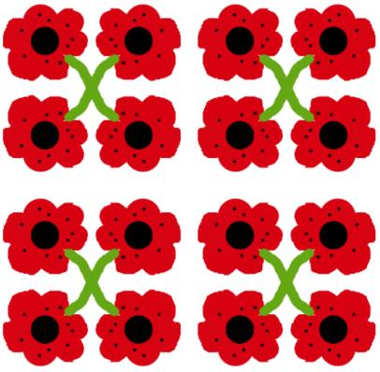
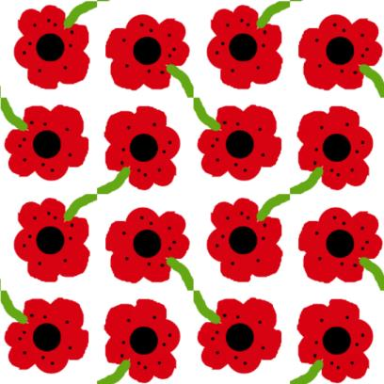
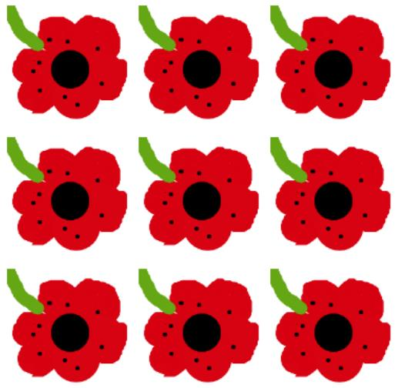

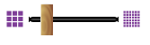
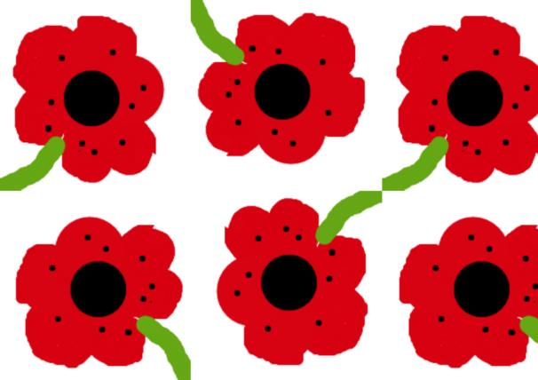
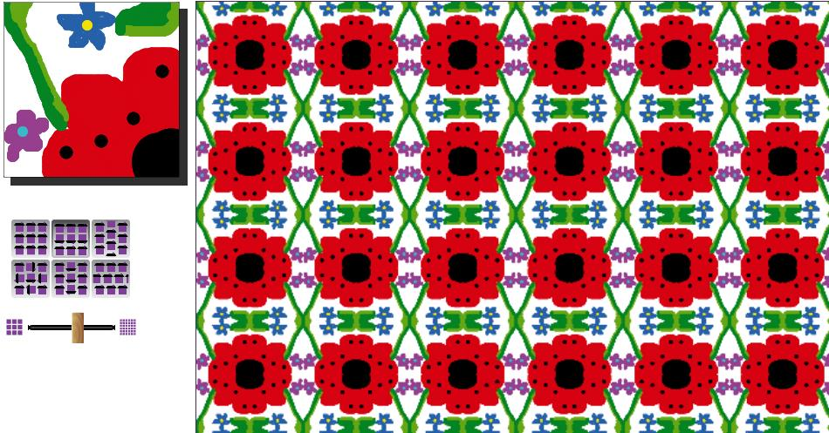
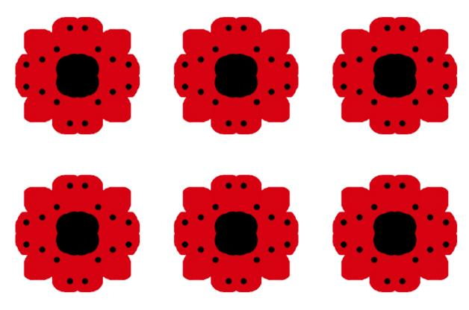
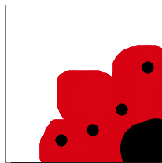
Next, use the size slider to change the pattern:

From: To:

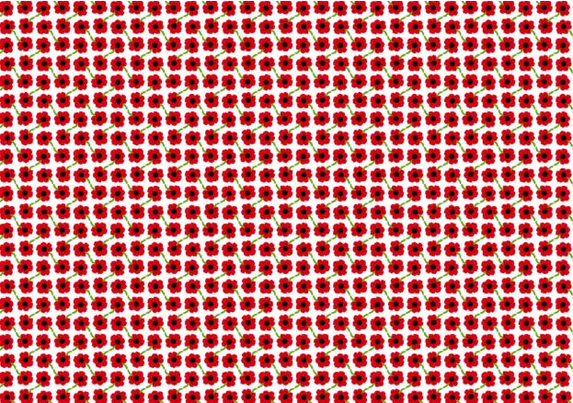

A different way to create a pattern is by drawing a quarter of a flower in the corner and making a rotating repeat that matches up the quarter flowers.

Try adding a stem and some smaller flowers to see the effect of this. The added small details are very typical of William Morris’s designs.

When you are happy with your design, you should save your work and hand your 2Do it in to me so that I can mark it.

If you would like to learn a bit more, you can investigate rotational effects and see how you can combine these with patterns.
First, you will need to open a new file in 2Paint a Picture and choose the Slice template. Whatever is drawn within the slice will be repeated by rotating it about the centre. The size of the slice can be altered during the process to alter the repeat of the subsequent drawing.

Have a go at this yourself and try to create a pattern. Here is an example of one:
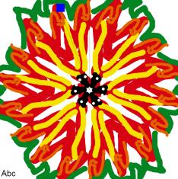

Now click on the New File button and select the Pattern template. When asked whether to use the current picture, select Yes.
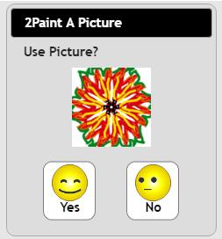

Now you will have the rotated image set up to repeat in the new file. Further details can be added in the top left box if you want to. Remember that you can always use the undo button if you don’t like what you add to your picture.
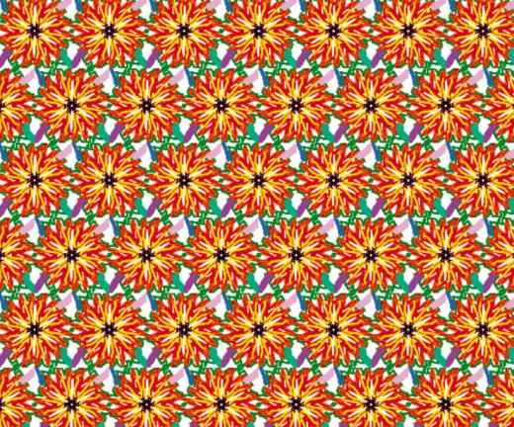

Spend some time experimenting with these effects to create patterns. When you have finished and are happy with your second design, please make sure you save it to your work. You will then need to email me a copy of it as your second piece of work as the first one was handed in as your 2Do for this week.

You have now finished all your Computing work for this term.
Well done and have a super summer break!

Appendix 4 – William Morris Fact File

William Morris was an English artist, poet and politician.

William Morris’s (1834–96) work includes textiles and wallpapers, furniture, book design, stained glass windows, tiles and tapestries.

He lived and worked during the Victorian era.

In 1860 he had a house built for him and his wife and they spent two years furnishing and decorating it in his styles by hand. Following the success of this, they started their own company to produce interiors for others. Their work included embroidery, tableware and furniture, stained glass and tiles.

Morris was unable to find any wallpaper he liked so he began to design wallpaper as well.

His art made use of nature as a source of ideas and he used many repeating patterns of plants, birds and flowers.

He was very interested in medieval art and design and in handcrafting rather than using machines.

He was also interested in politics and particularly free education, better working conditions and limiting the length of a working day. He joined a political party called the Social Democratic Federation. He also helped to start a new party called the Socialist League.

He wrote: ‘Have nothing in your house that you do not know to be useful, or believe to be beautiful.’ He believed that all people should be able to have quality furnishings and interiors in their homes, not just the rich.

