Lesson 1 – Introduction and Impressionism

Aim
To be introduced to 2Paint A Picture.
To look at the work of Impressionist artists and recreate them using the Impressionism template.

Success criteria
You will be able to describe the main features of impressionist art.
You will have used 2Paint a Picture to create your own art based upon this style.

Resources
Examples of impressionist art which can be seen on the PowerPoint presentation provided, or you could ask an adult to do a safe internet search for ‘famous impressionist paintings’.
Impressionism fact file which you can read at the bottom of this lesson plan.
There is a 2Publish activity that you could use to create an impressionism fact file as an extension to this work. Check your 2Dos folder and you will find this set as a 2Do called ‘Art Impressionism’.

Activities
1. First. Have a look at some examples of impressionist art, either using the PowerPoint presentation or doing a search on the internet.

2. Can you describe what they have in common?

3. With an adult, talk about what impressionist art is using the fact file information below or there is some super information about impressionism for children at the Tate Museum’s website which can be found here https://www.tate.org.uk/kids/explore/what-is/impressionism

4. Once you have found out about impressionism, you are going to create your own impressionist painting using 2Paint a Picture. This is a drawing tool that helps you to create various painting effects and combine these effects to make pictures. When the tool is first opened, you get a choice of painting effects. We will be looking at some of them during the next few lessons.

5. You will notice that you have a 2Do called 2Paint a Picture. When you open this, you should click on the Impressionism template.
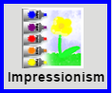

6. Notice how the tubes of paint have been ‘squeezed out’ and mixed in the palette on the left so they are ready for the impressionist artist to capture the impression. Colours can be selected here and then mixed with more water to give a watered-down paint effect by clicking on the water pot to alter the level of water. Other colours can be accessed by clicking on the white arrows to rotate the palette of paint up or down.
7. Now you can spend some time experimenting with painting with watery paint and layering the effect with short ‘brushstrokes’. Notice that the colour comes out in a mixture of tones to help create an impressionist appearance.
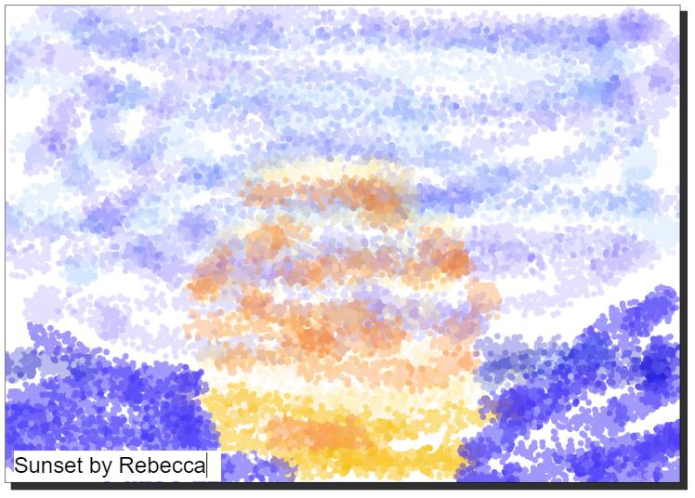

After spending some time on experimentation, you should create your own impressionist-style painting. Make sure that you enter a title and ‘sign’ your art.

8. Remember to save your work in your online work folder by clicking on the save button and entering a name for your piece before clicking Save. Please remember to click on Hand In when you have finished your project – that way I know to look at your work and to mark it.

9. Extension exercise: Find the 2Do called ‘Art impressionism’. You should open this and add your picture to it along with some accompanying details.

10. To add your own picture to a picture box. First, click on the green ‘plus’ symbol at the bottom of the clip-art picker:

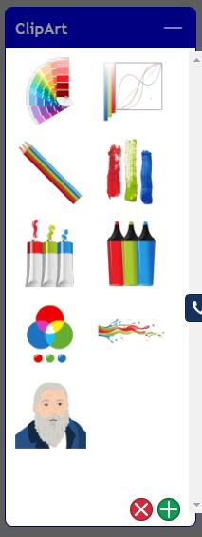


11. On the next screen, click the button.

12. Click on the folder ‘My Work’ and then on the name of the picture that you want to include. A small preview will be displayed:


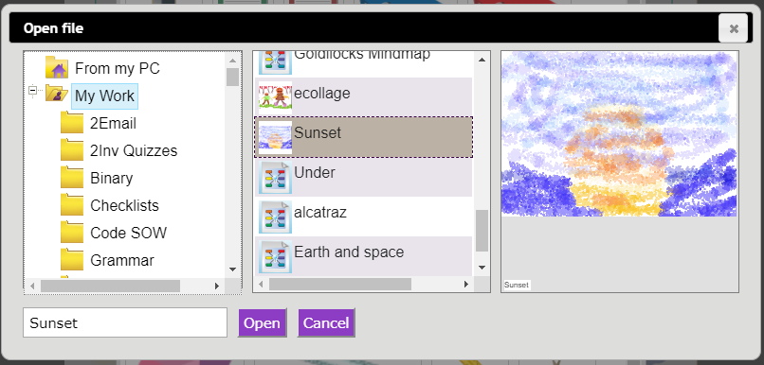

13. Click and the image will be added to the clipart picker.

14. Drag this image to a picture box and resize it.

15. You could also ask an adult to save some images from the Internet to your computer so that you can add them to your file.

16. When completing the work, you can add the images into a picture box by clicking on the green plus in the top right-hand corner of a picture box to open the picture gallery.


17. Then click on the button and find the file from your computer.

Appendix 1 – Impressionist Fact File

The impressionist movement began in the 1860s and became most popular in the 1870s and 1880s.

It differed from the common art of the time because it wasn’t religious art, showing scenes from religious stories or specific events, but was just intended to capture a scene at a particular moment. The art gave an ‘impression’ of the scene.

Famous impressionist artists include Degas, Monet and Manet. These artists used watercolour techniques. They often painted outdoors and at speed so that they could capture the impression that the light made at a certain moment.

The artists focused on the light and colour of the moment rather than details of the things that they were painting.

For some famous examples, look at:

Dance at Le Moulin de la Galette (Pierre-Auguste Renoir)

Sunset and Waterlily Pond (Claude Monet)

Ballet dancer paintings (Edgar Degas)

