Lesson 2 – Pointillist Art

Aim
To look at the work of pointillist artists such as Seurat.
To recreate pointillist art using the Pointillism template.

Success criteria
You can explain what pointillism is.
You can use 2Paint a Picture to create their own art based upon this style.

Resources

Examples of pointillist art on the PowerPoint presentation provided.
Pointillism fact file at the bottom of this lesson plan

Activities
1. Open the Pointillism PowerPoint presentation and look at some examples of pointillist art. You might also like to ask a parent to find some other examples by doing an internet search for you.

2. Pointillism is a special kind of impressionist art. What do you think these pictures all have in common? How do they differ from the other impressionist art you looked at last week?

3. Ask you parent to explain to you what pointillist art is by using the fact file information at the bottom of this lesson plan or you can visit this website for children to find out more: https://www.ducksters.com/history/art/pointillism.php

4. Now log in to Purple Mash and open 2Paint A Picture (it’s in the Art section). Which template do they think you will be using today?

5. Click on the Pointillism template.
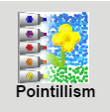

6. Pointillist pictures are made in a similar way to last week’s lesson. You can add water as before; this merges the dots together a bit. You can also experiment with the dot size by altering the slider at the bottom of the screen.

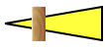

7. On the top right of the screen is a button that gives some outline options that can help you with your painting.

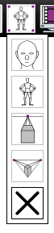
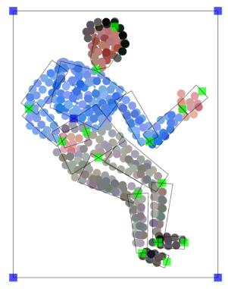
These outlines can be resized and repositioned using the blue and green draggable squares on them. For example, you can position a person template and use it to paint a person in a particular position. You can then move the template to add more people. There are templates for a face (for portraits), a body and vertical and horizontal perspective (not so relevant for this lesson).

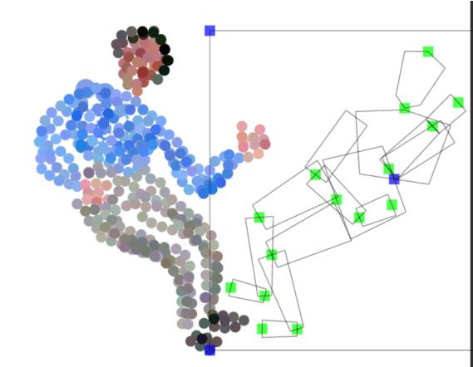


8. Remember that you can always use the undo button in case you make a mistake and want to reverse it.

9. After you have spent some time experimenting, you should create your own pointillist-style painting. Try to choose a different subject from last week’s lesson.

10. While you are working (or afterwards), think about how creating pointillist art on the computer differs from using paints. The artists who invented this style did not have computers. If you have time and want to try, you could even try creating pointillist art using paints. What are the advantages and disadvantages of the two methods? Which do you like best?

11. When you are happy with your picture, make sure you give it a title and add your name in the box in the bottom left-hand corner. Then remember to save your work into your My Work folder by clicking on the Save button and entering a name for you piece before clicking Save.
Please remember to ‘Hand In’ your work so that I know that it is finished and can mark it for you.

12. Extension exercise.

There is also another 2Do set for you to complete an information sheet on Pointillism. You can open this and complete it in a similar way to last week’s extension activity.

You can look back at last week’s lesson if you cannot remember how to complete your information sheet
Appendix 2 – Pointillism Fact File

Pointillism was a development of impressionism. It was invented mainly by George Seurat and Paul Signac.

Pointillist paintings are created by using small dots in different colours to build up the whole picture. Colours are placed near each other rather than mixed. Some pointillist pictures are huge and were all done by hand (not on a computer!). A Sunday Afternoon on the Island of La Grande Jatte by Georges Seurat is two metres high and three metres long!

The different colours close together trick the eye into blurring all the dots into an overall image. The brain mixes the different colours together.

Examples of pointillist paintings include:

A Sunday Afternoon on the Island of La Grande Jatte (Georges Seurat)

Cassis, Cap Lombard (Paul Signac)

The Pine Tree (Paul Signac)

