Making Music, Lesson 1 – Exploring Sounds

Aims
- To be introduced to making music digitally using 2Sequence.
- To explore, edit and combine sounds using 2Sequence.

Success criteria
- You will understand what 2Sequence is and how it works.
- You will have used the different sounds within 2Sequence to create a tune.
- You will have explored how to speed up and slow down tunes.
- You will understand what happens to the tune when sounds are moved.

Resources
- Headphones.
- Twinkle Twinkle file – you will find this set as a 2Do for you when you log into Purple Mash. Listen to this tune
before you begin your activities.

Activities
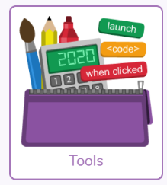
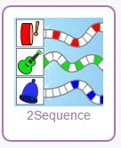
First you need to log in to Purple Mash. Then click on Tools and scroll down until you see Music and Sounds. Open 2Sequence (Launch App) – this will let you explore lots of musical sounds and make you own music.
- Start with a simple pattern of sounds. Select the bells and chimes from the bottom of the screen.
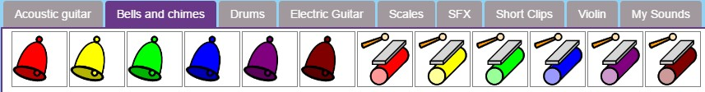
- Using the bells and chimes, drag each instrument onto a bar.
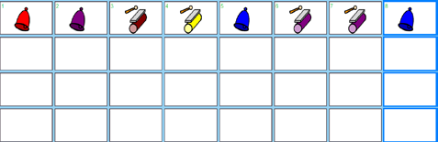

- You can now run your sequence by clicking on the big green for ‘go’ arrow at the top of the screen. Notice how each bar is highlighted as the tune is played.

Now try:
- To slow down and speed up the tune by using the bpm (beats per minute) slider.



Which tune did you like the best: the fast one or the slow one?

- Set the bpm back to the centre (about 140 bpm) drag the instruments from the bar and into the bin, leaving empty spaces.
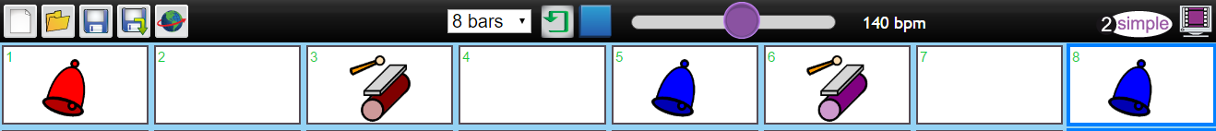
Now play the tune again; what does it sound like? Now speed it up and slow it down again. What does it sound like this time?

- Have a go at creating different tunes with the bell and chimes, speeding them up and slowing them down. You may need to use headphones so that only you can hear the tunes that you are creating!

- When you have had a chance to explore how to create your first tune, you can now add another set of instruments from the bottom of the page. Select the drums.
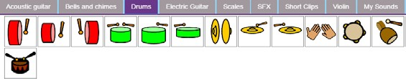

- Show the children how you can add more instruments and sounds to the bars and start to add different sounds to the tune you have just created.
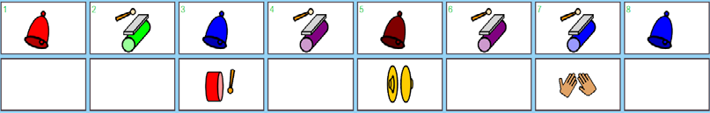

What does your tune sound like now? Try speeding it up and slowing it down. Which tune did you like the best?



- If you want to save your first tune, then click on the Menu icon and choose Save. Give your tune a name and save it into My Work. Then clear your tune and start again by clicking on the Menu icon, then on the New icon.

- Select the violins from the instrument bank.
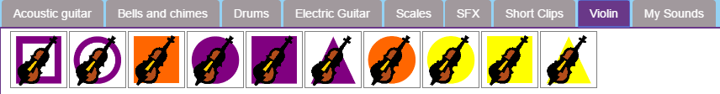
Each violin will play a short accompaniment; click on them one by one and listen to what each one sounds like.

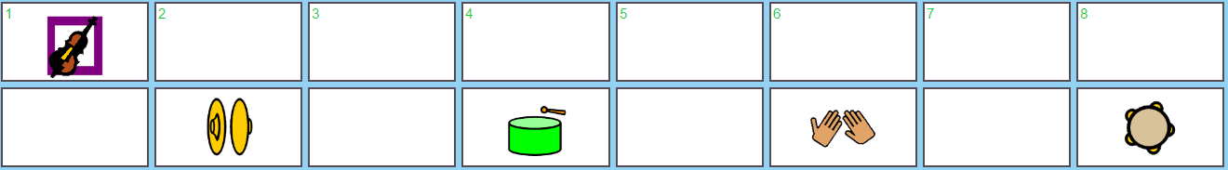
- Add one of the violin sounds to the first bar. Now add some sounds (the drum section) onto the second row underneath the violin.
If you play the tune now, you will hear the violin sound with the other sounds.

- Try moving one of the instruments up onto the same row as the violin. What happens to the sound of the violin?
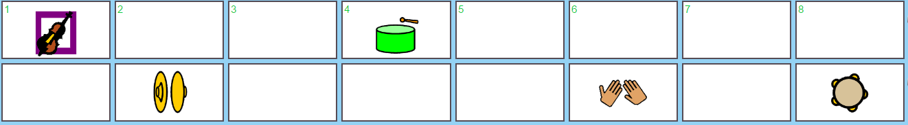

- Now experiment making different tunes with the violins and using different instruments as the backing sounds.

- You can change the volume of the backing sounds on each row by using the volume control at the side of each of the rows.
Dragging the small bar either up or down will control the level of the sounds in that row.

Try changing the volume for each of the rows. Which row works best louder?
Which is better quieter?

- When you are happy with the tune that you have created, remember to to save it into your My Work folder.

