Lesson 3 – Soundtracks

Aims
- To upload a sound from a bank of sounds into the Sounds section.
- To record your own sound and upload it into the Sounds section.
- To create your own tune using the sounds which you have added to the Sounds section.

Success criteria
- You will have uploaded and used your own sound chosen from a bank of sounds.
- You will have created, uploaded and used your own recorded sound.
- You will have created your own tune using some of the chosen sounds.

Resources
- Headphones.

Activities
- Remember that 2Sequence uses banks of sounds to allow you to create your own tunes and music.

- In today’s lesson you are going to create your own soundtrack for a film or cartoon you have seen, or you can think of your own idea for a film or cartoon and make a soundtrack for that.

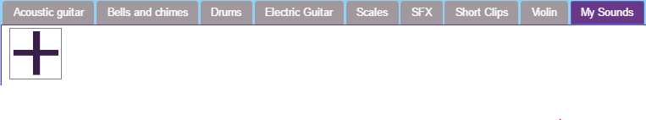
- Go back to the Sounds section at the bottom of the screen and from this section select My Sounds.
You will see a blank box with a big plus sign waiting for you to add your own selection of sounds.

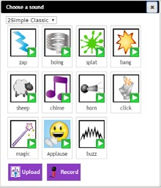
- You can find all the additional sounds by clicking on the plus sign.
This will show a bank of sounds which you can choose from and a drop-down menu with a selection of even more sounds to choose from.
Drop-down menu

- To play a sound to listen it, simply click on the white arrow next to the sound.

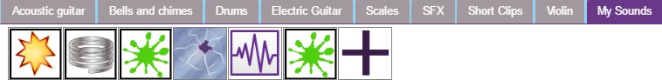
- If you are happy with the sound, click on the picture of the sound to select it. The sound will then appear in your own My Sounds section.
Now spend some time exploring, listening to the sounds and choosing ones you think will be useful for your soundtrack.

- Once you have added your sounds to your My Sounds section, you can start to use them as before. The bank of sounds will save with the sound file you are creating.

- There is also the option for you to record your own voice and add it to your My Sounds section.

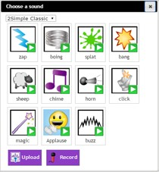
- Go back to the My Sounds section and select the plus sign. From the following window, select the Record button.

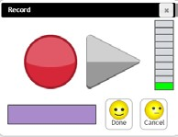
You will now be able to record for 15 seconds.

This could be your own voice or your own sound effect using instruments. You could even try to beatbox if you like! Here is a video for children which will teach you how to make all sorts of sounds with your own body:
How to learn to beatbox for children


- When have recorded your sound, selecting Done will add the sound to your My Sounds section and the Sound icon will appear as a microphone.
Only one sound can be recorded.
Recording a second sound will overwrite the first.

- Now spend some time creating your soundtracks. Start by creating a basic tune with different instruments as you learnt to do in our first two lessons, then when you have the basic tune, experiment with adding in sound effects. Which ones work best with your tune? Remember to save each soundtrack you create, giving each one a different name.

- At the end of the lesson, listen back to each of your soundtracks. Then please send me them attached to an email using 2Email. Remember to let me know what film or cartoon each soundtrack is for.

- As an additional activity, you can use the Export icon to export your soundtracks as an MP3 file.

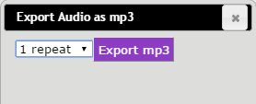

You can then save them to your own computer and play them whenever you want to!

That is the end of today’s lesson.

Have fun and don’t forget to send me your finished tunes!

