Lesson 1 – Animating an Object

Aims

To understand what makes a good animated film or cartoon.
To see how animations are created by hand.
To find out how 2Animate can be used to create animations in a similar way using the computer.

Success criteria
You will have put together a simple animation using paper to create a flick book. You will have an understanding of animation frames.
You will have made a simple animation using 2Animate.

Resources

Sticky notes (such as post-its) and pens.
If you have any, examples of paper animations such as flick books and scanimation books would be useful but they are not essential.

Activities

1. Think about which are your favourite animated films and cartoons. Why do you enjoy them? Why do you think that animated films can be much more fun than real images?

2. Animation can be something very simple and can start with simply animating a face so the character appears to smile when the animation is run.

3. Do you know how animated films are actually created?


Animation is described as a ‘process by which we see still pictures move’.

Each individual picture is shot on film one at a time. The pictures are shown at the rate of 24 pictures per second, which makes the pictures appear to move.

4. Try working out:

If you need 24 pictures per second, how many pictures will you need for:

…a five-second animation? …a 25-second animation? …a 60-second animation?

That’s quite a lot of images!

5. Our brain holds onto an image for a fraction of a second after the image has passed. When our eyes see a series of images very quickly one after the other, because our eyes cannot cope with fast-moving images, you are tricked into thinking that the images are moving.

6. If the images you are seeing change in some way, you see this as animation.

7. You can make a simple flick book using a ‘post-it note’ pad.


8. Make a ball move by drawing it in different positions diagonally across several of the pages at the beginning of the post-it note pad. Now flick the pages very quickly to see the image move.

9. Before digital images were used, all the animations would be drawn by hand – a very time-consuming activity.


10. If you have access to see if you can find one of the first animated films created by Walt Disney – these featured Oswald The Lucky Rabbit.

11. Now see if you can find some of the very early Mickey Mouse animations. (Look for ‘Steamboat Willie’)

12. Most of the images for animations today are created using computers. You can use 2Animate on Purple Mash to create both simple and more complex animations.

13. You will find 2Animate in the Creative Tools section on Purple Mash, nonetheless I have set a 2Do for this lesson which you will find in your 2Dos when you next log on to Purple Mash. This will open 2Animate for you, giving you a blank project to work on.
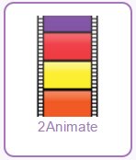
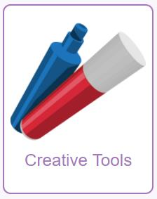

14. You begin by using 2Animate to create a series of frames, changing the picture in each of the frames. You could start with a simple face as shown in the next step.

15. You can drag the first frame you draw onto Frame 2. This will copy the image so you don’t have to draw the same image on Frame 2. Add to the image and drag it to Frame 3, etc.
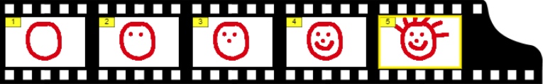

16. Click on the plus sign to add a frame if you need an additional one and the minus sign to delete one of the frames if you are not happy with the image. Try making your own crazy faces.



17. Once you are happy with your pictures, click on the green for ‘go’ arrow key at the top of the page to animate the frames.

18. Use the icons at the top of the page to speed up and slow down the animation or to pause and stop it and return to the previous screen.


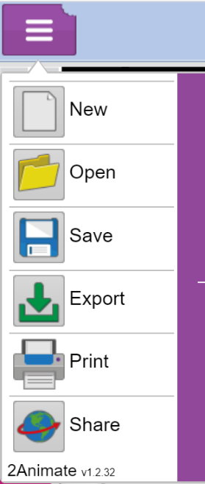
19. Once you are happy with your first simple ‘face’ project, try to create a second animation with a bit more detail to it. If you wish to save your first animation, remember to click on the Menu button and select Save. Once you have saved, you can then click on the Menu again and this time select New.

20. Some ideas for your animation could be space, growing things, weather (e.g. a thunderstorm happening), characters moving (human or animal) or even painting a picture frame by frame. There are some other good ideas on this website:
https://www.homeschooling-ideas.com/animation-ideas.html

If you would like to see simple Animation I have made as an example, click on Open, select the Beech folder then DrawingALadyAnimation. I am sure you can create something much more exciting than I have done!

Please remember to use 2Email to send me any animations you create this week – I am really exciting to see what interesting ideas you come up with.

Have fun!

