Lesson 2 – Other Tools
Lesson 2 – Other Tools
Aims

To learn about onion skinning in animation.
To add backgrounds and sounds to animations.
Success criteria
I know what the Onion Skin tool does in animation.
I can use the Onion Skin tool to create an animated image.
I can use backgrounds and sounds to make more complex and imaginative animations.

Resources

2Do called ‘Week Two Animation Project’. Activities
- Firstly, just open 2Animate (not the 2Do which I have set). You will be doing some practice first and you only need to open the 2Do once you wish to create the project you are going to submit to me as this week’s work. 2Animate can be found by selecting the Art icon on the home page.

- Thinking about your first animation, it is quite simple to add to an image once you have copied it from frame to frame.

- The original example (the face) was being added to but the face itself didn’t move. However you can make the whole object animate, e.g. a ball moving through the air.


4. Animating an object to make it look as though it is moving in a direction would call for a little more help from the Onion Skin tool.

5. You can practise using the Onion Skin tool by doing the following:

You are going to create an animation of a ball that has been kicked from one side of the screen to the other.

The Onion Skin tool helps you by showing you the shadow of the object on the previous frame.

6. Create your first frame by using the Pen tool and adding a circle at the bottom of Frame 1.
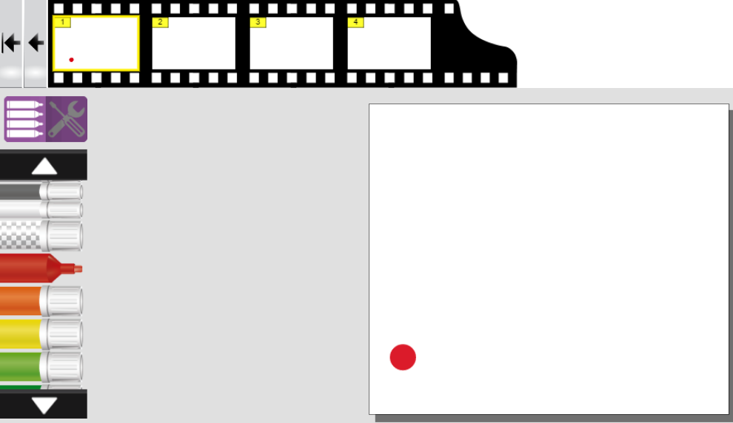

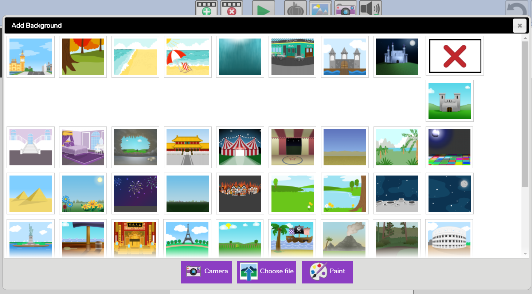
7. Now move to Frame 2, a blank frame (unlike with the first animation, you DO NOT copy Frame 1 onto Frame 2; you leave Frame 2 blank).


8. Select the Onion Skin tool from the top of the page. This will turn brown, indicating that it is turned on.

9. You should now see the shadow of the ball from Frame 1 on Frame 2. The Onion icon looks as though it is making Frame 2 into a piece of tracing paper so that you can see through onto Frame 1.

10. Now add the second circle a bit further away from the first to show that it has moved.
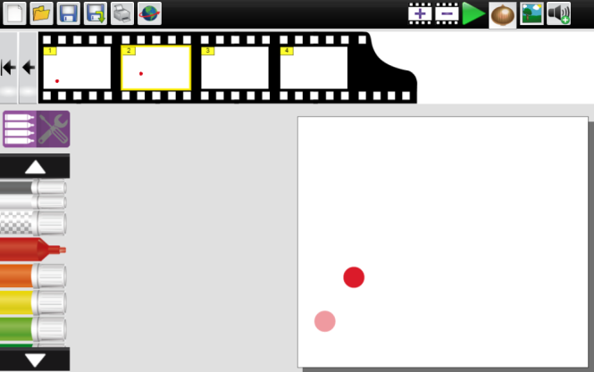

11. Repeat this until you have completed all your frames, drawing the circle so that it is following the same line as the previous circle.
12. Your animation frames should now look something like this. When you run the animation, it should look like the ball is travelling through the air.
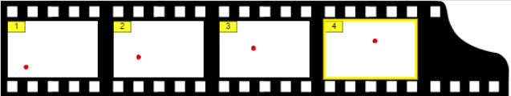

13. Now you can really start to have some fun with your animations by adding backgrounds and sounds. At this point you should save any work you have done and open the 2Do called ‘Week Two Animation Project’. The project you create now will be the one which you will be able to ‘Hand In’ to me once you are happy with it. I will then be able to mark it in Purple Mash.

Backgrounds



14. Click on the Background icon to choose from a selection of background images to add to your frames.

15. You can also paint your own background (Paint), upload your own image (Choose file), or take a photo using the computer’s own camera (Camera).

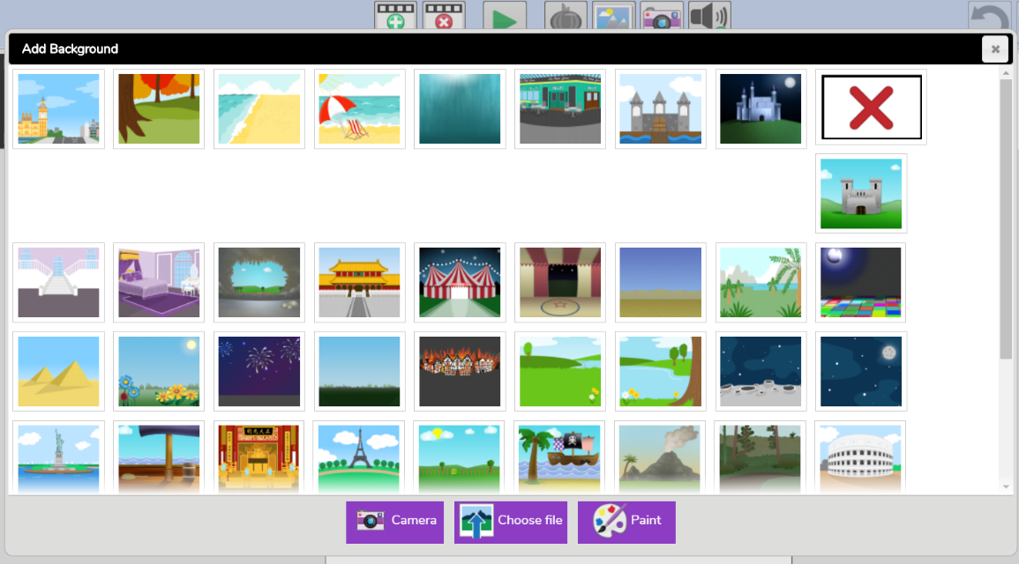

16. The background will be added to all the frames.

Sounds



17. You can add a sound to an individual frame by selecting the frame you want to add the sound to then choosing the sound you want to add to it. A Play icon will appear on the frame in question.
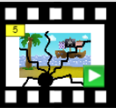

18. You can also upload a sound and create your own sounds too.

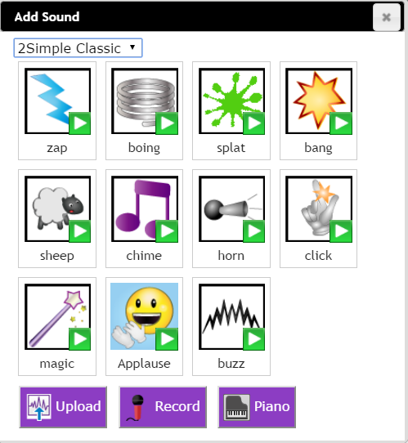

Be creative!

19. Using the Onion Skin tool, backgrounds and sounds, try creating your own ideas which start to show an animated picture.

20. The example below shows a cannon being fired out of a pirate ship.

The ball appears to hit a glass window and the sound of glass breaking is played.
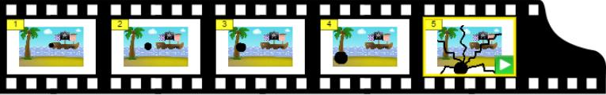

21. Can you create the same idea or come up with a similar, new idea of your own?

22. Make sure that once you have finished you save the 2Do. You can go back and work on it as often as your like, but don’t forget to hand it in when it is finished.

Have fun!

