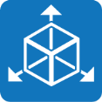
Purple Mash Computing Scheme of Work – Unit 5.6 – 3D Modelling – Lesson 3

Lesson 3 – Designing for a Purpose Aim
To design a 3D model to fit certain criteria.

Success criteria

You will have explored how to edit the polygon 3D models to design a 3D model for a purpose.

Resources

Before you begin, have a look around your house at a selection of oddly shaped items which you could create a design for. For example: a guitar, a cricket bat, some children’s toys. Alternatively, you can simply use your own imagination to decide upon an item to design.
I have set the design brief activity as a 2Do for the class. You will find this in your 2Dos when you next log on to Purple Mash. The design brief asks you to upload a picture of an item similar to the one you are going to design in 2Design and Make if possible. You could take a photo and upload it, or search online for a picture of something very similar.

Activities

1. Today, you are going to be designing packaging for an item. It is up to you to decided which item you would like to design the packaging for.

2. It is up to you which of the available polygon templates you use as the beginning point for your design, but it needs to be something suited to the item and to the type of person who would receive it.
3. Watch the help video called ‘Adding and removing points’. This demonstrates that the polygon templates can be adapted to making alternative shapes. Ensure that you understand how to add and remove points:
Have the Points View on the main screen Click on the Add Points button
Click on the line where the new point should be added
The point will appear halfway along the line but can be dragged to a new position There can be a maximum of 16 points (nodes)

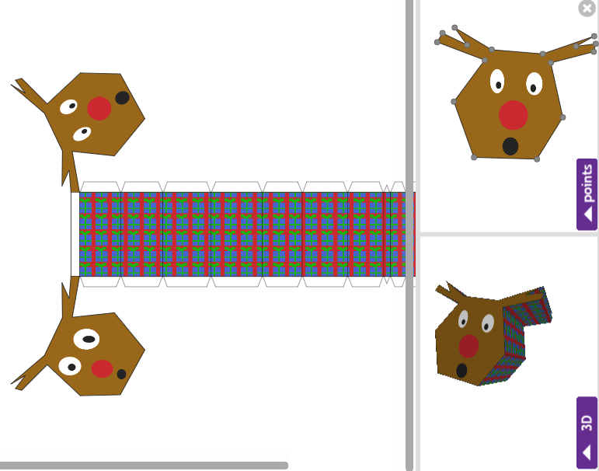
4. In this example, points have been added to a hexagonal prism to make a surprised reindeer covered in a repeating pattern of presents!

Purple Mash Computing Scheme of Work – Unit 5.6 – 3D Modelling – Lesson 3

5. Remember to fill in the design brief activity file (this week’s 2Do) as you go along. To have both 2Design and Make and the activity file open together, you should open a new tab in your browser and open Purple Mash on this second tab as well. Complete the sections about the design before you start using 2Design and Make. You can then insert screen prints from your finished design afterwards.

6. Look for the Zoom tool icon at the top of the template. This will help you to be able to see the

text in the template more clearly.

7. To insert images of the item use some of the included clipart if it is appropriate, draw a picture using the drawing tools or import a picture by searching the Internet. First, save the image on your computer. In the
design leaflet, click on the green arrow on an image box. Locate the file on your device and click Open. There are controls to rotate and zoom in on parts of an image on this screen. When you are happy

with the image, click .

8. How to create screenshots will depend upon which platform you are using 2Design and Make on. One way to do so is to use the Windows Snipping tool (type ‘snipping tool’ in the search bar on your computer to locate this). This enables you to capture a section of the screen and save this as an image file which you can then upload to the design. On an iPad, press the Home button and the Off button at the same time. Other devices will have different methods of creating a screenshot.

9. Make sure that you save both the 2Design and Make model and your design brief information sheet. I will be able to see when you have completed the design brief information sheet as it is set as a 2Do, but you will need to email me your actual design as you have done with your other projects.

I am really excited to see what you come up with! Good luck and have fun.

