
Purple Mash Computing Scheme of Work – Unit 5.6 – 3D Modelling – Lesson 1
Lesson 1 – Introduce 2Design and Make

Aim
To be Introduced to the 2Design and Make tool.
Success criteria
You will know what the 2Design and Make tool is for.
You will have explored the different viewpoints in 2Design and Make whilst designing a building.
Resources

2Design and Make.

Activities

1. Log in to Purple Mash and open 2Design and Make from the Creative Tools area.


2. Look at the different types of available templates. Today, we are starting with the house; in future lessons, we will be exploring other templates and their functions.
3. Select the house and click OK.

4. Note that there are four screen areas:

Painting Tools
Points View (the default large view)
Net View
3D View

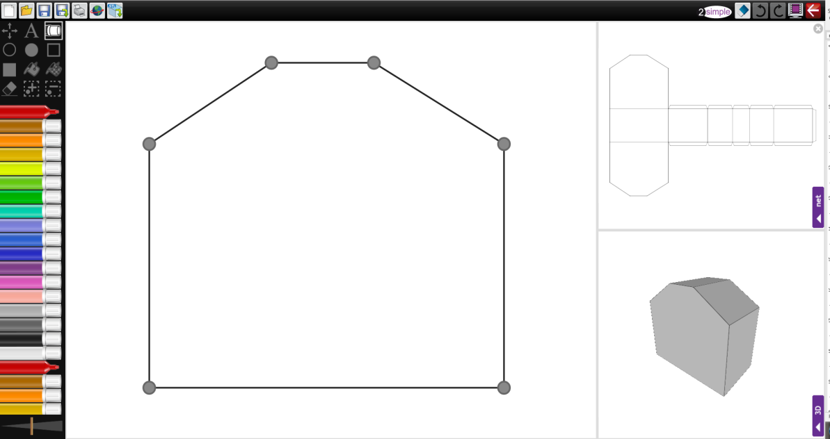



Painting Tools Points View Net View

3D View

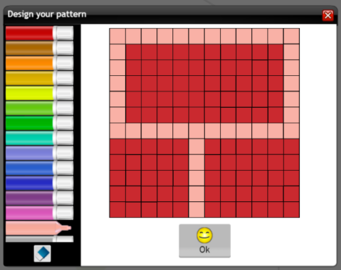
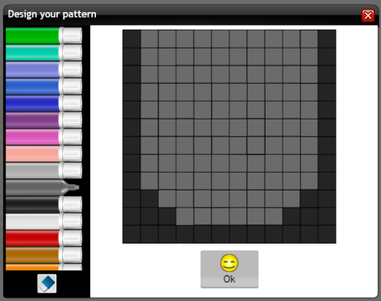
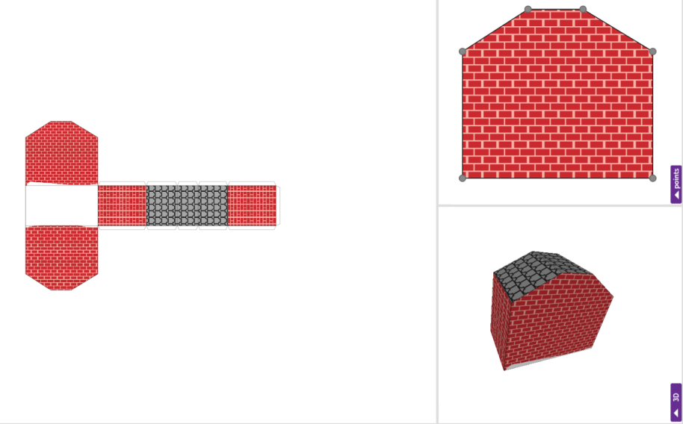
Purple Mash Computing Scheme of Work – Unit 5.6 – 3D Modelling – Lesson 1

5. Try making a different view in the main view by clicking on the purple tab of the view they desire.
6. You can use the zoom control for the main window and scroll around the image; this is useful for adding smaller details to Your design.


7. Make the 3D View the main view and practise spinning the model in different directions by dragging the mouse or swiping. You can also alter the speed and stop the model moving temporarily by clicking without dragging.

8. Explore how the Net View relates to the 3D model by making the net the main view and using the Drawing tool to draw on one of the surfaces. You will see the 3D View change as well.
9. Next, practise adding repeating patterns to your design by using the Pattern Fill tool.


10. Click on the Pattern Fill tool icon . Click OK to accept the default image of red, green, yellow and blue squares and then click somewhere on the net. The area should be filled with the pattern.


11. You can also create a brick or tile pattern. First clear the default pattern by using the button on the Pattern Fill tool, then make a pattern like these for bricks and tiles:

Purple Mash Computing Scheme of Work – Unit 5.6 – 3D Modelling – Lesson 1

12. Now have a go at making your own building.

13. Please note that this week we are not focusing on moving the points in the Points View and if you do try this, you will find that it removes any drawing you have done. Points need to be set before adding the design. We will be exploring points next lesson.

14. Now make sure that you save your work into your Work folder.

15. Finally use 2Email to send me a message with your work attached. I will look at it and send comments back to you.

If you have any problems with how to use 2Design and Make, the User Guide has been provided for you to use if necessary.

