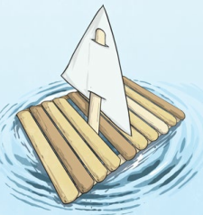
You will need:
- 13 sticks (around 15cm long)
- String or elastic bands
- Paper or fabric (for the sail)

Instructions:
- Lay four sticks on the ground in a square.
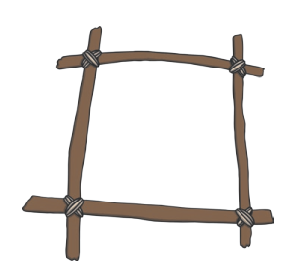
- Tie these four sticks together by wrapping string (or elastic bands) around each corner. Wind the string around and overlap it until the corner feels strong.
- Lay the other sticks across the square frame. Tie them onto the frame.
- Continue until you have a strong base for the raft.
- Chose long stick for the mast. Stick this through the base of the boat.
- Create a sail from paper of fabric and attach to the mast.
- Place your raft in some water – does it float? Try adding some small plastic toys and record how many it will hold.
- Once you have finished keep your boat somewhere safe as you will need it in a few weeks.

Here is my design.

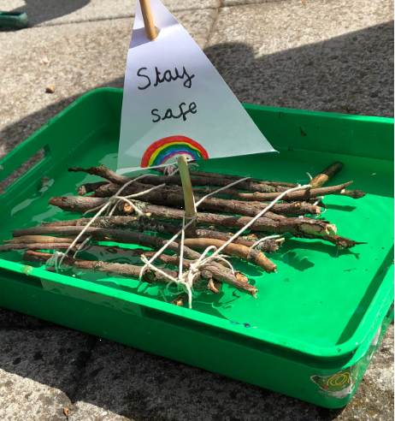
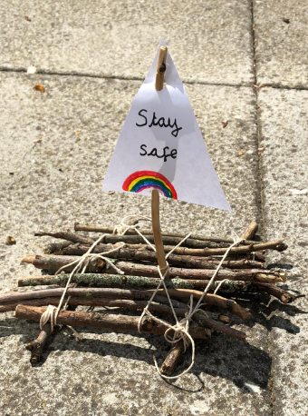

My raft wasn’t very stable but it did float – just!
Once you have made your boat and completed the activity have a go at the evaluation sheet.

