My stick raft
What materials did you use?

I followed the instructions well when I was making my raft?  Colour one face that best describes how you feel about the question | 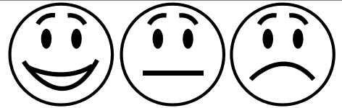
My raft can float on water?

Colour one face that best describes how you feel about the question
I worked safely and carefully when making my raft?

Colour one face that best describes how you feel about the question
If you placed small plastic toys on your raft how many did it hold before it sank?

What do you like best about your raft?

What could you change to make your raft even better?

