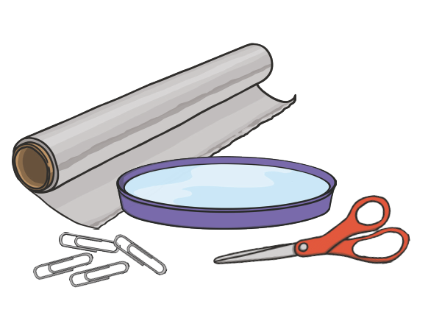
You will need:
- tinfoil
- scissors
- bowl of water
- paperclip

Instructions:
- Use scissors to carefully cut the foil into a rectangle shape.
- Use the foil piece to form a boat that will hold paperclips.
- How many paperclips do you think your boat will hold?
- Place the foil boat in the water.
- Place two paperclips at a time in the boat (practice your counting in twos). Keep adding paperclips until the boat sinks. Make sure you count them as you go!
- Once you have finished keep your boat somewhere safe as you will need it in a few weeks.
Here is my design.
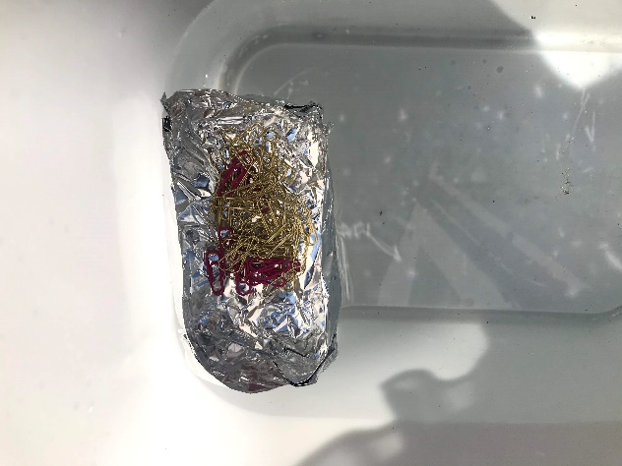
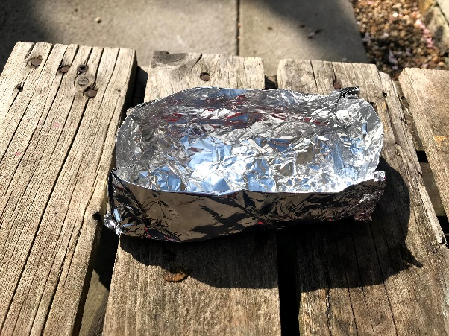

- We ran out of paperclips – my foil boat didn’t sink with 46 paperclips in it!

Once you have made your boat and completed the activity have a go at the evaluation sheet.

