My tinfoil boat
What materials did you use?

I followed the instructions well when I was making my boat?  Colour one face that best describes how you feel about the question | 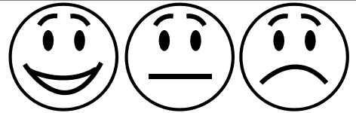
My boat can float on water?

Colour one face that best describes how you feel about the question
I worked safely and carefully when making my boat?

Colour one face that best describes how you feel about the question
How many paperclips did your boat hold before it sank?

What do you like best about your boat?

What could you change to make your boat even better?

