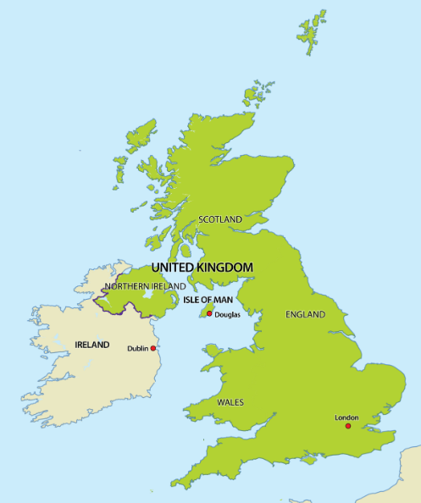
Can you point to Elham on this map of the United Kingdom?

Elham

Can you point to Makara on this map of New Zealand?

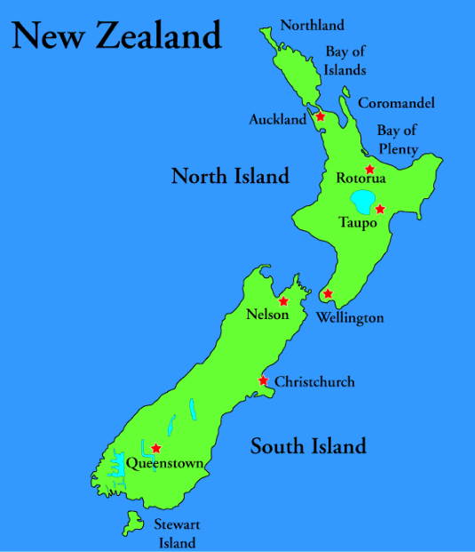

Makara
Makara is at located at the western edge of Wellington, New Zealand.

