Hazel Class Term 5 Computing Project – Animals Presentation

This term I would like you to create a presentation on animals. To do this, you will be making a slideshow in Purple Mash. I would like you to create one slide each week this term. At the end of the term, please ‘hand in’ your work in Purple Mash so that I can see it and mark it.
When you next log on to Purple Mash, click on the bell at the top of the screen.



Click on the 2Do called Term 5 Computing – Animal Presentation and this will take you to your blank slideshow. It will look like this:

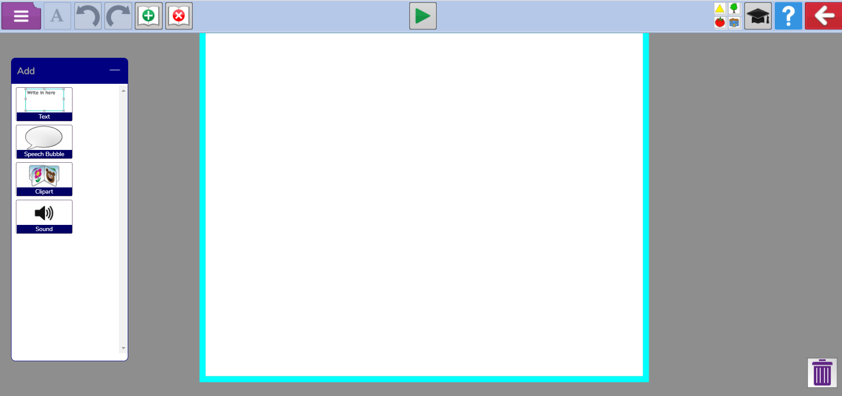

The next few pages will explain how everything works in Slideshow mode. Once you have read and understood these with your parents, then you can follow the detailed instructions further down this document.
Now please ask your parents to explain how to create slides using the instructions given below.

On the left-hand side is the Add box. You can drag a text box, a speech bubble or a picture (Clipart) onto your slide from here.
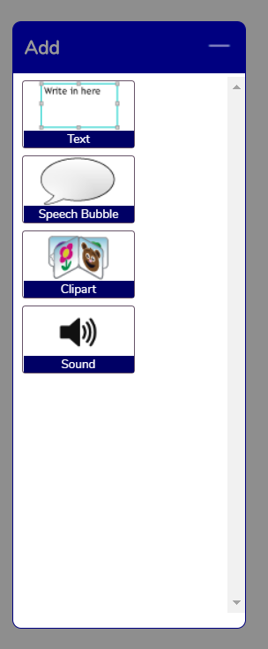
At the top left hand of the screen are these buttons. You can add a new slide or delete a slide using these buttons.



This button lets you change the size, style and colour of your text. When you click on it, you will see all these options. You need to make sure your text is highlighted before you can make changes to it.

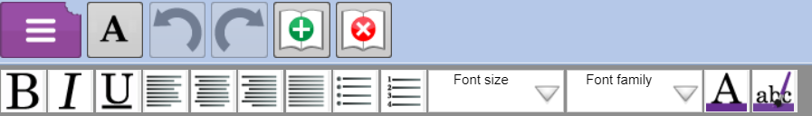

When you drag a picture box to your slide, you will see this screen appear. To choose your picture, click on this button.

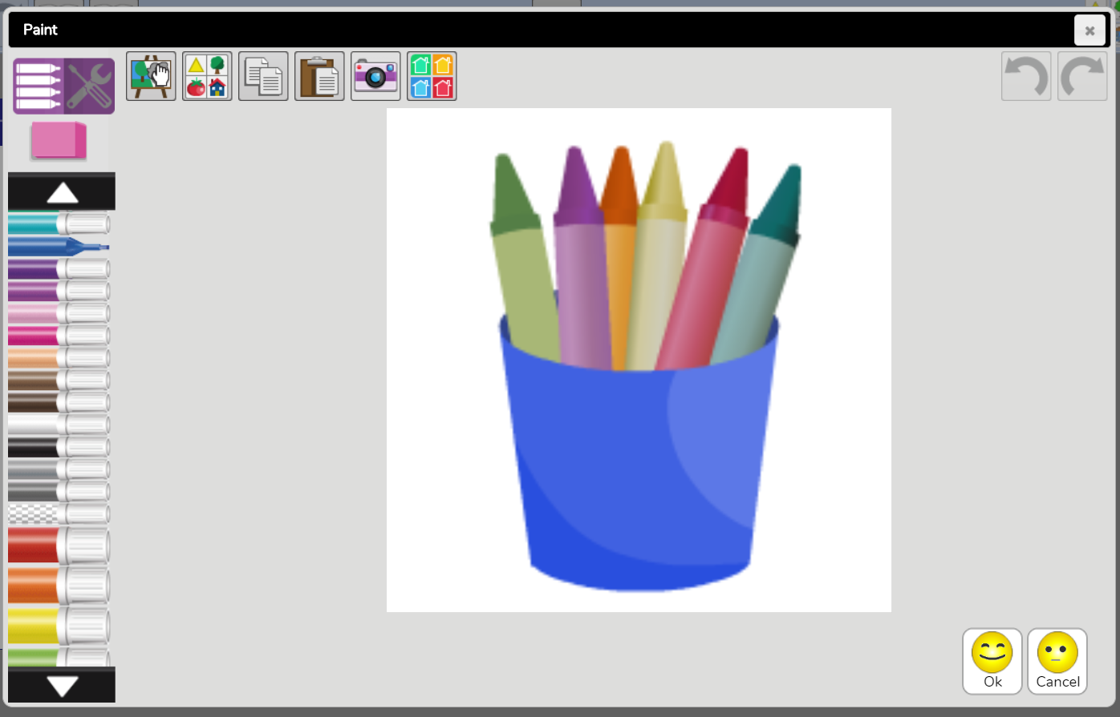

Now you will see the Clipart picker. Choose animals from the drop-down menu on the left and you will see all the available animal pictures. Click on your chosen picture to add it to your presentation.

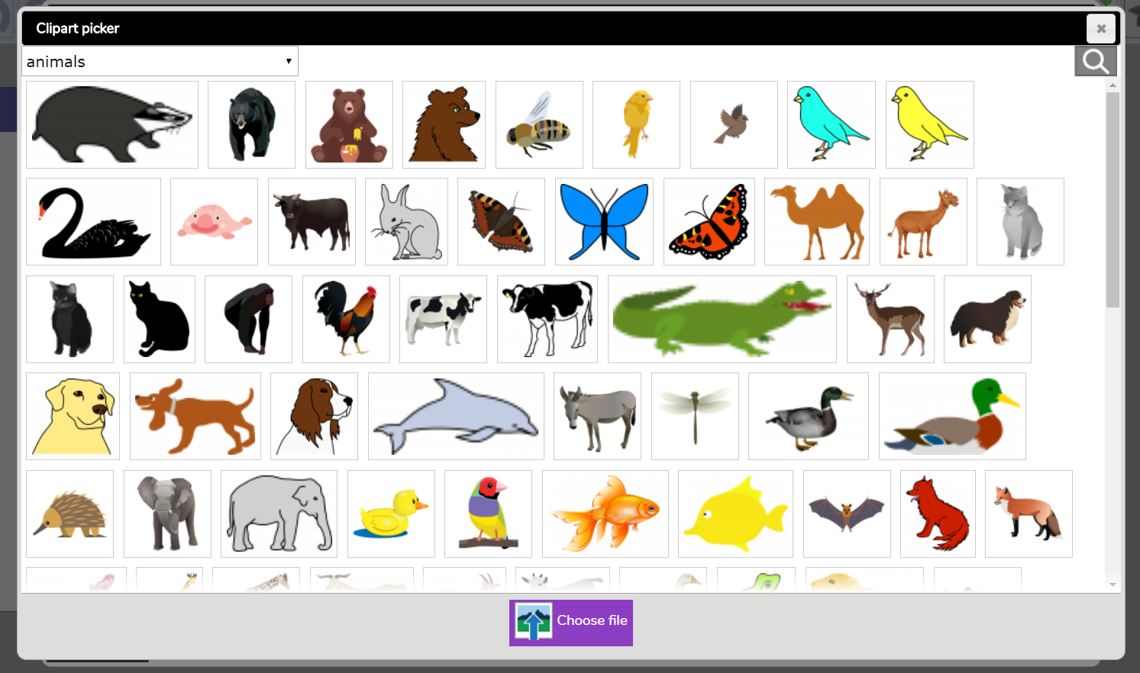

If you want to add a picture of your own from your own computer, then click on this button.
You will see this screen and you click on From my PC and you can insert a photo from any of the folders on your own computer.

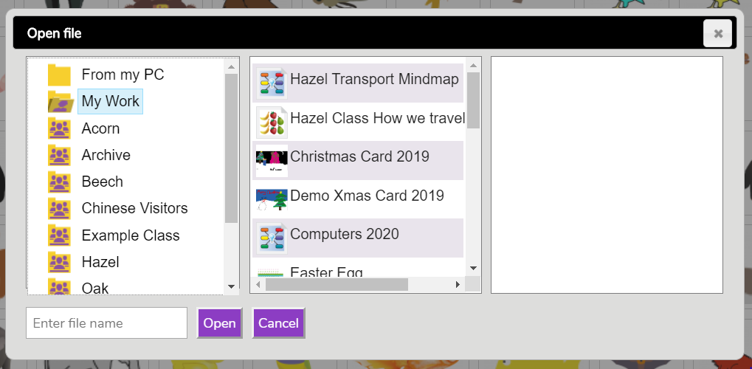
You can also click on this button at the top of the screen. This will bring up the Clipart pictures on the right-hand side of the screen and you can drag pictures onto your slide from here.
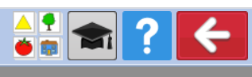

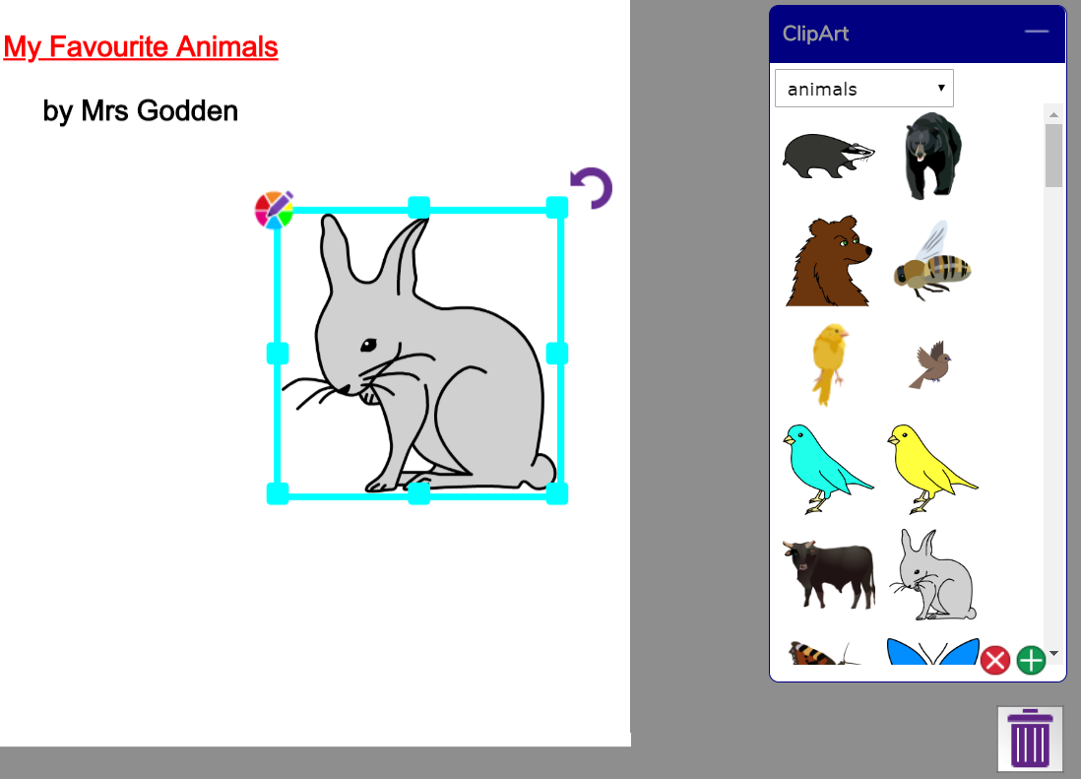
Click and pull the picture from any corner to make it bigger or smaller.
Click on the bin to delete highlighted text, pictures and speech bubbles.
Finally, you need to save your work. Click on the white arrow in a red box at the top right of the screen.

This screen will appear. Click on Save & exit.
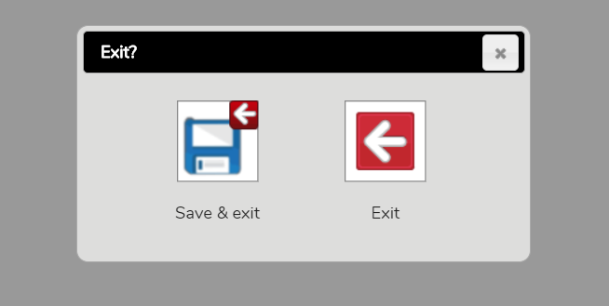

Make sure that My Work is highlighted and type the name of your file (Animals + your name) into the file name box at the bottom.
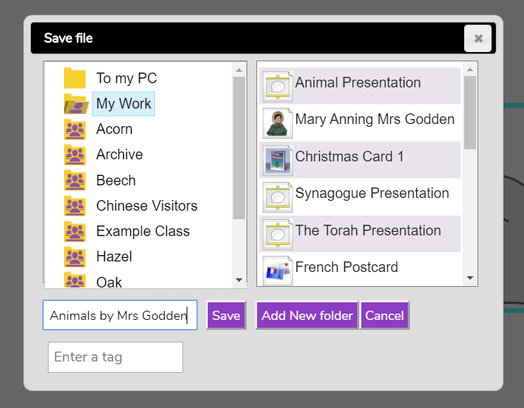
Click the Save button and your work is saved.
You can re-open it and work on it again by clicking on the Work button at the top of the Purple Mash home screen.


How to create your slideshow

- First drag a text box onto the slide and type in your title text. Change the size and colour of the text using the text button if you want to. Remember to highlight your text before you try to change it.

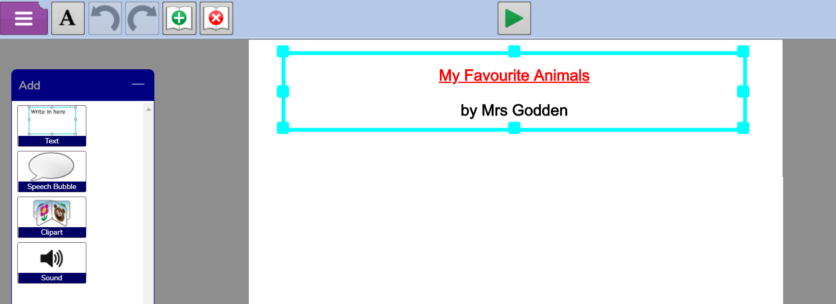

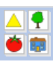
- Next, click on the button at the top, select animals from the drop-down box and drag in some pictures of your favourite animals.

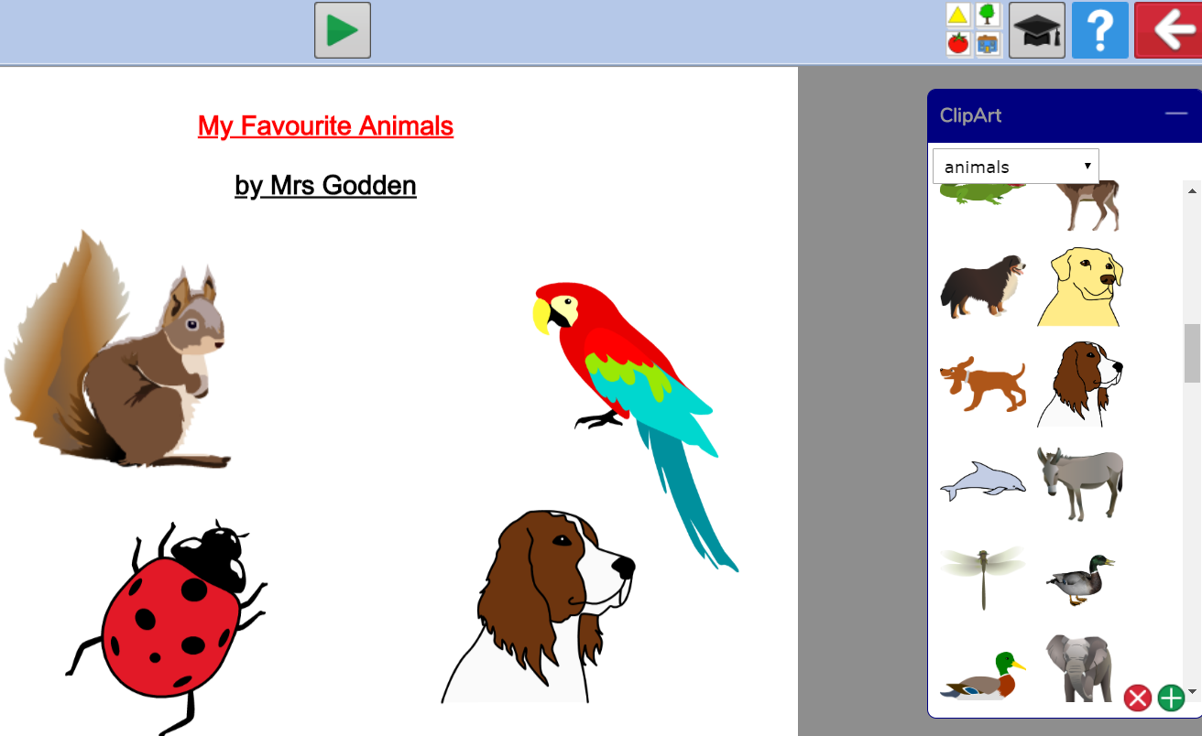

Change the size of your pictures and move them around until you are happy with them.
If you want to use pictures from your own computer, or draw you own, click on the + button.
Then choose either Choose file or Paint at the bottom of this screen.
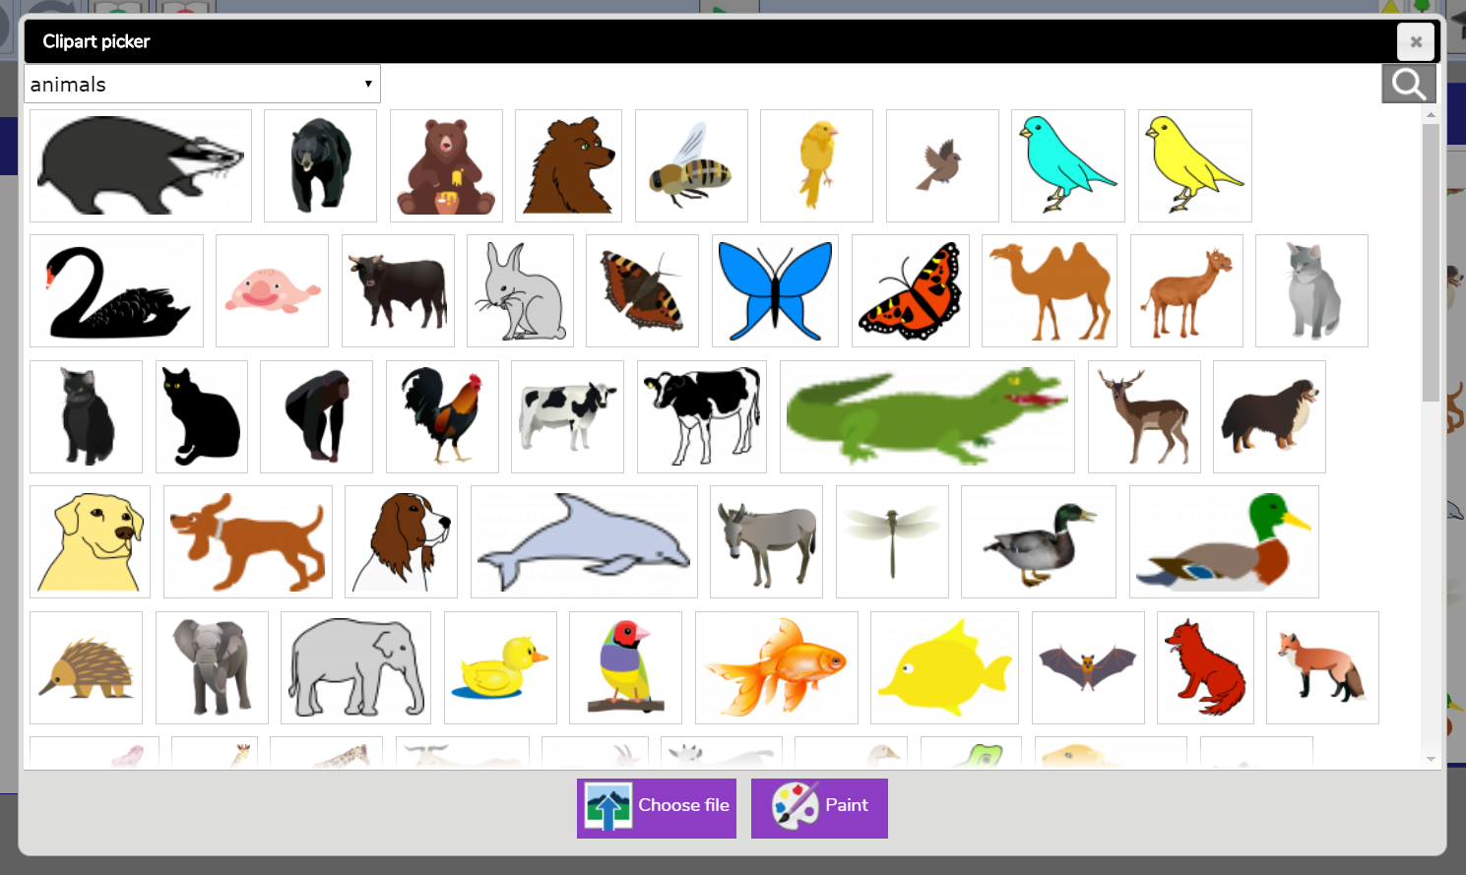
- Now drag in a speech bubble and have one of your animals introduce your presentation.

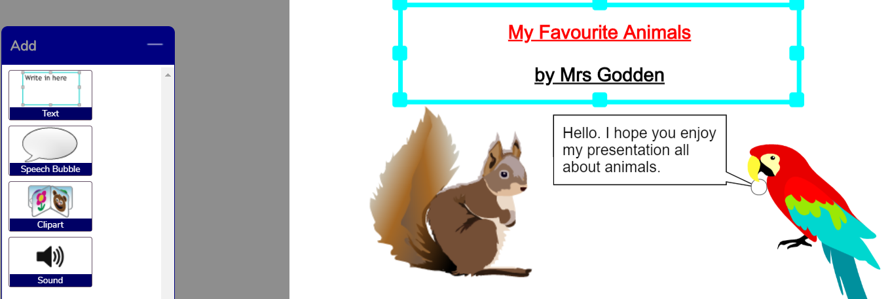

- Finally, click on the new slide icon at the top to add another slide. On this slide put a title with the name of your animal and drag in a picture (or more as long as they are of the same type of animal). In a text box or a speech bubble (or both if you wish), write a sentence or two about your animal.

A very safe website for you to use to find out facts about your animals as well as photos of them is: www.kiddle.co

Each week during this term, I would like you to add a new slide and tell me about a different animal. At the end of Term 5 you should have six slides in total – the first is your slideshow introduction and the other five will each talk about a different animal.

- Remember to save your work each time you make changes to it. Where you are asked if you want to overwrite your previous work, click on OK.

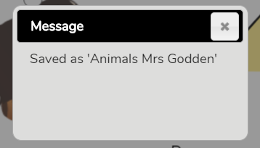
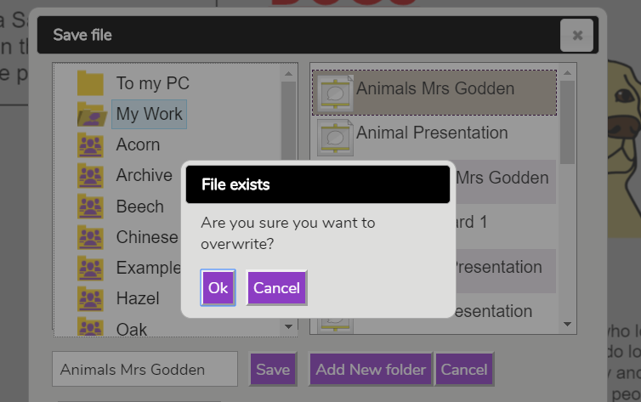

- At the end of term, when your work is finished and you are happy with it, you need to hand it in to me on Purple Mash. Go to your 2Dos on the home page. Click on Hand in, write me a message (or record one if you prefer) and click on OK. You have finished – well done!

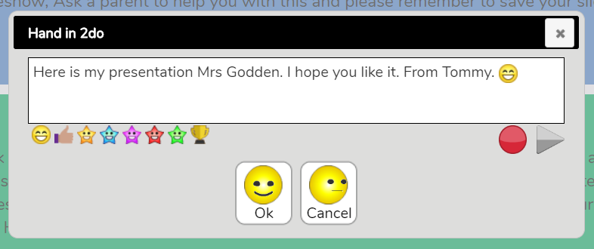
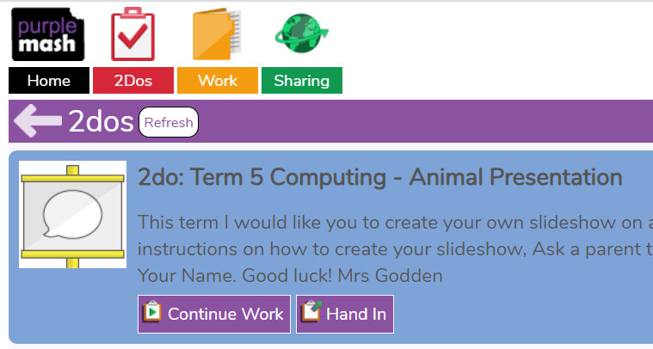

P.S. You can play your finished slideshow by clicking on the Play arrow.

Stop button here.


