You will need:
- Spoon
- Bowl
- A few vegetables or fruit such as (peppers, tomatoes, cucumber, melon)
- Fillings such as (hummus, cheese, chopped fruit, dried fruit or nuts)
- Cocktail sticks
- Paper
- Scissors
- Sellotape

Make sure you follow these rules before you start.
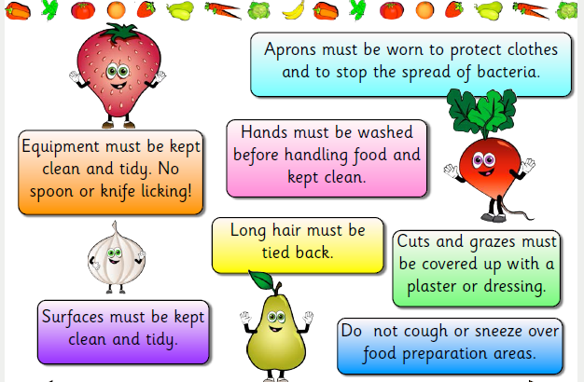

How to make:
- Choose your fruit or vegetable and carefully (with a grown up to help) cut it in half.
- Place you halved vegetable or fruit on a clean flat surface. Scoop out some of it to create space for your filling.
- In a bowl mix together the fillings you would like.
- Place these in the halved-out vegetable or fruit.
- Design and make a sail for your boat. Attach a cocktail stick using tape.
- Place your sail in your boat!

