How to make a windsock

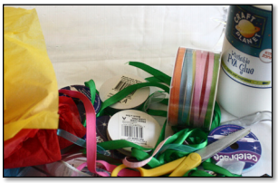
You will need: Plastic bottle
White glue
Tissue paper
Ribbons
Hole puncher

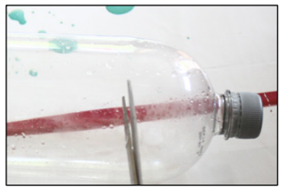

Cut off the top and bottom of a plastic bottle to make a tube.

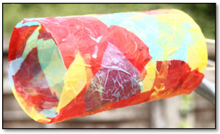

Mix glue and water in equal parts. Tear up strips of tissue and paint them onto the bottle tube with the glue/water. Punch holes in one end and tie ribbon through them. Punch two holes at the top to tie a string loop.

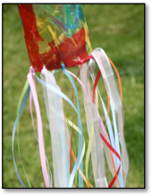
Hang the windsock up on a stick, pole or washing line. Watch which way the ribbons blow. The wind is blowing in that direction!

