Animated Story Books

Lesson Two - Animation

Aims

- To be able to continue the saved story.
- To be able to add animation to the picture.
- To be able to play the pages created so far.
- To be able to save the additional changes and overwrite the file.

Success criteria

- I can open work that I saved in my last lesson.
- I can add an animation to my picture.
- I can play the pages I have created.
- I can save my new changes and overwrite the file.

Resources

- 2Create a Story

Activities


- First you will need to log in to Purple Mash and find the file you previously saved in 2Create a Story. To do this go to your Online Work section on Purple Mash and finding your My Story file (you may have given your file a different name).

- Double-click on the file or click on the file and then the button and it will open.

- Over the last two weeks you should have created a very short story of a few pages with a picture and some text on each page.


- You can play and continue your story by moving to the next page: click on the forward arrow at the bottom of the page.
- Do you remember how to access all the pens and add text? Check that everything is OK with your story. Use the arrow keys to go forwards and backwards through the pages.

- When you are happy that you have finished both your pictures and your writing, try running all the pages together by using the big ‘green for go’ arrow at the top of the page.

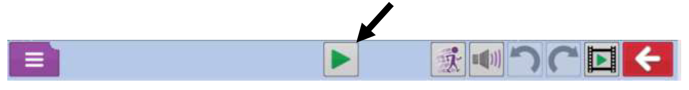

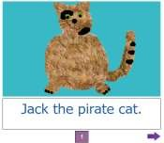
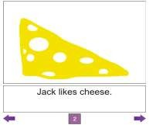
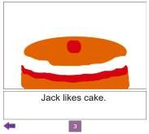
- You can then move forwards and backwards through the book by clicking on the purple arrow keys at either side of the pages.
- Now comes the fun part! You can add animation (movement) to your pictures by using the Animation tool. Click on this button at the top of the screen and you will see lots of different animations to the right of your picture.
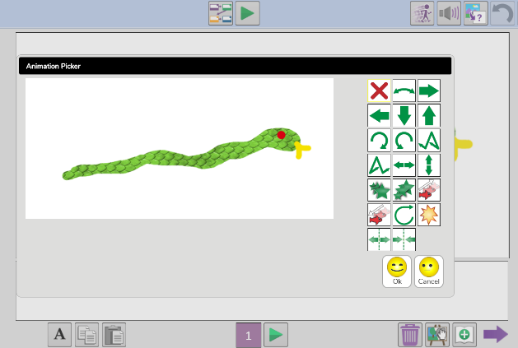



- Spend some time clicking of the different animations to see what they all do and then choose one which you think works best for your picture. Once you are happy with the animation you have chosen, click on the OK button and your animation will be added to that page. Press the green arrow to run the page and to see your picture animated. Repeat this for each page of your story – you can have a different animation on each page. Remember to click OK each time you choose an animation.

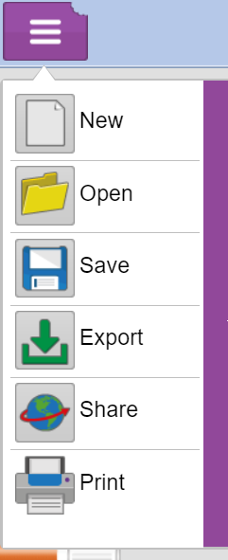
- Some of the animation effects might not fit your story, but they might be more suitable for using in other stories that you might write in the future.

- Now that you have added to your work, remember that you must save the changes you have made. Click on the Save icon. The name of the file should appear and you should select the Save option. At this point, you will be told that you are going to overwrite your work.

Is this ok? Yes, this just means that you are going to save the changes that you made today. It’s really important to save your work each time you add to it as you don’t want to lose it.
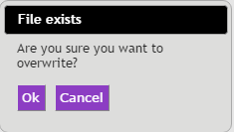

Well done – you have finished this week’s lesson. Your story should now have animation on each page.

