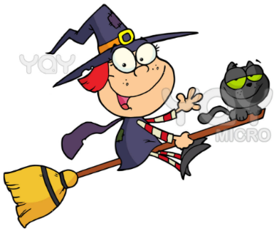
Which witch is which!!

Work out the correct ‘w’ or ‘wh’ spelling for these words.

Paint the walls _________ite.
The blue ______ale is the largest mammal.
Are you coming out _____ith me?
_____ere have I put my keys?
North, south, east and _____est.
Ms Shepherd loves all _____ater sports.
_____ich cake would you like?
Mrs Grady spoke in a _____isper.

