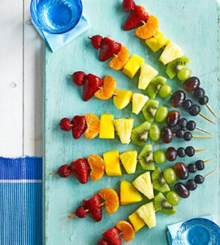
Fruit skewers
You will need:
- 7 kebab stick or wooden skewers
- Selection of fruit such as raspberries, strawberry (with the top bit taken out), red grapes, green grapes, blueberries, melon (or any fruit you like or have at home)

Make sure you follow these rules before you start.
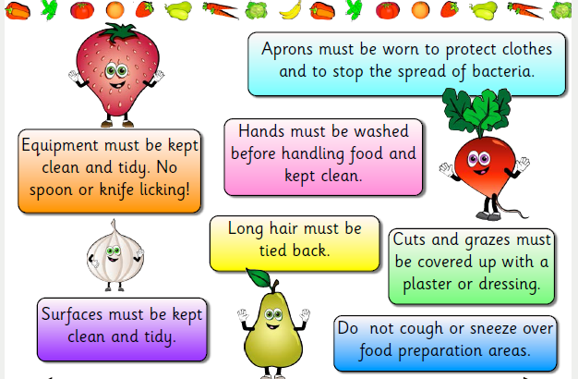

How to make:
- Thread the fruit you have chosen onto your kebab sticks or wooden skewers.
- Arrange in a rainbow shape and let everyone help themselves!

