Lesson 4 – Adding backgrounds

Aims

To understand how to use additional feature in the next level: My Story. To be able to add a background to the story.
To have a good understanding of all the tools you have used in 2Create a Story and use these successfully to create your own story.

Success criteria

I can add a background to the page.
I can copy and paste a page in the book.

Resources

Your story which you have already drawn, written and animated or if you want to create a new project, you could use the words to a simple nursery rhyme. This is a good place to look if you want to create a nursery rhyme book:
https://www.bbc.co.uk/teach/school-radio/nursery-rhymes-a-to-z-index/z4ddgwx

Activities

- Log in to Purple Mash and click on your 2Dos – you will find a new 2Do called Nursery Rhyme. Click on Start and when 2Create a Story opens you should on the next level, My Story. You are going to use this level to draw, write and animate a nursery rhyme.
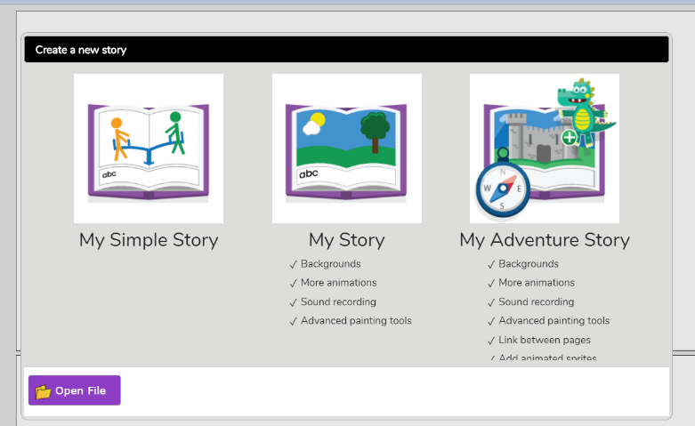

2. This level has some new tools that you are going to explore.

3. Click on the background Image tool until you see this screen. From here you can draw your own background, choose a background from the image library or upload your own picture from your own computer (you will need an adult to help you to do this).
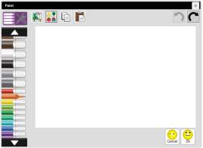



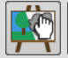
To draw your own background click on this button then use the pens and tools to create your design.

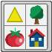
To choose a background from the image library, click on the clipart gallery icon.

You will see a selection of backgrounds. Click on the one you want to use and then click OK. You will need to repeat this for each page of your nursery rhyme. You could use the same background all the way through or choose a different one for each page – it’s up to you!
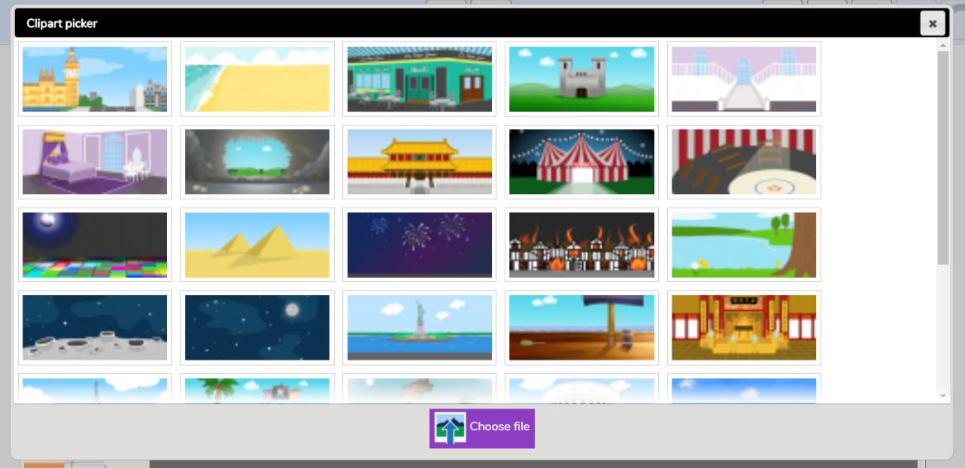

If you want to add your own background from your own computer, click on the Choose File button and then select the From my PC folder. Find your file and click on Open to upload it.

4. You can draw on top of the backgrounds but you can only add animation to the picture that you draw, not the background.

5. Now that you know how to use backgrounds, you can either add them to your existing story, or create a completely new story (a nursery rhyme perhaps). If you make a new story, don’t forget to add your animation and sounds and to save your work before you exit and to click on Hand In when your story is complete. I will look out for your finished work and mark it in Purple Mash.

