How to make a rain gauge

You will need: Plastic bottle
Scissors
Duct tape/Sellotape
Marker pen
Small stones.

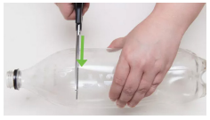
Cut the neck of the bottle off (an adult needs to do this).
The cut needs to happen just beneath where the bottle begins to narrow.

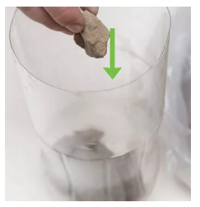
Pop the stones into the bottom of the bottle to even out the bottom and to keep the gauge from tipping over if it’s windy or it rains hard.

Take the lid of the bottle off. Turn the neck upside down and put it into the bottom half of the bottle. Use duct tape to tape it together.

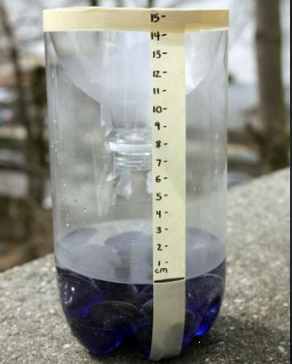
Fill the bottom of your rain gauge with some water. From the top of the water line use a ruler to mark each centimetre till you reach the top.

Put your gauge on a level surface. Make sure it is out of the way of people walking and not covered by branches and trees.

Check your rain gauge each day for a week. There is a sheet on the website to record your results.

