Animated Story Books
Lesson 1 – Drawing and Creating

Aims

- To get started with 2Create a Story’s My Simple Story level.
- To be aware of the differences between traditional books and e-books.
- To become familiar with the drawing tools.
- To become familiar with the Text tool.
- To save the page they have created.

Success criteria

- I know the difference between a traditional book and an e-book.
- I can use the different drawing tools to create a picture on the page.
- I can add text to a page and change the colour, font and size of the text.
- I can save my work.

Resources

- 2Create a Story – available in the Tools (English) section on Purple Mash.
- Some examples of actual paper books with sound buttons or buttons that read the story would be useful but not essential.
- 2Create example – The Pirate Cat

Activities

- Earlier this year, we looked at how books can be read on the computer as well as the traditional books we usually pick up in the classroom and read. Do you remember that these are called ‘electronic books’ or ‘e-books’ for short? If you would like to look at some e-books before beginning this lesson, then click here: https://www.booktrust.org.uk/books-and-reading/have-some-fun/storybooks-and-games/

- Now take a look at an e-book created using 2Create a Story in Purple Mash. Click here: The Pirate Cat. Press the ‘play’ button to play the story and use the arrows to move to the next page.

What are the differences between an e-book and a traditional book?
How does the animation make the story more interesting and how do the sound effects can help the story to come to life?
What do you like about e-books and what do you like about traditional books?

- Now you are going to make your own e-book like The Pirate Cat.

- Before you begin creating your animated story book, you will need to write a very short story similar to The Pirate Cat. Ask a parent to help you write down your story. It should only be a few lines long – you will be drawing a picture for each line of the story, so don’t make it more than five or six lines long.
Your first page should be the title of the story and your name. Here is an example of a short story I wrote:

Sammy The Snake Who Liked Snacking by Mrs Godden
On Monday, Sammy ate an apple.
On Tuesday, Sammy ate a banana.
On Wednesday, Sammy ate an apricot.
On Thursday, Sammy ate an orange.
On Friday, Sammy ate a pear.
On Saturday, Sammy ate a big bowl of strawberries.
On Sunday, Sammy tried to slither off to visit his friend, Dolly. However, he had eaten too much and was too heavy to move! What a greedy snake Sammy is!

- Once you have your short story written down, go to the Purple Mash home screen, click on English and open 2Create a Story and go to the My Simple Story level.
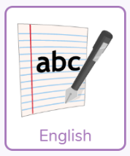

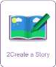
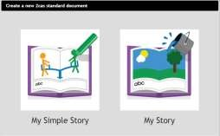

- First you are going to create some pictures to make you own e-book. In the big box try using the pens to draw your own character. Explore and create by using the different-textured pens.

Below is an example of a picture of Sammy The Snake.

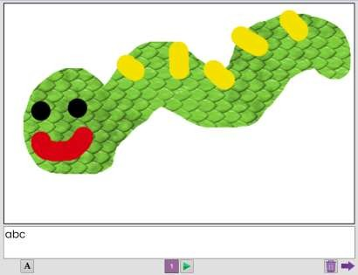


- When you have finished your first drawing, add the title of your story in the text box at the bottom of the page. You can experiment with changing the text style (font) and size by clicking on this button.

Below is a picture showing a page with a picture and some text underneath.

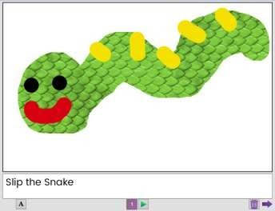
- When you have finished your title page, add a new page using this button and type in the first line of your story. Then add a picture which shows what is happening. See if you can do two or three pages this week. You will have time to finish your pictures and text next week before we move on to animation.

- It is really important to save your work so that you are able to add to your story in the next lesson.

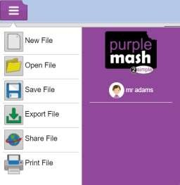
Click on the Menu button. From the drop-down menu, select the Save File option.

Give your piece of work a name. You could call it ‘My Story’ or the name of your character, but try to add your name on the end so that I know whose work I am looking at when I mark your work.
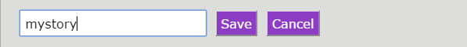
Make sure that you save your work in your own My Work folder.

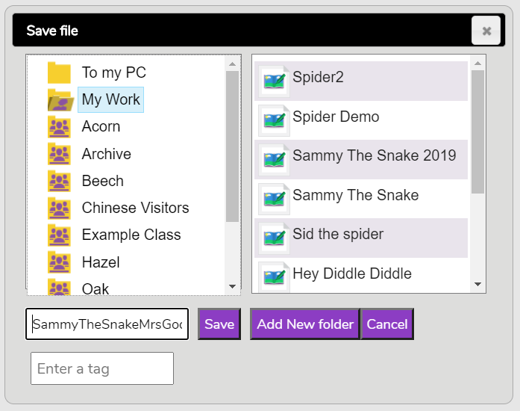

Well done! You have now started your first e-book.

