Lesson 5 – Copy and Paste Aims

To understand how to use additional features in the next level ‘My Story.’ To be able to open and add to the story
To be able to continue with the story using the copy and paste feature to create additional pages. To create a class, display board of the story books created by the children.

Success criteria

I can enhance the features of my story book by adding additional pages and animations. I can share my story book on a class story book display board.

Resources

Display boards

Activities

1. Firstly, please find and open your last saved file in the My Story level of 2Create a Story.

2. Take some time to go back to your story and read the story so far.

3. Remember to try all the features you have added so far to their story.

4. You can easily continue with your story by copying and pasting pages.

5. This is a really useful feature which can help you to save time making pages.

First, go to the page you want to copy, then click on the copy icon underneath your story. Use the purple arrows to move to the place where you want your copy to be, then click on the paste icon. Your whole page, including the picture and writing will appear as a new page. You can then change the writing and also change the picture slightly if you wish.

You can also change the animation and sounds on this new page.



6. Now spend a little time copying and pasting pages and changing the text and pictures to make your story longer. You can do this at the end or in the middle of your story. Don’t forget to save your work as you go. If you make a mistake and decide that you don’t want the page you have copied, you can simply use the delete button.


7. Finally, we are going to create our own online library of all the stories that Hazel Class has written. That way, everyone in the school can see and enjoy your wonderful work. To share your story, first click on the menu button and then on the Share button. You will see this pop-up appear. Click on Share and then on the display board called Hazel Class 2020 Animated Stories. Then when you are asked if you are sure you want to submit your story, click on OK.

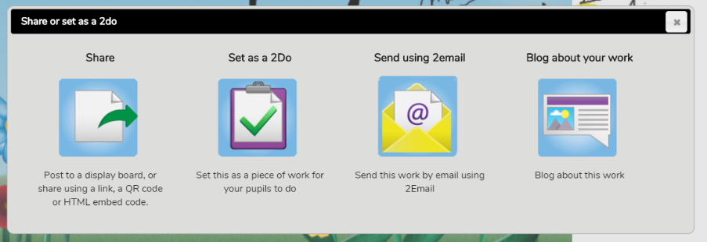
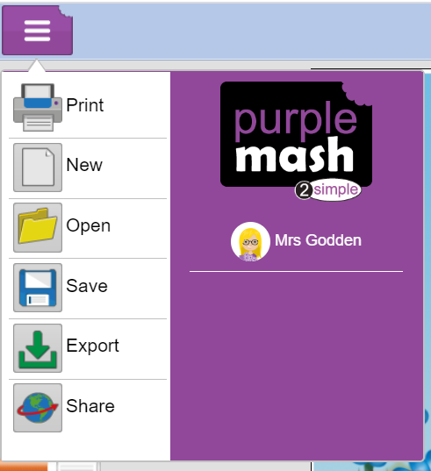
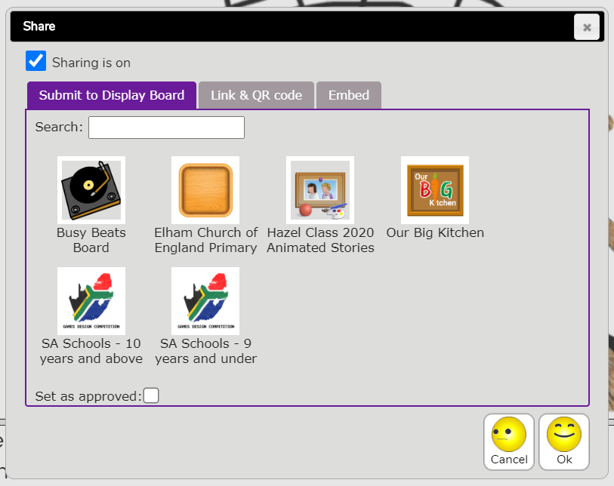

8. I will receive a message telling me that you have submitted your story to the display board. I will check it and approve it so that it appears on the display board.

To visit the display board, close down 2Create a Story (remembering to save your work first). Then on the home screen, click on Sharing, then on the display board called Hazel Class 2020 Animated Stories. You will be able to see a story which I created and any other Hazel Class stories that I have already approved. Keep checking the display board regularly to see whose stories have been added.

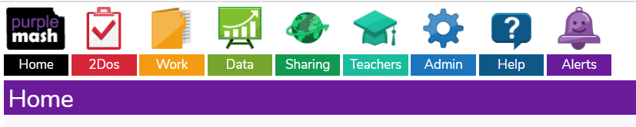

9. If you would like to see how much you have learnt this term, ask a parent to print out the marking sheet provided and tick all the things you can now do. Decide with your parent what you have done well and what you think you could do better next time.

Please send me an email (using 2Email) when you have finished your project and saved it to the display board. I will print out a copy of your project to go into your Computing folder at school.
Well done – you have finished this term’s computing work!

