Name……………………………………………………………….. July 2020

We are animators
LI: to create an animated story book using 2Create a Story

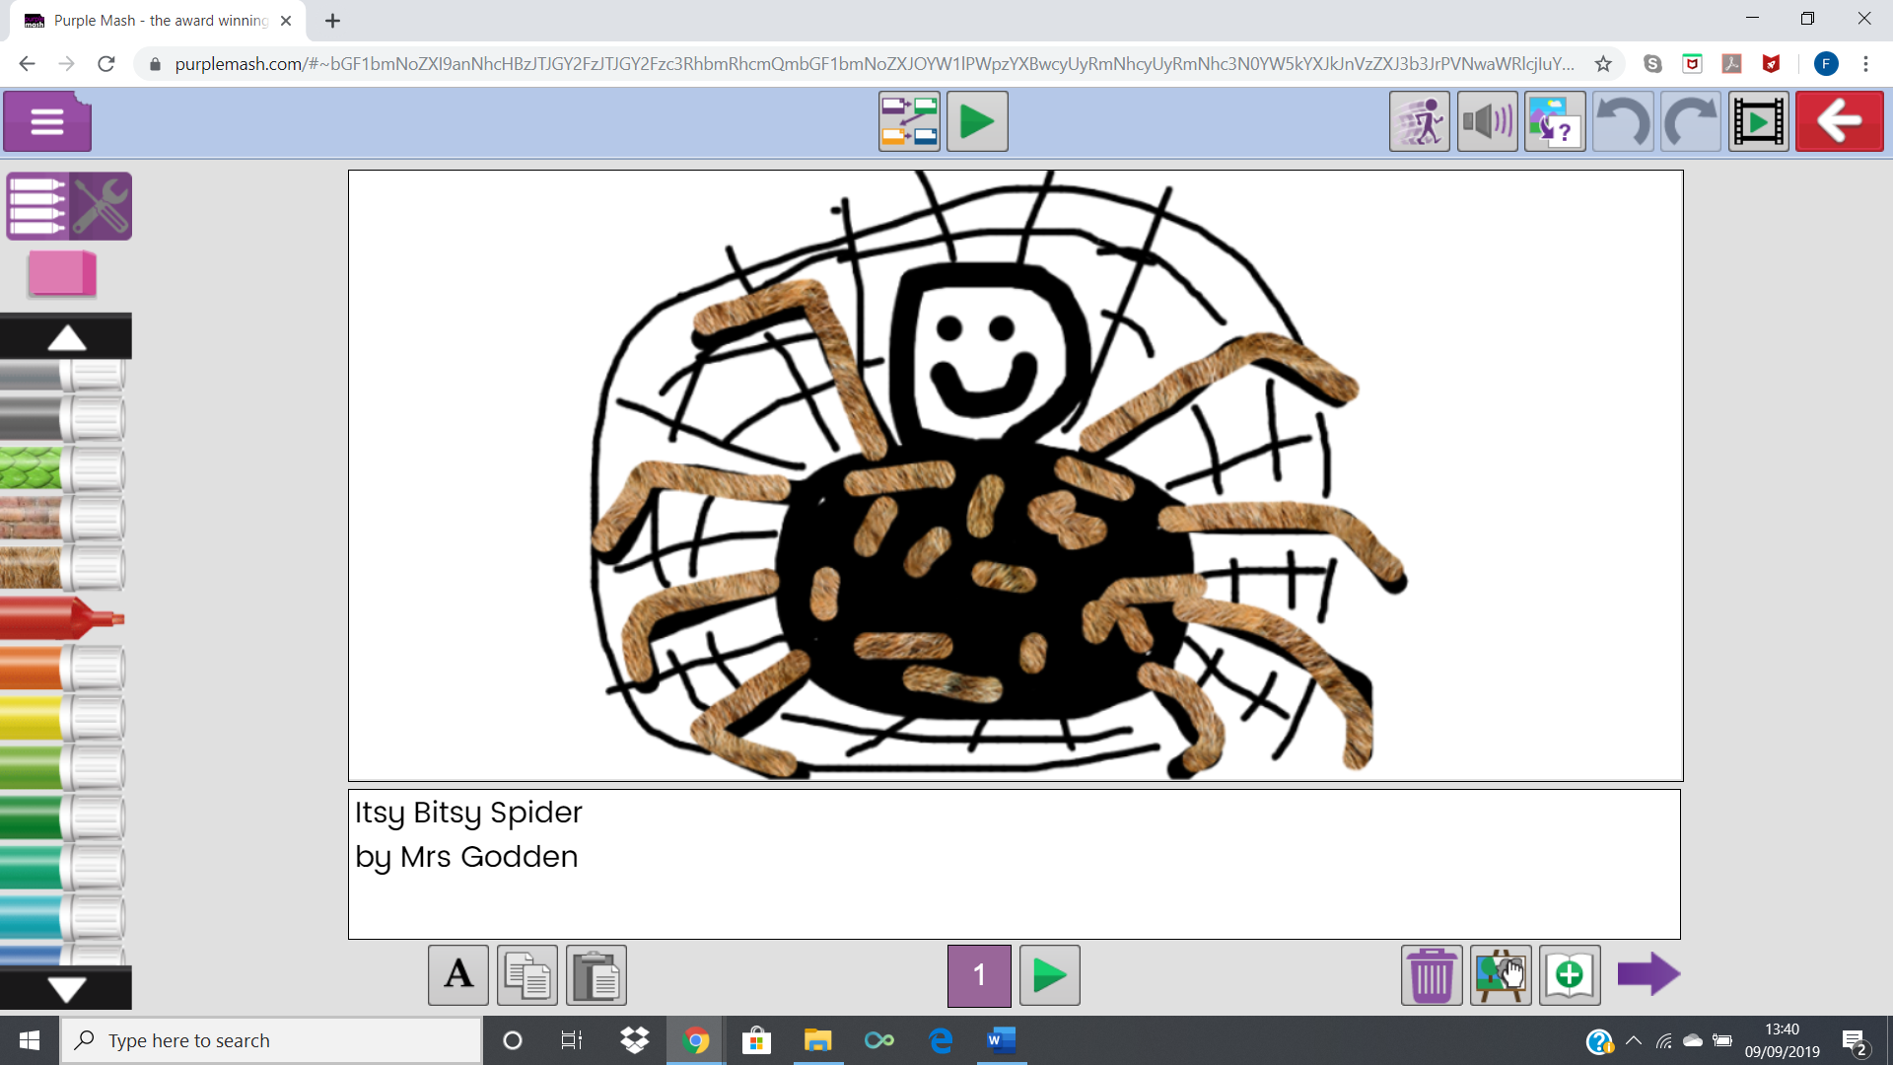
I can:

- I can use the different drawing tools to create a picture on the page
- I can add text to a page and change the colour, font and size of the text
- I can save my work
- I can open work that I saved in my last lesson
- I can add an animation to my picture
- I can play the pages I have created
- I can add sound to my animation
- I can add a background to the page
- I can enhance the features of my story book by adding additional pages and animations

What you did well | What you could do better

