Lesson 3 – Sounds and More!
Aims

To be able to open and continue working on your saved file.
To work on the next level: My Story.
To be able to add a sound to the picture.
To be able to add a voice recording to the picture.
To be able to create and add music you have created to the picture.

Success criteria

I can add a sound to the page.
I can add my own voice recording to the page.
I can create my own music and add it to my page.

Resources

2Create a Story

Activities

1. Today you are going to work at the next level in 2Create a Story and you are going to find some new features to use.
2. Open 2Create a Story and select the My Story level.

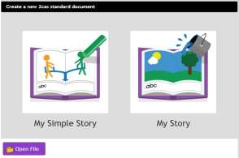

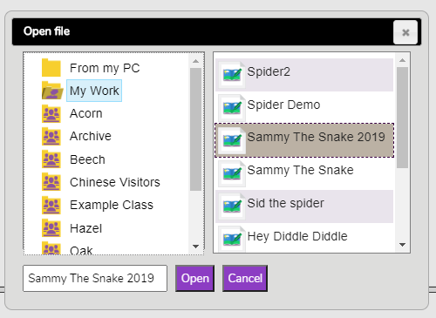

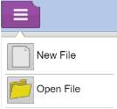
3. Now you should open the story you previously saved. To do this, click on the drop-down menu, choose Open File and then click on your file name and finally click on Open.

4. Now you can go back and run the pages you have created so far in your story. Remember that you do this using the big ‘green for go’ arrow at the top of the page.

5. Last week you added some animation to your story. Adding the sounds and animation to the pictures makes the pages of the story more fun to look at and this could make the stories that you write in 2Create a Story more exciting.

6. To add sounds to your pictures you click on the sound button at the top of the page.

You will see this screen appear:
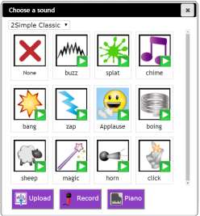
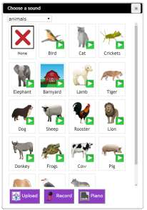

Spend some time listening to the different sounds. Click on the white arrows in the green boxes to do this. When you are happy with a sound, click on the picture and it will be added to your page.

7. There are lots of different sound categories to explore; these are often missed so make sure you click on the drop-down menu to choose a different category.

8. Once you have explored the range of sounds in 2Create a Story, you can try recording your own music and adding it to the page.

This could be useful in your stories if you wanted to make your own tune or sounds.

You do this by clicking on the Piano button and the using the Record and Stop buttons. Now try making and creating your own tunes. You can then add your own tune to your story pages.
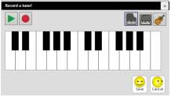


9. Adding different sounds might help people to ‘feel’ what the story is all about. How could you make music that made you feel happy, sad or scared?

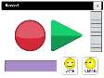
10. In the final section of the sounds, you can make stories for people who may not be able to read or see very well and you could help someone to understand the story better by recording your own voice to tell part of the story. Click on the Record button to do this.



You will have 15 seconds of recording time to create a recording for the page.

Now try recording yourself – you could make different sounds, or just record your voice telling the story.

Explore all the sound recording options and try adding different options to the pages you have created. You can use different sounds on each page – one might have a sound-effect which you have chosen from Purple Mash, another might have a sound-effect which you have recorded and another may have your voice. It might be nice to add your voice reading the story title and your name to the first page of your story.

REMEMBER though, only one sound option can be added to a page; you cannot add a voice-over with a sound effect too.

By the end of today’s lesson, you should have some sound to each page of your story.

11. Finally, remember to save all the additions to your work and overwrite your existing file.

You have now finished today’s lesson. Well done!

