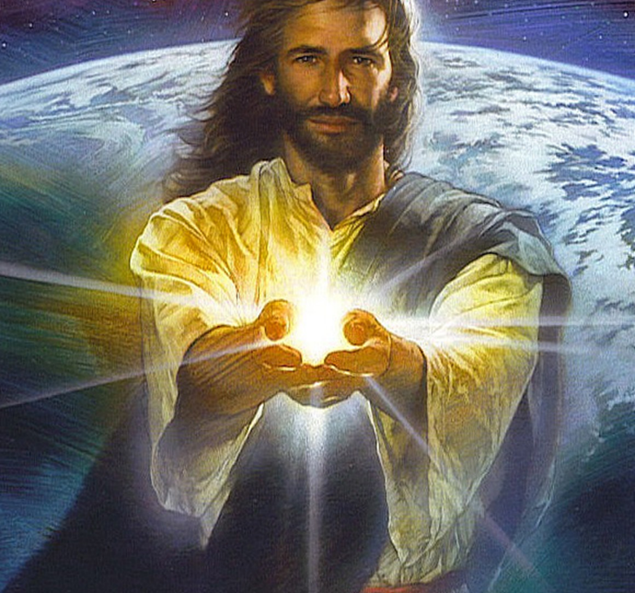
Incarnation

Salvation

Sacrifice

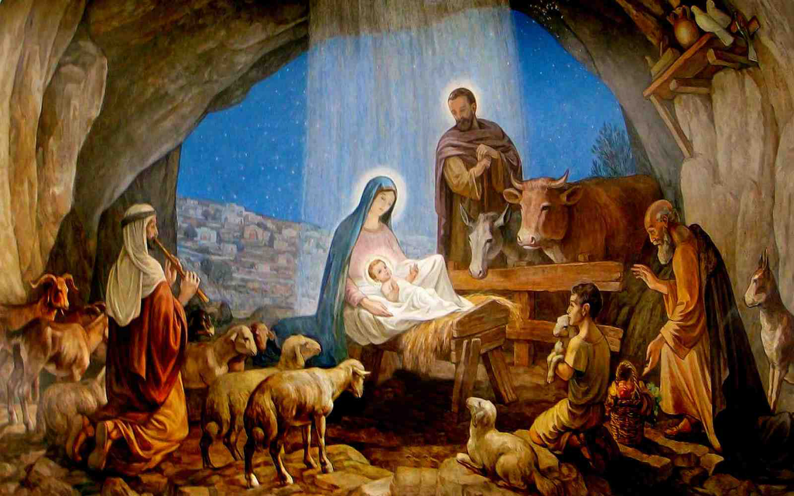
Resurrection

Hope

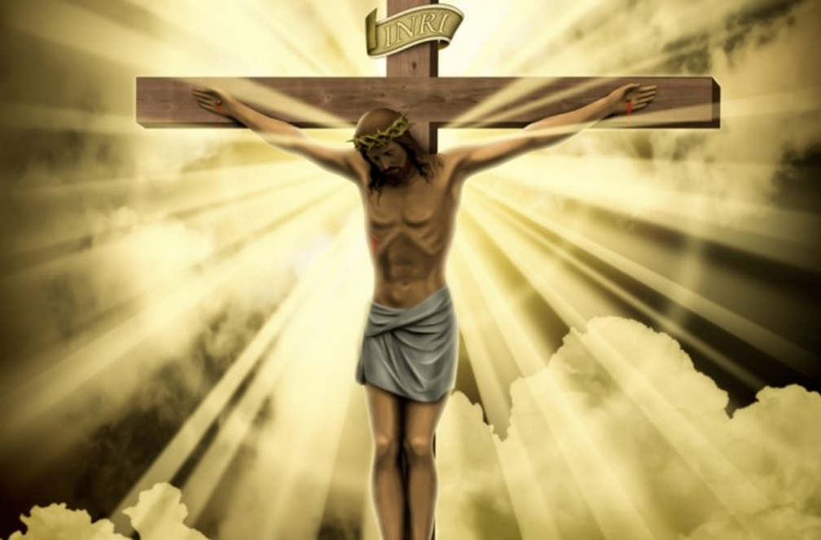

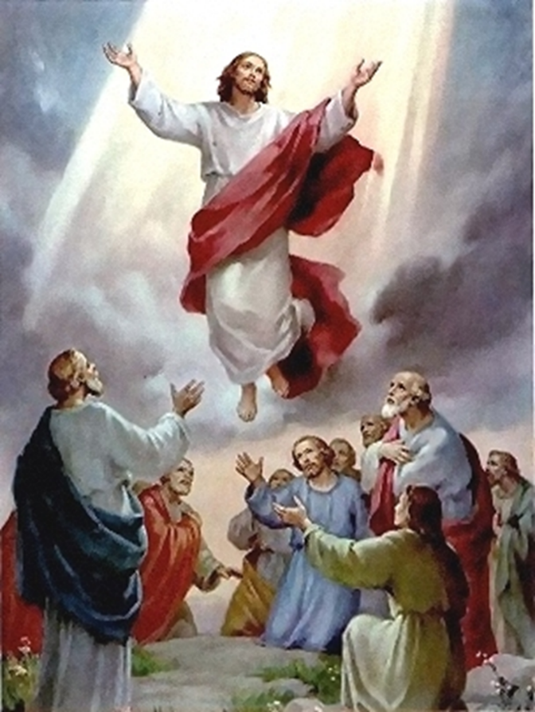

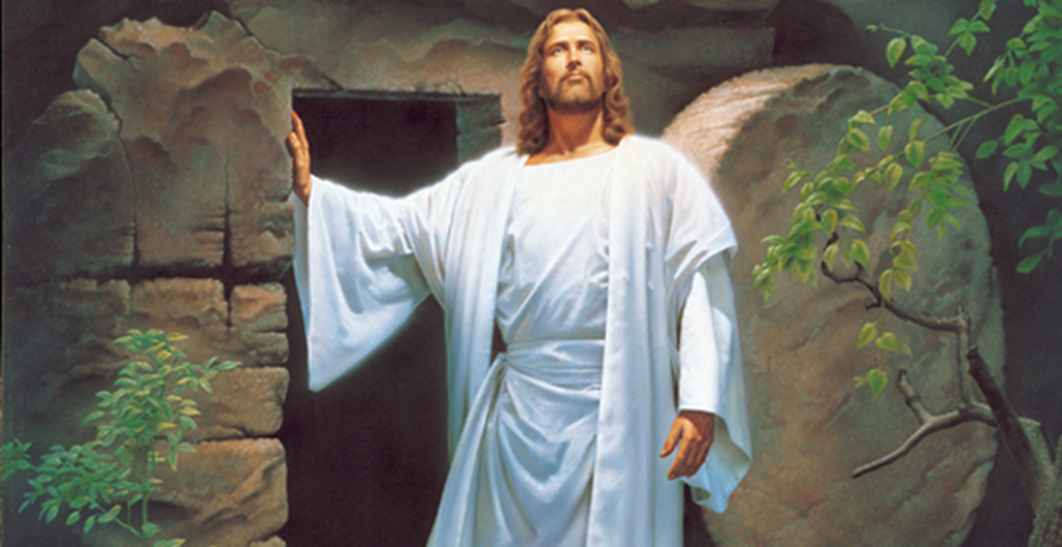

http://request.org.uk/festivals/holy-week-and-easter/why-is-the-resurrection-so-important-to-christians/

