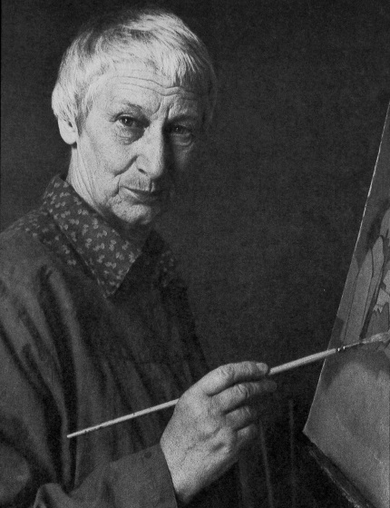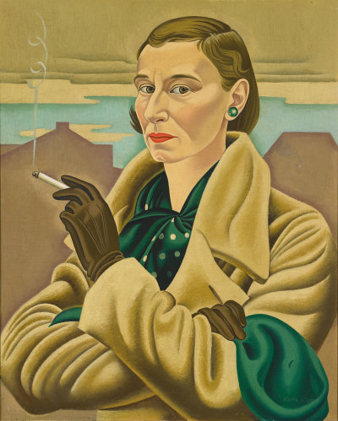
Rita Angus

Born: 12 March 1908 as Henrietta Catherine Angus (Hastings, New Zealand)
Died: 25 January 1970 (aged 61) Wellington, New Zealand
Nationality: New Zealand
Education: Canterbury College School of Art, Elam School of Fine Arts in Auckland
Influences: Byzantine art and cubism
Known for: Oil and water colour painting
Website: www.ritaangus.com
Rita Angus is one of many artists in New Zealand, painting both landscapes and portraits, including a self-portrait in 1937.
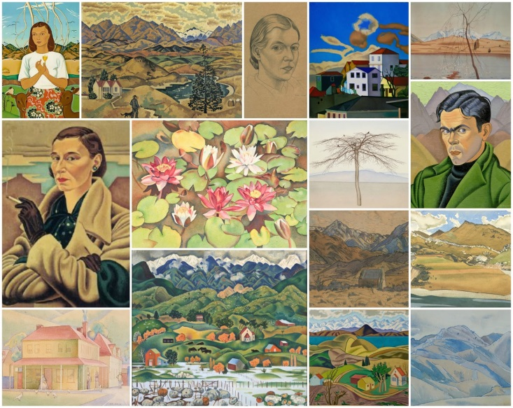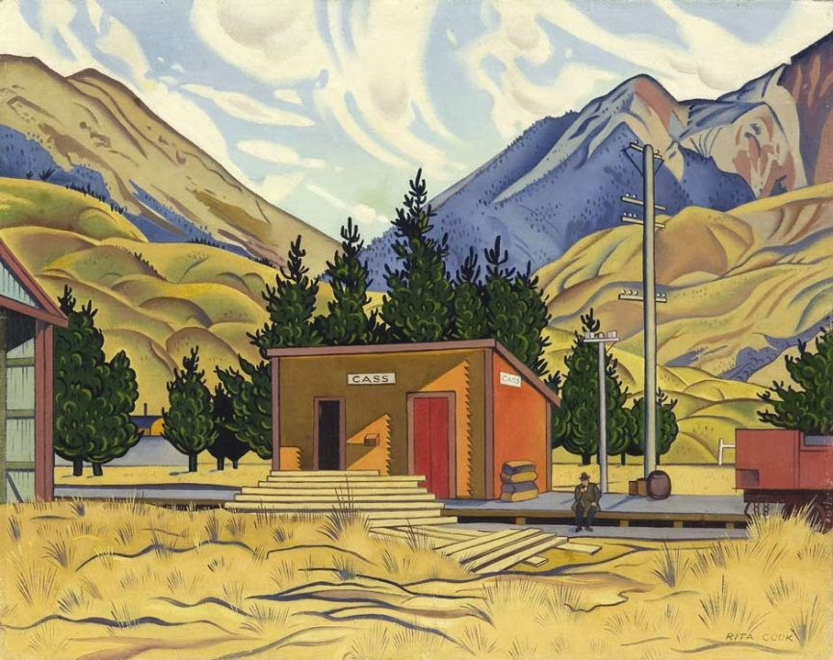
Her most famous painting was a painting called Cass, painted in 1936, which was voted New Zealand’s most-loved painting in 2006.

