Wednesday 6th May 2020
L.I: Art styles in different countries

Danny Eastwood
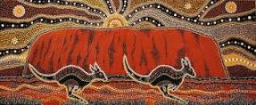
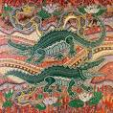
Danny Eastwood is an Australian aboriginal artist, who has drawn lots of beautiful things like Uluru and this crocodile painting.

Danny Eastwood originally came from New South Wales in Australia but he now lives in Western Sydney. Uluru can be found in The Maritime Museum, Sydney.
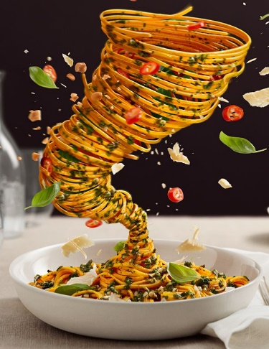
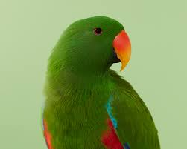
He is also a professional photographer and has taken lots that you can see on his website http://www.dannyeastwood.com/. My favourite is Bird Box, but I also like Latina.

