LQ: How might believing in the resurrection of Jesus make a difference to how people live today?

This is our final lesson about Salvation and we would normally have lots of discussion in class about today’s LQ as there are some quite difficult ideas to understand. You may therefore find it helpful to discuss the ideas in this lesson with an adult before putting your thoughts onto paper.
This week we are investigating what some famous people throughout history have said about the resurrection and thinking about how believing in the resurrection is still important to Christians today.
Firstly, I would like you to read the four quotations at the bottom of this document and then read up about the people whose opinions these were (from the biographies document). Look carefully for information about their religious beliefs.
Secondly, I would like to you decide if each person was either:
- A Christian
- A follower of another religion
- An atheist – a person who disbelieves or lacks belief in the existence of God or gods.
- An agnostic - a person who believes that nothing is known or can be known of the existence or nature of God
Thirdly, choose the quotation that you think you can explain the best. Cut it out and stick it onto the worksheet below. Thinking about what you have learnt about that person and what they have said about the resurrection, try to explain what their view of Jesus and the resurrection is. Here are some questions to help you think about your response:
- Do they believe Jesus lived and rose from the dead?
- Do they believe Jesus never even lived?
- Do they believe that the resurrection was impossible and therefore never happened (it is just a story)?
- Do they believe that there is life after death? If not, what is there? How does this affect the way in which they live their lives?
- Do they believe that Jesus’s resurrection proves that there is life after death for everyone?
- Do they believe that because of the resurrection, Jesus has ensured Christians that their sins are forgiven?
Finally, you need to try to explain how believing in the resurrection of Jesus might make a difference to Christians today. Think about some of the problems in the world today (for example – inequality (wealth and poverty), illness, loneliness, injustice). How do Christians deal with them?
Now try your best to answer this question, using examples, if possible, to explain your opinions:
What difference does the belief that Jesus rose again for the forgiveness of sins and to offer them eternal life make to Christians today?

As usual, please email your work for me to have a look at and comment on.

Thank you

Mrs Godden

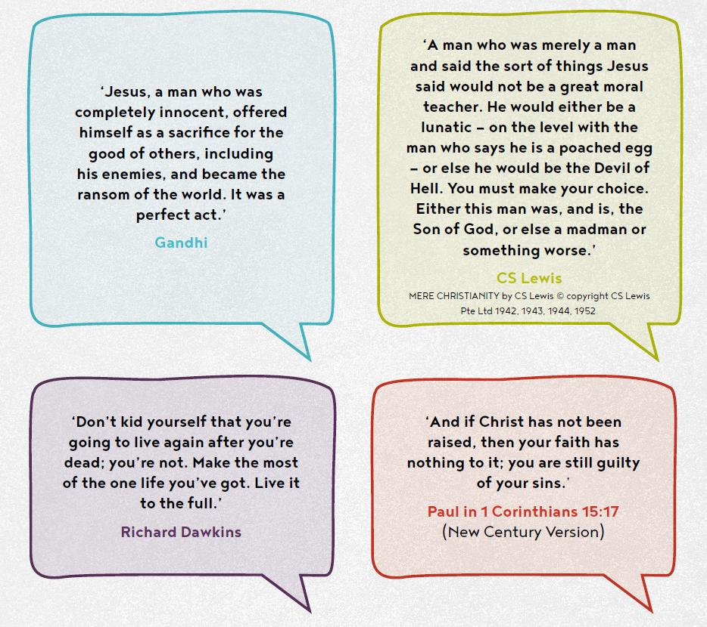
Name………………………………………………………… Date……………………………………………………

LQ: How might believing in the resurrection of Jesus make a difference to how people live today?

This quotation is from a person who is a ____________________ .

- I believe that ______________________________________ is saying that
…………………………………………………………………………………………………………………………………………………………………………………………………………………………………………………………………………………………………………………………………………………………………………………………………………………………………………………………………………………………………………………………………………………………………………………………………………………………………………………………………………………………………………………………………………………………………………………………………………………………………………………………………….…………………………………………………………………………………………………………………………………………………………………………………………………………………………………………………………………………………………………………………………………………………………………………………………………………………………………………………………………………………………………………………………………………………………………………………………………………………………………………………………………………………………………………………………………………………………………………………………………………………………………………………………………………………………………………………………………………………………………….

- What difference does the belief that Jesus rose again for the forgiveness of sins and to offer them eternal life make to Christians today?
…………………………………………………………………………………………………………………………………………………………………………………………………………………………………………………………………………………………………………………………………………………………………………………………………………………………………………………………………………………………………………………………………………………………………………………………………………………………………………………………………………………………………………………………………………………………………………………………………………………………………………………………………….………………………………………………………………………………………………………………………………………………………………………………………………………………………………………………………………………………………………………………………………………………………………………………………………………………………………………………………………………………………………………………………………………………………………………………………………………………………………………………………………………………………………………………………………………………………………………………………………………………………………………………………………………………………………………………………………………………………………………

