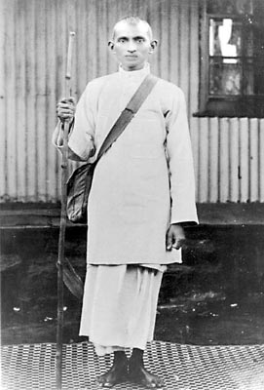
Mohandas Gandhi
- Occupation: Civil Rights Leader
- Born: October 2, 1869 in Porbandar, India
- Died: January 30, 1948 in New Delhi, India
- Best known for: Organizing non-violent civil rights protests
Biography:
Mohandas Gandhi is one of the most famous leaders and champions for justice in the world. His principles and firm belief in non-violence have been followed by many other important civil rights leaders including Martin Luther King, Jr. and Nelson Mandela. His renown is such that he is mostly just referred to by the single name "Gandhi".
Where did Mohandas Gandhi grow up?
Mohandas was born in Porbandar, India on October 2, 1869. He came from an upper-class family and his father was a leader in the local community. As was tradition where he grew up, Mohandas' parents arranged a marriage for him at the age of 13. Both the arranged marriage and the young age may seem strange to some of us, but it was the normal way of doing things where he grew up.
Mohandas' parents wanted him to become a barrister, which is a type of lawyer. As a result, when he was 19 years old Mohandas travelled to England where he studied law at the University College London. Three years later he returned to India and started his own law practice. Unfortunately, Mohandas' law practice wasn't successful, so he took a job with an Indian Law firm and moved to South Africa to work out of the South African law office. It was in South Africa where Gandhi would experience racial prejudice against Indians and would begin his work in civil rights.
What did Gandhi do?
Once back in India, Gandhi led the fight for Indian independence from the British Empire. He organized several non-violent civil disobedience campaigns. During these campaigns, large groups of the Indian population would do things like refusing to work, sitting in the streets, boycotting the courts, and more. Each of these protests may seem small by themselves, but when most of the population does them at once, they can have an enormous impact.
Gandhi was put in prison several times for organizing these protests. He would often fast (not eat) while he was in prison. The British government would eventually have to release him because the Indian people had grown to love Gandhi. The British were scared what would happen if they let him die.
One of Gandhi's most successful protests was called the Salt March. When Britain put a tax on salt, Gandhi decided to walk 241 miles to the sea in Dandi to make his own salt. Thousands of Indians joined him in his march.
Gandhi also fought for civil rights and liberties among Indian people.
Did he have other names?
Mohandas Gandhi is often called Mahatma Gandhi. Mahatma is a term that means Great Soul. It's a religious title sort of like "Saint" in Christianity. In India he is called the Father of the Nation and also Bapu, which means father.

Was Gandhi a Christian?
While Gandhi was a practicing Hindu, Christianity intrigued him. In his reading of the Gospels, Gandhi was impressed by Jesus whom Christians worshipped and followed. He wanted to know more about this Jesus that Christians referred to as “the Christ, the Messiah.”
The Rev. Pattison tells the following story: One Sunday morning Gandhi decided that he would visit one of the Christian churches in Calcutta. Upon seeking entrance to the church sanctuary, he was stopped at the door by the ushers.

He was told he was not welcome, nor would he be permitted to attend this particular church as it was for high-caste Indians and whites only. He was neither high caste, nor was he white. Because of the rejection, the Mahatma turned his back on Christianity.

With this act, Gandhi rejected the Christian faith, never again to consider the claims of Christ. He was turned off by the sin of segregation that was practiced by the church. It was due to this experience that Gandhi later declared, “I’d be a Christian if it were not for the Christians.’’
How did Mohandas die?
Gandhi was assassinated on January 30, 1948. He was shot by a terrorist while attending a prayer meeting.

Fun Facts about Mohandas Gandhi
- The 1982 movie Gandhi won the Academy Award for best motion picture.
- His birthday is a national holiday in India. It is also the International Day of Non-Violence.
- He was the 1930 Time Magazine Man of the Year.
- Gandhi wrote a lot. The Collected Works of Mahatma Gandhi have 50,000 pages!
- He was nominated for the Nobel Peace Prize five times.

C.S. Lewis
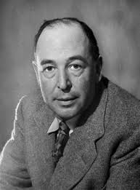
The British writer C.S. Lewis is famous for writing a series of books called The Chronicles of Narnia. Lewis wrote many other books, including poetry, science fiction, and books about Christianity.
Clive Staples Lewis was born on November 29, 1898, in Belfast, Ireland. As a child, he missed a lot of school due to illness. In 1916 he went to University College in Oxford, England. He left school for a time to fight in World War I with the British Army. After college, he became a teacher.
Lewis published many books throughout his teaching career. Some were about the subjects he taught. He also wrote about being a Christian. (He was a very committed Christian.) One of his most well-known Christian books is called The Screwtape Letters. It was published in 1942. It is a humorous story about devils trying to tempt a young Christian.
In 1950 Lewis wrote one of his most famous books. It was a children’s book called The Lion, the Witch, and the Wardrobe. This book was the first of the series called The Chronicles of Narnia. The seven books tell the story of four brothers and sisters. They discover a magical world called Narnia, where they have many adventures.
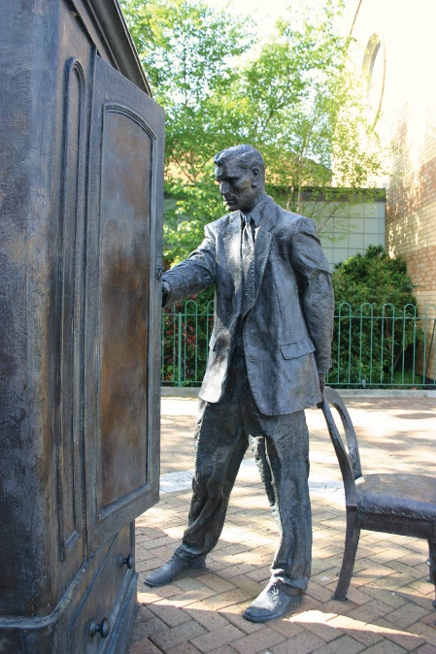
C.S. Lewis died on November 22, 1963. He had retired from teaching the summer before.

Richard Dawkins

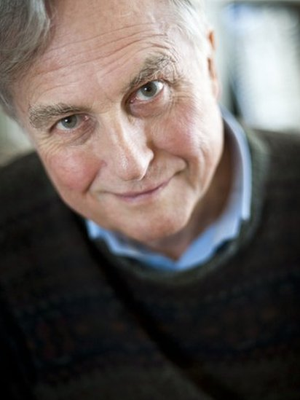
Professor Richard Dawkins is a British evolutionary biologist, ethologist and writer. He is often referred to as "the most famous atheist in the world".
He was born in 1941 and holds a degree in zoology, as well as an MA and PhD, all from the University of Oxford, where he was tutored and supervised by Nobel Prize-winning ethologist Nikolaas Tinbergen.
From 1995 to 2008 he was the first Simonyi Professorship for the Public Understanding of Science, a chair whose purpose is to make science more accessible to a wider audience, without oversimplifying it.
In his scientific work, Dawkins is mostly known for his gene-centred reformulation of Charles Darwin's theory of natural selection. In his book, The Selfish Gene (1976), he argues that it is not groups or organisms that adapt and evolve, but individual genes.
Whilst the selfish gene theory is one of the most significant concepts of his scientific work, Dawkins is also very well-known for his openly anti-religious views and his anti-creationist stance.

“Start Quote
One of the truly bad effects of religion is that it teaches us that it is a virtue to be satisfied with not understanding.”
Richard DawkinsThe God Delusion

Dawkins believes that the theory of evolution and natural selection can explain the universe much better than the idea of an intelligent design carried out by a God.
In his 2006 book The God Delusion, Dawkins contends that a supernatural creator almost certainly does not exist and that religious faith is a delusion—"a fixed false belief".
In his debate with the Archbishop of Canterbury Rowan Williams in February 2012, Prof Dawkins defined himself as an agnostic, rather than an atheist. He argued that, as a human, he cannot be 100% sure that God does not exist.
Many interpreted this statement as Dawkins abandoning the atheist cause to embrace a softer agnostic stance.
In the debate, however, he added that he rates himself a 6.9 on a scale of 1 to 7, where 7 is the absolute certainty that God does not exist

Atheist
A person who disbelieves or lacks belief in the existence of God or gods.
Agnostic
A person who believes that nothing is known or can be known of the existence or nature of God.

Saint Paul

St. Paul the Apostle, original name Saul of Tarsus, (born 4 BCE?, Tarsus in Cilicia [now in Turkey]—died c. 62–64 CE, Rome [Italy]), one of the leaders of the first generation of Christians, often considered to be the most important person after Jesus in the history of Christianity. In his own day, although he was a major figure within the very small Christian movement, he also had many enemies and detractors, and his contemporaries probably did not accord him as much respect as they gave Peter and James. Paul was compelled to struggle, therefore, to establish his own worth and authority. His surviving letters, however, have had enormous influence on subsequent Christianity and secure his place as one of the greatest religious leaders of all time.

Of the 27 books in the New Testament, 13 are attributed to Paul, and approximately half of another, Acts of the Apostles, deals with Paul’s life and works. Thus, about half of the New Testament stems from Paul and the people whom he influenced.

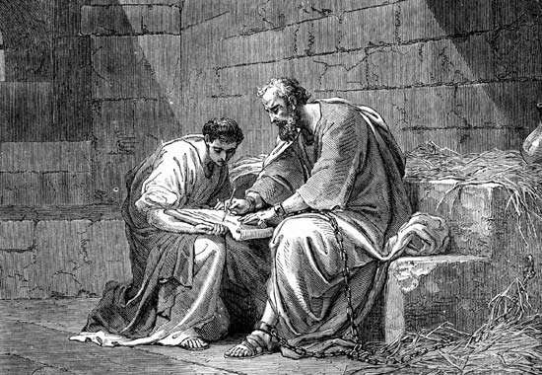
Paul the Apostle in prison, writing his epistle to the Ephesians.
Life

Paul was a Greek-speaking Jew from Asia Minor. His birthplace, Tarsus, was a major city in eastern Cilicia, a region that had been made part of the Roman province of Syria by the time of Paul’s adulthood. Two of the main cities of Syria, Damascus and Antioch, played a prominent part in his life and letters. Although the exact date of his birth is unknown, he was active as a missionary in the 40s and 50s of the 1st century CE. From this it may be inferred that he was born about the same time as Jesus (c. 4 BCE) or a little later. He was converted to faith in Jesus Christ about 33 CE, and he died, probably in Rome, circa 62–64 CE.
Play
Unmute

