Easter Photo Collage Project

It would be lovely to share what we have all done over the Easter break, so I have put together an ICT/Art project for you.

Your task will be to create a photo collage of your Easter break – it could be pictures of you and your family doing things at home, springtime pictures you take in your garden or on your walks, or even a collage of some of the projects you have worked on over the last two weeks.

I have put two photo collages I have made on our class page and at the bottom of this document so you can see examples of what I would like you to create.

Here are the instructions:

- Begin my taking some photographs, either on a digital camera or a mobile phone. Upload these to a computer – ask an adult to help if you are unsure how to do this. Save them all together in a folder so that you can find them again easily.

- Go to this website: www.photocollage.com. Along the top menu bar, click on the mountain icon and upload your photos. They will appear on the main screen and in a menu down the right-hand side.
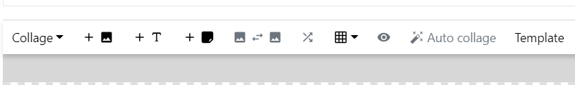

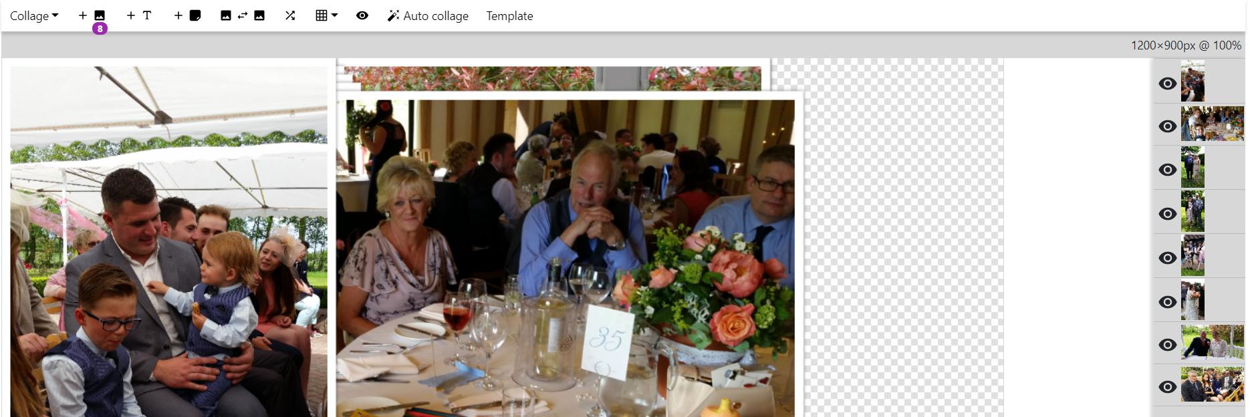
- Next, click on the word Template in the menu and choose a template to use. You will need to choose one with the same number of pictures as you have uploaded.

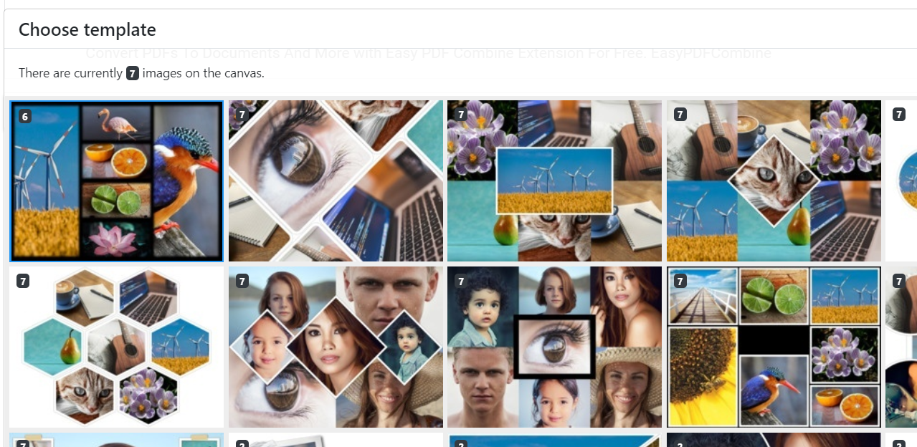

- When you click to choose a template, it will automatically place your pictures for you. If you are not happy with where they are, you can swap images by using the Swap images button.

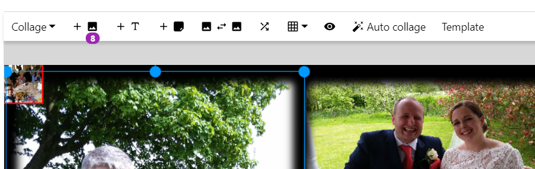

- If your pictures do not fit very well, you may need to click on the More button and then select Zoom & pan. Move the arrows to the part of the image you want to see in your collage.

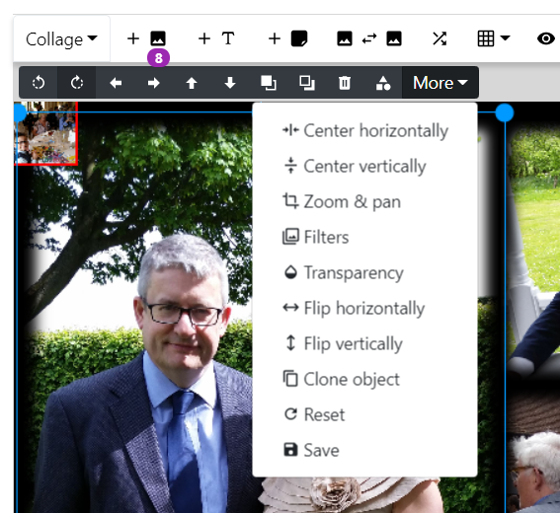

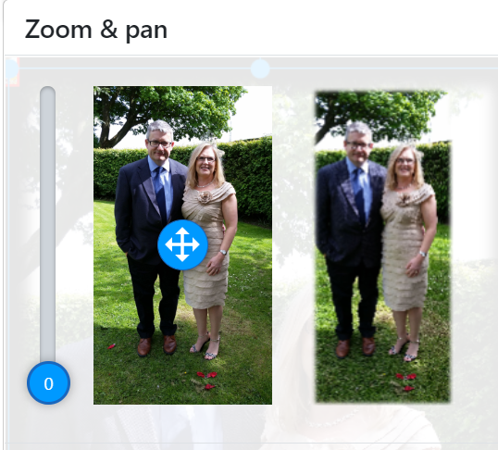

Use the left-hand button to zoom in and the arrow button to move to the part of the photo you would like to see in your collage.

Alternatively, you could try a different template – try to find one which has the same number of portrait and landscape boxes as the photos you have chosen.

- When you are happy with your collage, you will need to save it. Click on Collage button, then Save image as SD. Name your file and save it as a JPEG. Please include your name in the file name so that I know whose is whose.

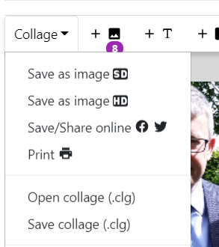
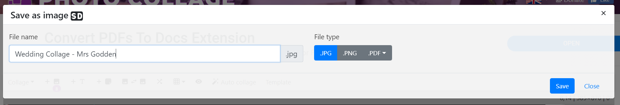

- Your file will appear in a box at the bottom of your screen.

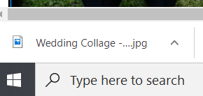

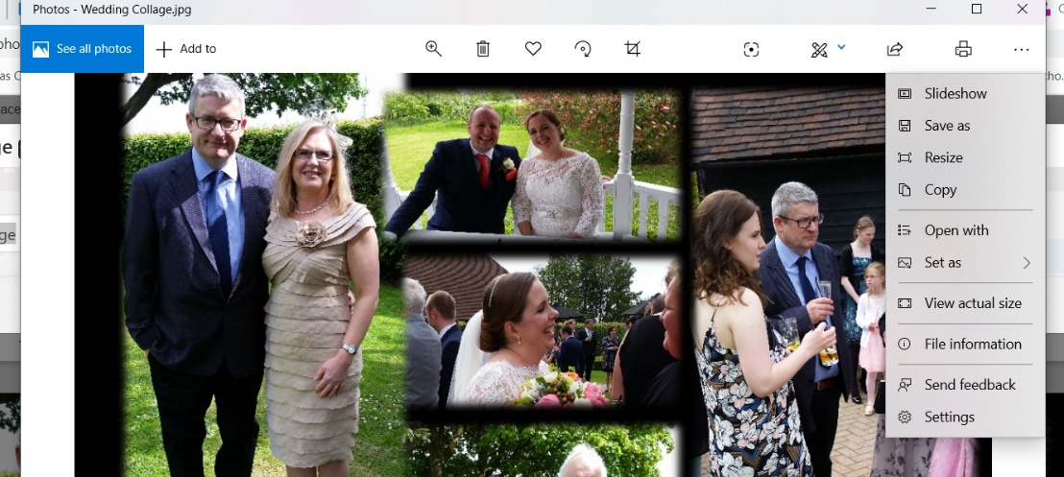
Click on the up arrow and your collage will open in your photo editor. Now click on the dots at the top right-hand side of the screen and select Save as.

I would suggest saving it into your Pictures folder. Don’t forget to include your name in the file name.

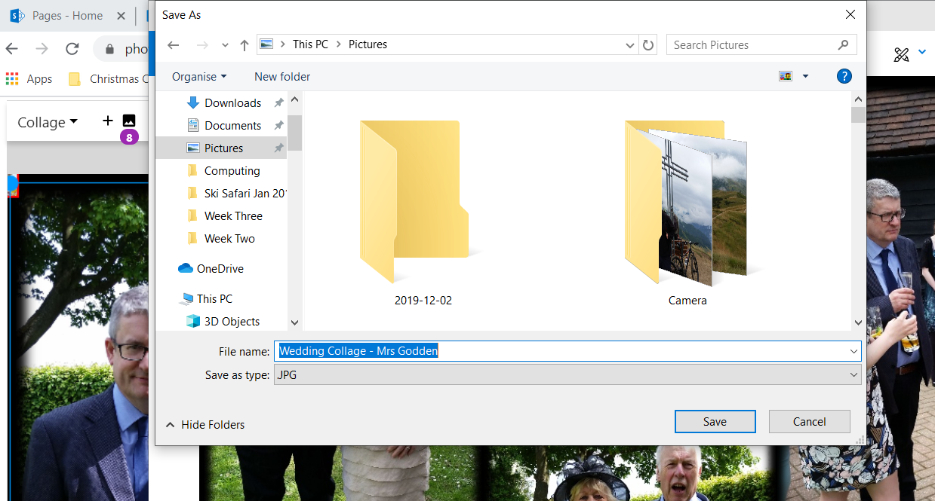

- Finally, please send your finished work to me at fionagodden@elham.kent.sch.uk and I will upload it to our class page.

I really look forward to seeing your Easter photo collages. Have fun!



