GALETTE DES ROIS
Recipe from Kitchen Secrets by Raymond Blanc.
This dessert is only served once a year and every child in France is waiting for 6 January (Epiphany). To honour the Kings who travelled thousands of miles to welcome our Saviour…maybe a white lie! It was probably organized by an opportunistic pâtissier who saw the opportunity of a huge market. It is a marvellous party dessert as it is the custom to hide two little figurines in the almond cream. The ones who find them will become the King and Queen for the day and of course have all of their wishes realised. Two crowns would be perfectly befitting the winners. It is also a remarkably simple dessert as you can buy the puff pastry and the almond cream takes just a few minutes to make.
Special equipment: Peel and baking stone, 20cm and 22cm ring or plate to cut out pastry disks, rolling pin.

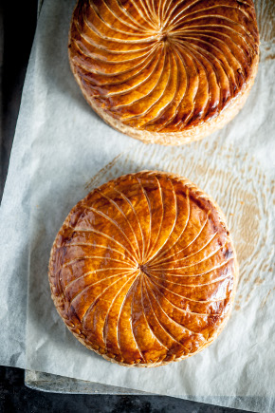

- See more at: http://www.raymondblanc.com/recipes/galette-des-rois/#sthash.asVmjIfA.dpuf

Ingredients Required
For the puff pastry
400g | Puff pastry, all butter, ready rolled (*1)
For the almond cream
75g | Butter, unsalted, at room temperature
75g | Icing sugar
75g | Almond, powder
1 | Egg, free range/organic, whole
1 | Egg yolk, free range/organic (*2)
1 tbsp | Dark rum or cognac

Cooking Method
Cutting out the circles of pastry
You will get two sheets of pastry – 35 / 22.5 cm in a pack, so cut a 20cmØ for the base from one sheet and a 22cm circle for the top out of the other sheet; refrigerate for a minimum of 1hour (*3). Any excess pastry can be kept for other use.
Making the almond cream
Preheat the oven to 180°C. In a large bowl, whisk all the ingredients together and mix to a smooth texture; reserve in the fridge.
Making the Galette
Spoon the almond cream into the centre of the puff pastry reserved for the base. With a palette knife spread the cream into an even circle leaving a 2cm gap from the edge. Brush the beaten egg yolk mixture around the 2cm gap and carefully drape the top circle of pastry neatly on top, press gently to expel all the air and using your thumb seal the pastry all around the edge. Chill or deep freeze the galette for 1 hour to firm up the pastry and with a sharp knife, trim the edge of the galette to an even circle so that it rises evenly (*4).
With the back of a knife crimp the outside edge of the pastry all around (*5). Here you can use your artistic flair.
Scoring the Galette & egg washing
Brush the Galette with beaten egg yolk. With the side of a fork or back of a knife, start from the centre of the Galette and score a spiral right up to the edge of the pastry. Repeat this to achieve an attractive design (if you feel unsure you could just simply criss cross the top of the galette).
Cooking the Galette
Cook in the preheated oven at 180°C for 45 minutes. Leave it to rest for 5 minutes before serving.

