An Introduction to Spreadsheets

Lesson One

LIs: to identify the key elements of a spreadsheet (rows, columns and cells)
to reference cells in a spreadsheet
to enter formulae into a spreadsheet to perform calculations

First, you will need to open up Excel and choose Blank Workbook. You will see a blank spreadsheet which will look like this:

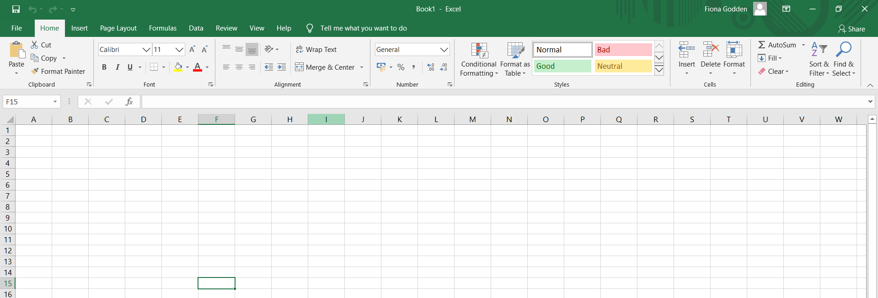

The screen in a spreadsheet program is made up of a large table called a sheet.

Each cell (box) can be identified by a unique name called a cell reference. This can be worked out by writing down the letter of the column the cell is in and the number of the row that it is in. It is important to understand that spreadsheets operate by referring to the cell reference, rather than the actual contents of a cell. The letter always comes before the number. For example, B10, F20, J45, etc.

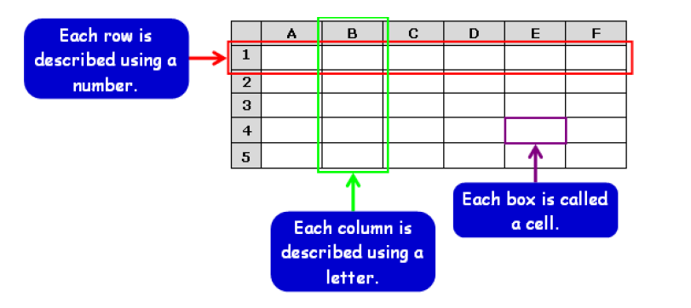
Open the Excel document called 1. Wizard’s Challenge

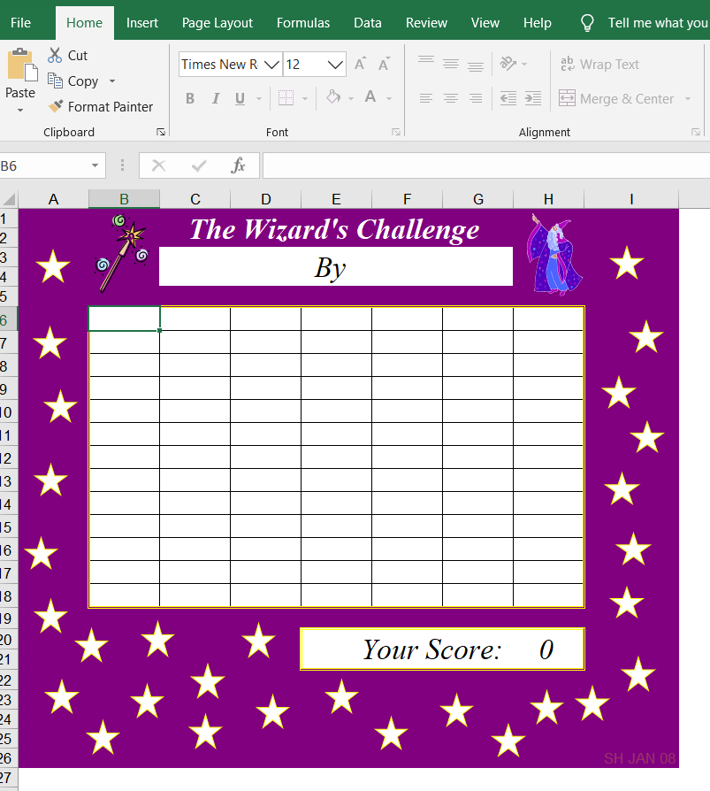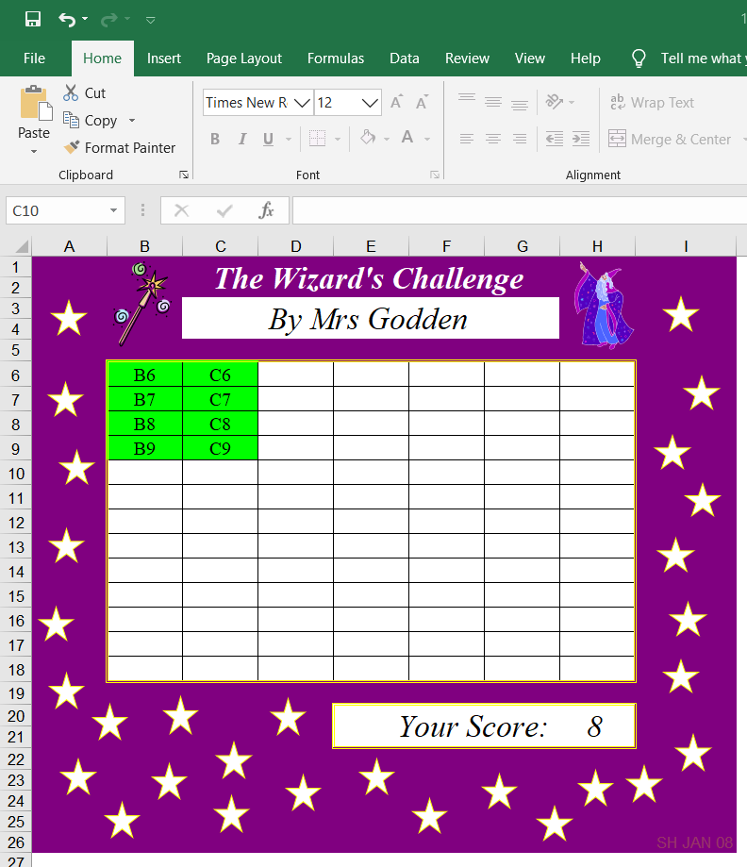

and then see if you can enter the correct cell reference in each of the cells in the table. To do this, simply click on any cell to start typing into it, and then your press the ENTER key once you have finished. See how quickly you can type in all the cell references. When you have finished, save your work, adding your name in the correct box (By…..) so that I know whose work it is if you send it to me for marking.

It is useful to know that you can also move around in a spreadsheet by using the arrow keys to move from cell to cell.

Next, you are going to learn how spreadsheets can be used to perform calculations quickly and accurately. To do this you will need to open up the file called 2. The Gold Mine:

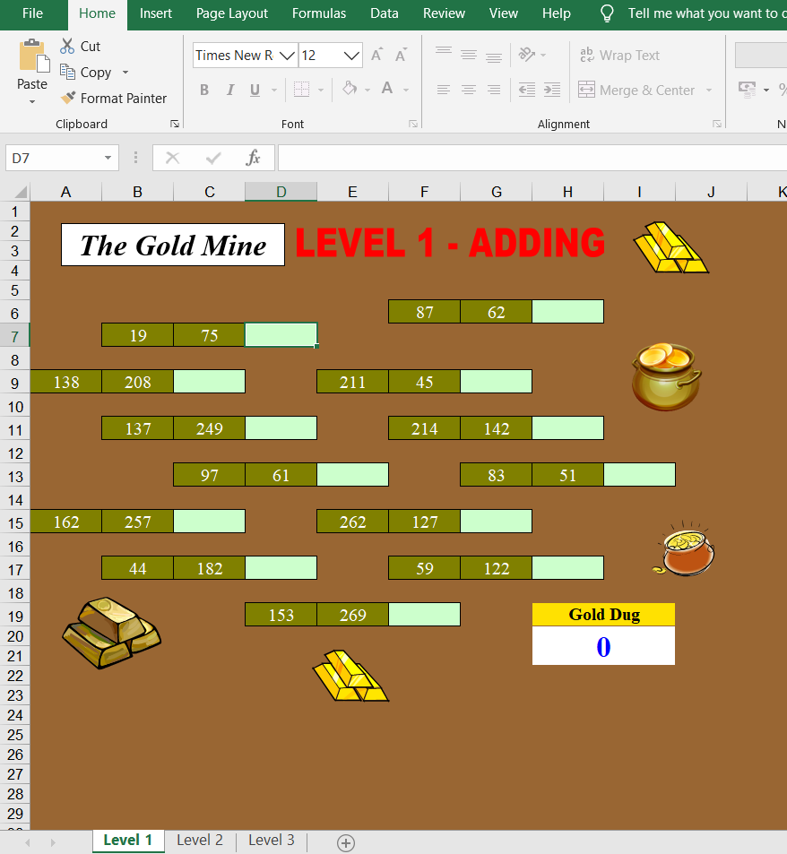

In this task you will need to work out the answers to the calculations and if they are right, the answer cells will automatically turn gold. You will see at the bottom of the spreadsheet there are three tabs – Level 1, Level 2 and Level 3. Each of these tabs is called a worksheet. Level 1 contains additions, level 2 has addition and subtraction and level 3 has all four operations.

In a spreadsheet, we enter what we call formulae into cells to work out the answers to calculations. To do this, click into the answer box to highlight it. You will then type in your formula in the box at the top of the sheet.

Every formula must begin with an equals sign = followed by the first cell reference (in this example that is B7), then you add the operator (+, -, x or ÷) followed by the second cell reference (C7 in this example). Finally, you hit the enter key and the answer to the calculation will appear in the cell.

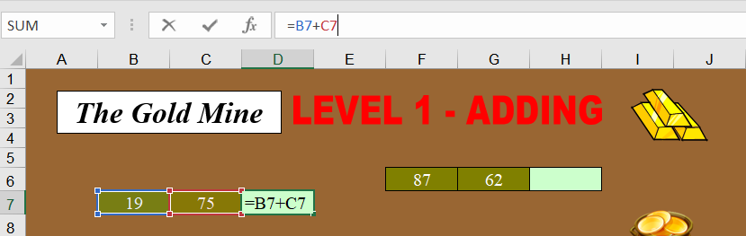

The formula you are typing in will always be visible in the formula box at the top of the spreadsheet as well as in the cell itself whilst you are typing. Once you have hit the enter key, the answer will appear in the cell, but the actual formula will remain visible in the formula bar at the top of the sheet.

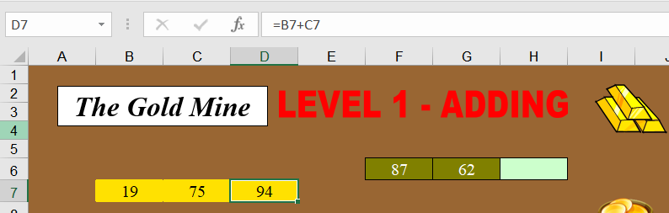

You must always start any formula with the = sign as this tell the program that ‘here comes a formula’. If you do not begin a formula with an = sign, the program will think you are just typing text and will not carry out the operation.

Please also note that not all the operation symbols are the same in spreadsheets.

Operation Symbol
HINT - The four symbols can all be easily accessed using the numeric keypad on the right-hand side of your keyboard.

+ +
_ _
x *
÷ /

So, an example formula for 30 x 3 would be =A1*B1.
For a division of 30 ÷ 3 it would be =A1/B1.
Now, go to The Gold Mine spreadsheet and practice typing the correct formula into each answer box. If you have done it correctly, when you hit the enter key, you will see the answer to the sum and the whole sum will turn gold.

When you have finished, remember to save your work (including your name in the file name) and send it to me please.

Have fun!

