An Introduction to Spreadsheets

Lesson Four

LIs: to use ‘SUM; to calculate the total of a set of numbers in a range of cells.

Resources
- Spreadsheet file 6. Race Points
- Spreadsheet file 7. Shopping Bills (with worksheets called Race Points, Lunch Box and Birthday Cake)

First you will need to load up the Race Points spreadsheet provided. What formulae would need to be entered and where to help determine which child received the most points?

Using =B10+B11+B12+B13+B14+B15 would produce a total, but it would require a lot of typing. A much shorter way of doing this would be to use =SUM(B10:B15). This is a quicker way of adding a series of numbers in a column. Using the brackets () around the range of cells and separating them by a colon : is really important as your formula won’t work without them.

Now use this formula to calculate who got the most points. Top tip: once you have input the formula once, you can copy it into the other total cells by grabbing the small cross + in the bottom right-hand corner and dragging it across the other blue cells. Excel will change all the cell values automatically and you will see all the totals appear immediately.

Remember to type the answer in the yellow box and to save your work with your name added to the file name.

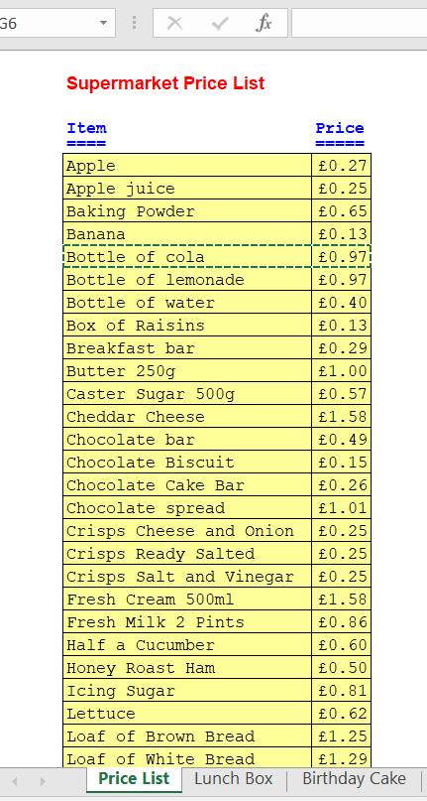
For your next task, you will need to open the Shopping Bills spreadsheet. The first sheet (Price List) gives a list of items and their costs.

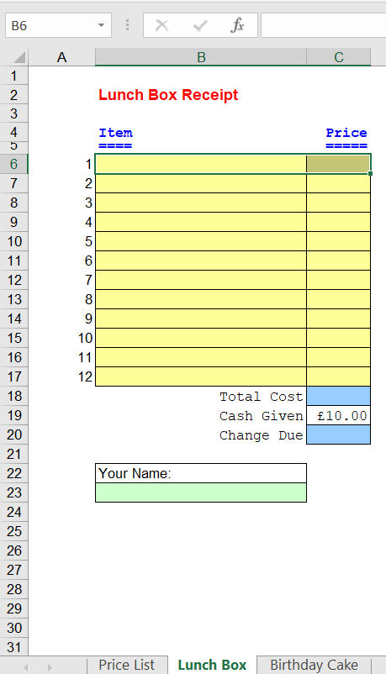

You should select the Lunch Box tab. You are going to create receipts on the computer for if different selections of food were bought for a week’s worth of lunch box meals.

After copying each item name and price over onto the receipt tab (use Copy and Paste on the Home Menu, just like in Word), you should enter the appropriate formulae (the first formula is the one you learnt earlier in this lesson) to calculate the total cost and the amount of change that would be received from £10. For the second formula can you remember how to calculate a subtraction for the ‘Change Due’ cell?
(For example: =A6-A5)

If the change due is a negative number it means that you have spent too much so you should think about which variables can be changed. You should check to see the effect of any amendments you make to your shop.

How can you check your total is reasonable?
What did shops do to calculate using lots of numbers before computers and
calculators?
How could you do lots of additions in a spreadsheet more quickly in the future?

Challenge
Complete the Birthday Cake exercise on the third tab, then change it to reflect the following scenario.

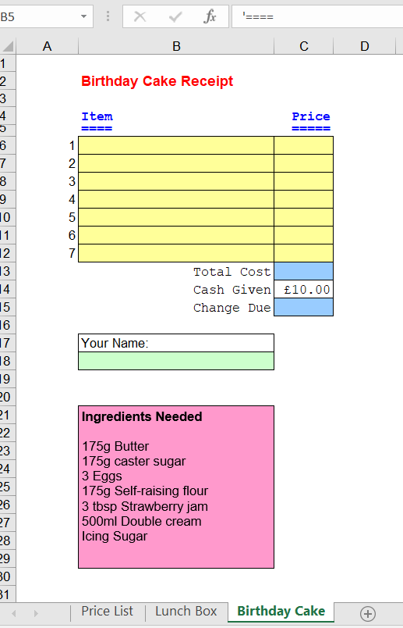
What if you were having a birthday party with lots of friends and needed to bake three cakes?

Copy the spreadsheet on the Birthday Cake worksheet to a new worksheet (click on the + inside a circle to create a new worksheet) and give it a new name.

Now think how you are going to calculate the new costs. Be careful as you don’t need to buy three of everything! (e.g. You originally bought a dozen eggs, but only needed three – will a dozen be enough for three cakes or will you need to buy more?)

You will probably have to add a column named ‘Price for Three Cakes’ and put in the correct formulas.

Finally, now you know the cost for one cake and the cost for three cakes. How much is the cost per cake when you buy the ingredients for three cakes? How much cheaper is this than just buying for one cake? Can you calculate this in a new cell using a new formula?

Once you have finished all your spreadsheets, remember to name every sheet, save your work and email me a copy to look at please.

Good luck and have fun!

