An Introduction to Spreadsheets

Lesson Three

LIs: to understand that when you change the numbers used in a spreadsheet, the results of the calculations are worked out again (recalculated); to be able to enter labels and numbers into a spreadsheet.

Today you will be creating your own spreadsheet from scratch. Open Excel on your computer and start with a new workbook. Before you even begin, it is a good idea to save your workbook and you should call it ‘Times Tables’. As your file name tells you, you will be using the spreadsheet to calculate times tables very easily.

Firstly, enter these labels into a blank spreadsheet:

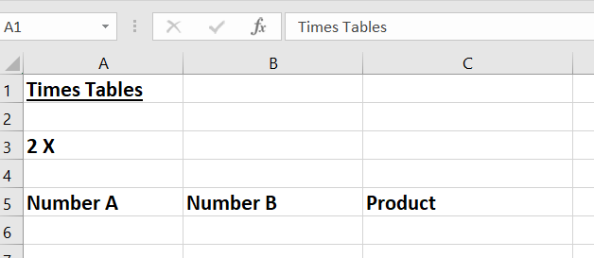

Hint – you can format cells (bold, underline, etc) just as you would do in Word. Highlight the text you want to format and use the buttons in the toolbar at the top of the screen. You can also click on the right of each column and drag it to make it wider, as I have done.
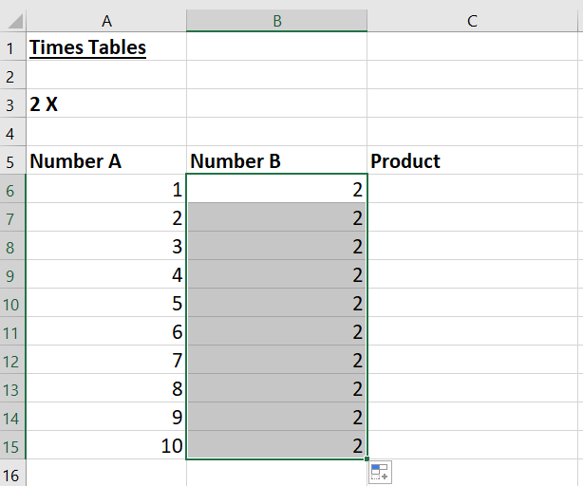
Next, enter the numbers 1 to 10 in the cells underneath the heading ‘Number A’. After that, enter the number you want to times them by in the cells underneath the heading ‘Number B’. For example, if you wanted to create the two times table, you would need to type ‘2’ into each cell. A quick and easy way of doing this is to put ‘2’ into the first cell, click on the bottom right of the cell and drag it down. It will copy your number into each cell until you stop.

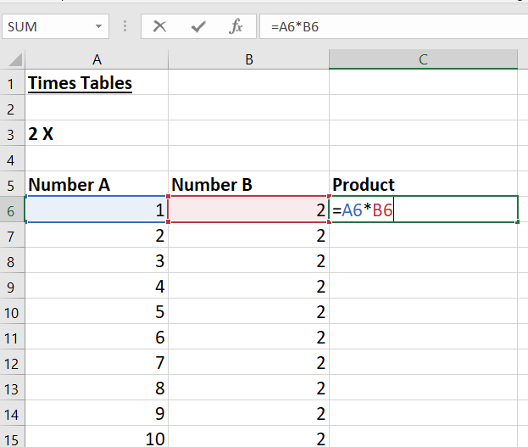
Finally, can you work out the formula you would need to type into each cell underneath the heading ‘Product’ to multiple the numbers in columns A and B together?

Click in the first cell under the Product heading and enter the formula, using the correct cell references. In this demonstration spreadsheet, my formula would be (=A6*B6).

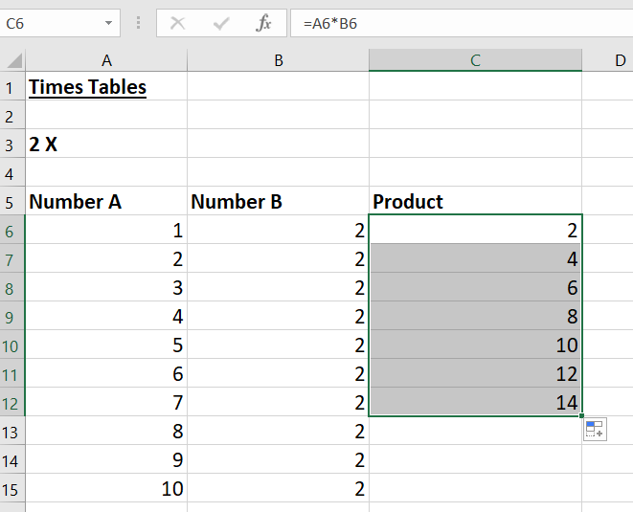
Once you hit the Enter button, the answer to the calculation will appear. As before, you can click on the small cross + at the bottom right of the cell and drag it down. It will copy the formula to the rest of your column and will automatically change all the cell referenced for each row.

Here you can see that I have only dragged my formula down as far as 7 x 2:

Can you add more rows underneath to get the times table multiplying numbers up to 20?

Can you quickly and easily change the multiple that each of these numbers is being multiplied by? (e.g. 3x, 4x.)

It is really important to understand that when you change the numbers in a spreadsheet the results of
calculations are worked out again automatically. You never need to calculate manually and add answers to your spreadsheet.

When you have finished your times table to 20, think about any problems or issues that arose.

What happens if you make a mistake, either with a formula or a number?
How can you check for mistakes?

Don’t forget that you have to use cell references in your formulas and that every formula must begin with an = sign.

Challenge
Once you have completed one times table it is very easy to create a whole page of times tables with very little work.

Can you think of a way of doing this quickly and easily?

A very quick way of doing this is to copy everything within your times table, paste it somewhere new and simply change the values.

Before you do this, make sure you are happy with everything in your first table, as it will all be copied exactly as it is. If you want to change the font, the size, etc. do this before you copy it.

First, starting at the bottom right of your calculations, click and drag to highlight the whole table. The highlighted area will change to grey. Then click on ‘Copy’ in the toolbar above.
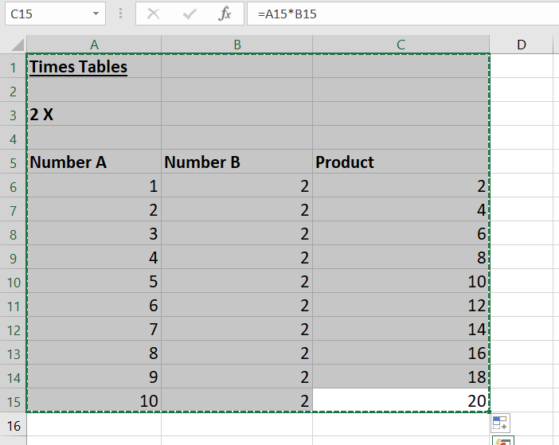
Secondly, find an empty cell in the top row, click into it and press ‘Paste’ on the top toolbar. Your table will have been copied (you can then change the column widths if you wish).

Now all you have to do is to click into the first cell under Number B and overwrite it with your new multiple. As before, drag this cell down to copy your new number. Here you can see that I have only dragged as far as 7 x 3 so far. All the values in the Product column will change as you drag your new number down.

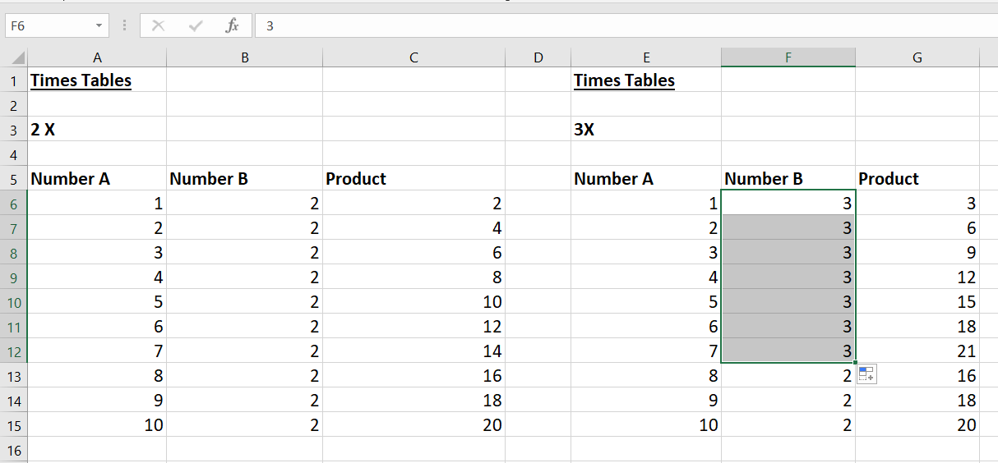

Remember also to change the cell of text saying which table it is.

Practise doing this for as many times tables as you wish, saving your work as you go.

Once you have finished your spreadsheet, remember to save your work and email me a copy to look at.

Good luck and have fun!

