An Introduction to Spreadsheets

Lesson Two

LIs: to understand that spreadsheets can be used to explore many possible outcomes to a problem; to change the data in a spreadsheet to answer ‘What if…?’ questions

First, you will need to open up this week’s spreadsheet Sweets Problem. It should look like this:
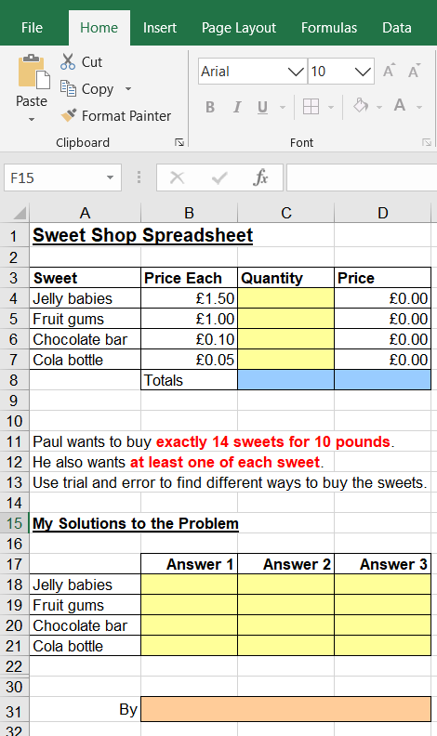
You are going to use this spreadsheet to solve this fictitious problem:

‘Paul wants to buy exactly 14 sweets for £10. He also wants to buy at least one of each sweet.
Use trial and error to find a way to buy the sweets.’

Firstly, you will need to type a formula in the two blue cells to add up the total number of sweets being bought and the total price of all the sweets.

The formula that you will need is:
=SUM(C4:C7).
This tells the program to add together all the totals in cell references C4, C5, C6 and C7). Once you hit enter, you will see the number 0 appear in the first Totals cell. This is because you do not have any values entered in cells C4 to C7.

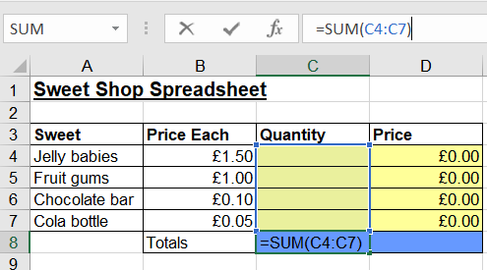
Notice that your formula appears in the cell itself, but also in the formula bar at the top.

Once you have typed the correct formula into cell ref. C8, type in the same =SUM formula in D8, remembering that your cell references now need to be (D4:D7).
Now start to enter numbers in the first column of yellow cells (Quantity) column. What happens to the totals in the two blue cells?

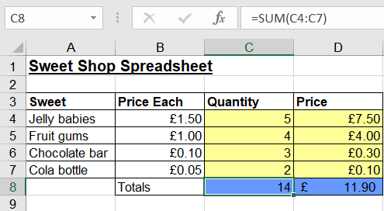
Note that each time you change the numbers, both totals change because the formulas you entered ensure the results are calculated automatically.

Now you should explore changing the quantity of sweets until the two totals update to being 14 and £10.00. As you can see, my Quantity adds up to 14, but the price is incorrect at £11.90.

To delete a value in a cell, you can either select the cell and press delete, or you can simply begin typing and your new value will replace it.

Try to find trends in the numbers. For instance, Can you buy more packets of jelly babies than cola bottles with £10?

It is thought that there are at least three solutions to the problem, but we only managed to find two in class last year. Can you find them all?

Can you think what the advantage of using a spreadsheet for this task is compared to pencil and paper?

You can change your mind and try out lots of different numbers very quickly and easily without having to write down lots and lots of sums.

Once you find one or more solutions, record your answers in the solution boxes and send me a copy for me to see please. Don’t forget to put your name in the pink box at the bottom.

Good luck and have fun!

Challenge

If you have enjoyed doing this task, you can create a new version of it yourself if you wish.
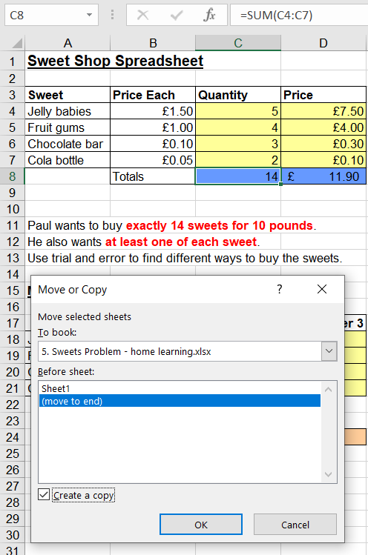
Right-click on the Sheet1 tab at the bottom of the spreadsheet and choose Move or Copy… Highlight (move to end) in the box, tick the box saying Create a copy and then click on OK.

You will now have a new sheet (Sheet2) which is an exact copy of Sheet1. You can make whatever changes you want to it. You could:

- Change the problem to a new one.
- Change the types of sweets or type in other items.
- Change prices.
- Add more rows or delete them by hovering over the number at the side of the sheet until you see a solid black arrow , then right-clicking on Insert or Delete.

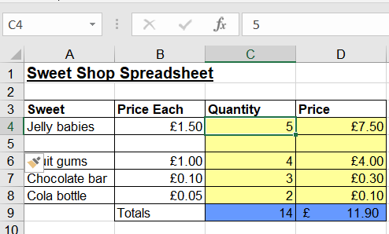
You will need to drag the formula down into the new box in the Price column. To do this, hover over the bottom right-hand corner of the cell above until you see a thin cross like a plus sign +. Then left-click and drag the cell down into the new cell below. This will copy the formula correctly for you.

Notice that any cell formatting, such as the colour, will automatically be added when a new line is inserted.

If you do create a second sheet with a new problem, please do let me see your work.

