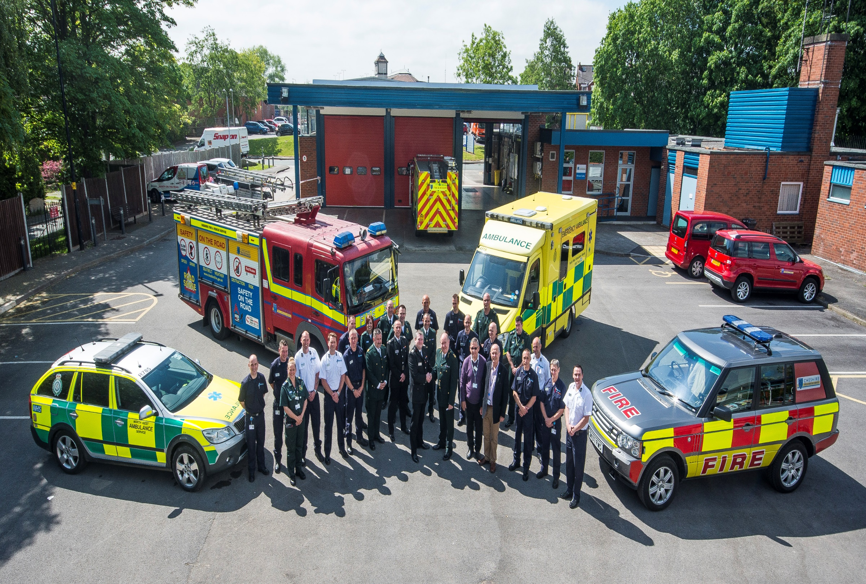
Expressive Arts and Design
Music express – Chinese New Year
Music – explorimg instruments
Painting and making to express weekly theme

Mathematics
Days of the Week
Months
Passing of Time
Problem solving
Positional Language
Addition and Subtraction
Physical Development
PE – Gymnastics
Balances
Dance
Outdoor play
Fine Motor activities
Forest School
Personal, Social and Emotional Development
School routines
Circle times
Keeping Safe
Who helps us?
Growing
Growth mindsets

Communication, Language and Literacy
Listening and responding
Questions
Discussions with people who help us
Learning digraphs.
Writing sounds and CCVC/CVCC words.
Reading CVCC/CCVC words and tricky words
Letters
Lists
Non-fiction texts

The World
Materials- waterproof
Chinese New Year
Role of Police, Paramedic, Fire Fighters, Doctors, Nurses, vets.
Stories from the Bible
Easter
Community Heroes

