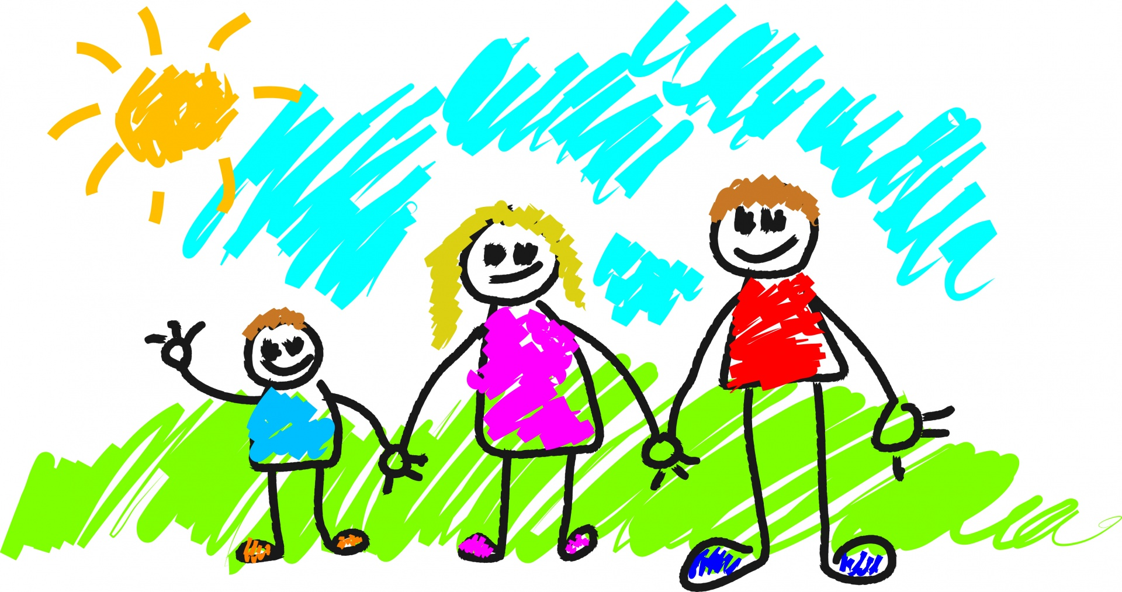
Marvellous Me!
This term our topic is titled Marvellous Me and is a celebration of who we are as individuals and will include learning about our families and popular families in stories.
Each week we will look at a different theme or story.
Week 1 and 2 - Will be very much settling in and getting to know the children and them getting to know us. We begin to establish the rules and routines within school. We have our first lunches, we begin to go into assembly and we start to go onto the playground with the other children.
Week 3 - We will be looking at our class identity and learning about acorns, and thinking about the seasonal changes which happen in the autumn.
Week 4 – We will look at popular stories with families in such as Titch, and Alfie and relate them to ourselves.
Week 5 - Harvest – we will look at farming, fruit, veg, and saying thank you for all that we have.
Week 6 - We will begin to get to know the family from the Oxford Reading Tree books.
Week 7 - Book week, the theme for book week this year will be Shakespeare, and we can interpret this however we want to. In Acorn class we may look at some or the characters in Midsummer Night’s Dream and look at costumes people wore at the time of Shakespeare.

