LO;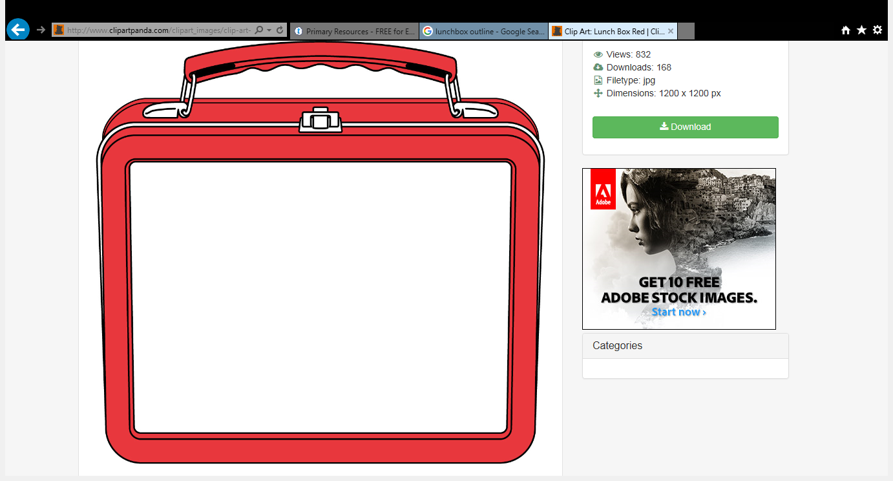
13.6.18 T.D To be able to write a label.
My yummy lunch box!

