Game Notes

Notes About?
Lego City Undercover
Who is the game for? (audience)
7+years
What is the aim of the game?
To complete all of the missions and to arrest criminals and get as many undercover kits as posable. And you need to arrest a robber Named Rex Fury known as Rex.
How good is it?
On a scale of 1-100, I personally would say 100/100!
How is it played? (rules)
You have to complete the missions by unlocking new disguise’s and arresting robbers.
What skills are needed to play?
You need a hand eye co-ordination.

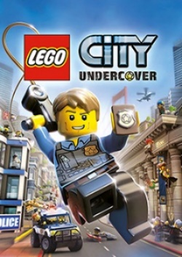
Lego City Undercover Review

What is Lego City Undercover.
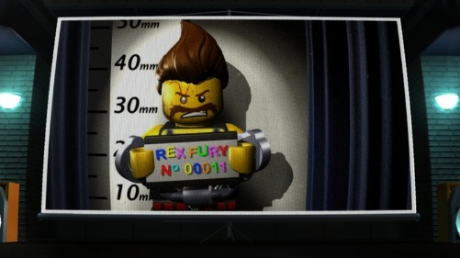
Lego City Undercover is a police game where you play as a character called Chase McCain (Chase), completing 20 chapters trying to arrest someone called Rex Fury known as Rex. Lego City is based in America.
You can find something called a super brick, there are 2 kinds of super bricks, large and small. Plus, every Lego object contains bricks and you can build things with them and the super bricks, for an example a car ramp.
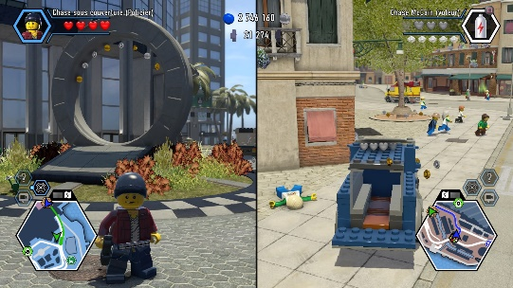
How Is Lego City Undercover played?
The game can be played by ether 1 or 2 players, when you’re playing 2 players you work as a team.
On some of the missions you are involved in a car chase. And in other missions you are in a running chase.

A mission might have steeling a dinosaur from a museum.

Is it any Good?
Pros
- Visually excellent!
- All of the new kits
- The police station
- All the different islands
- The whole game
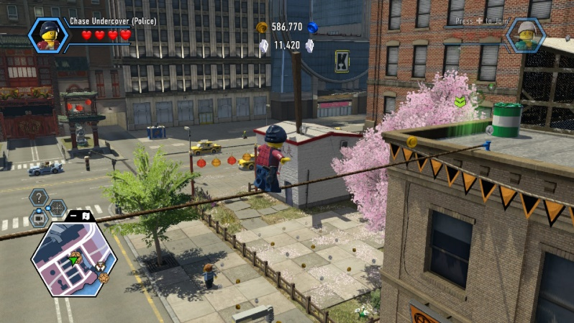
Cons
- Losing lives then dying

