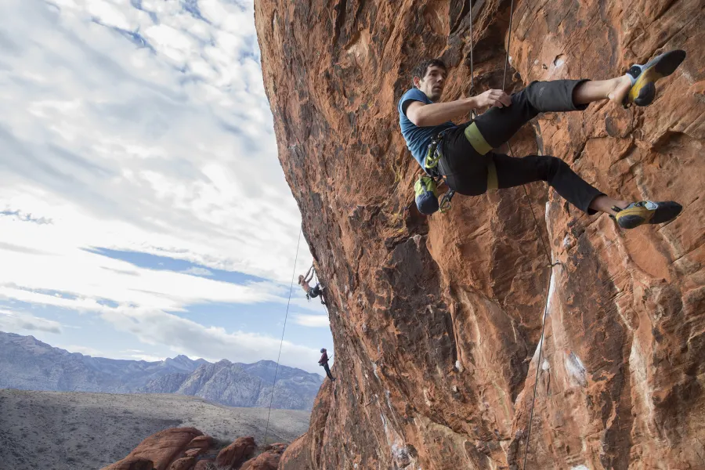

I was climbing up a mountain,
next to a cloud,
floating in the air over a fountain,
when the birds were singing aloud.

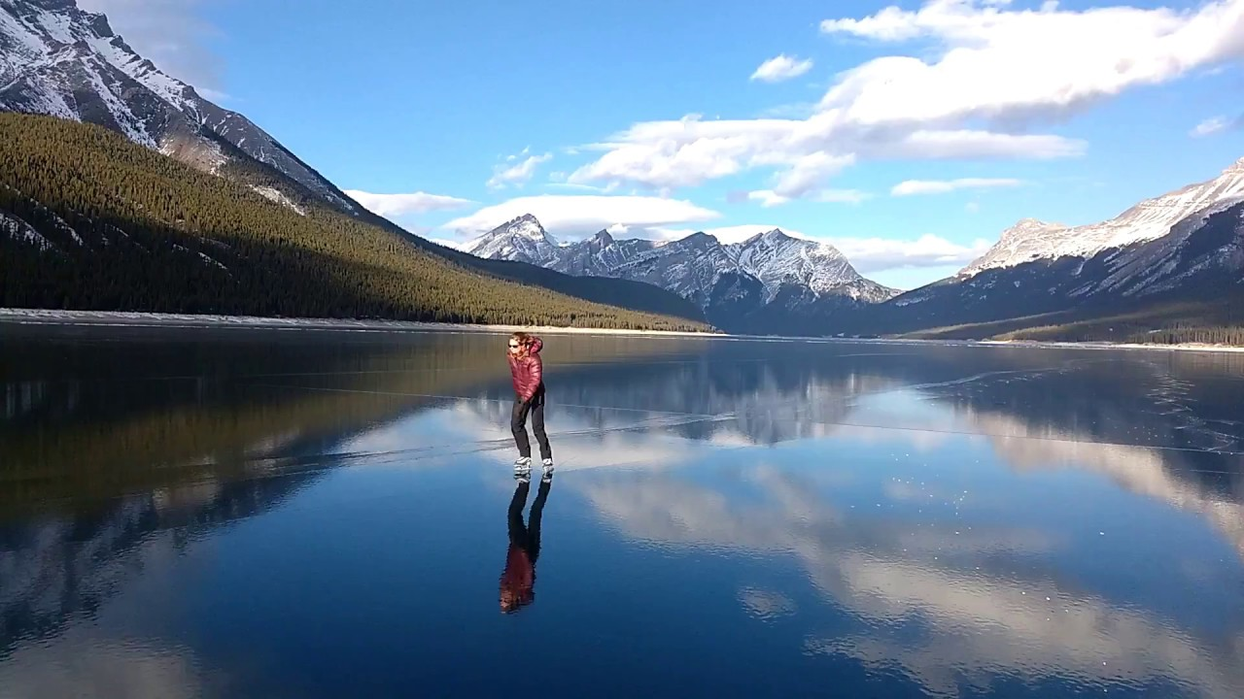

I was skating round a lake,
next to a big snake,
then I threw a steak,
what a big mistake.

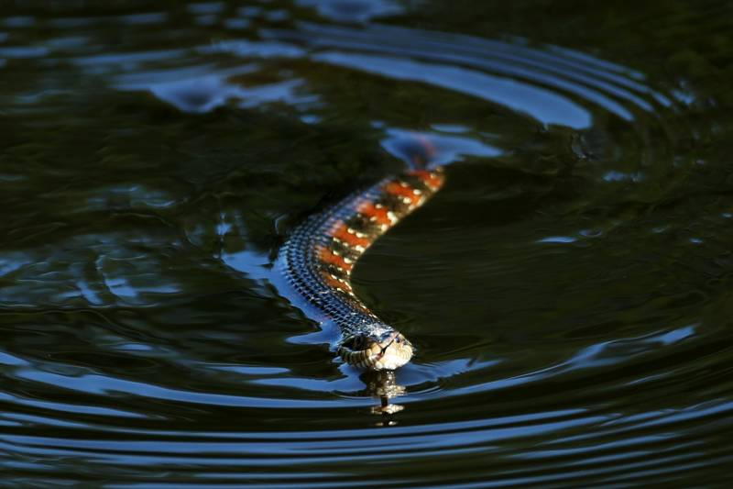



I have had a day that made me mad,
it has been raining bad,
so I had to practice inside with my pad,
I couldn’t play with my dad,
as he has been working with his lad,
but suddenly a phone call came from my grandad,
that made me feel glad,
and a cuddle from my mum I had.


