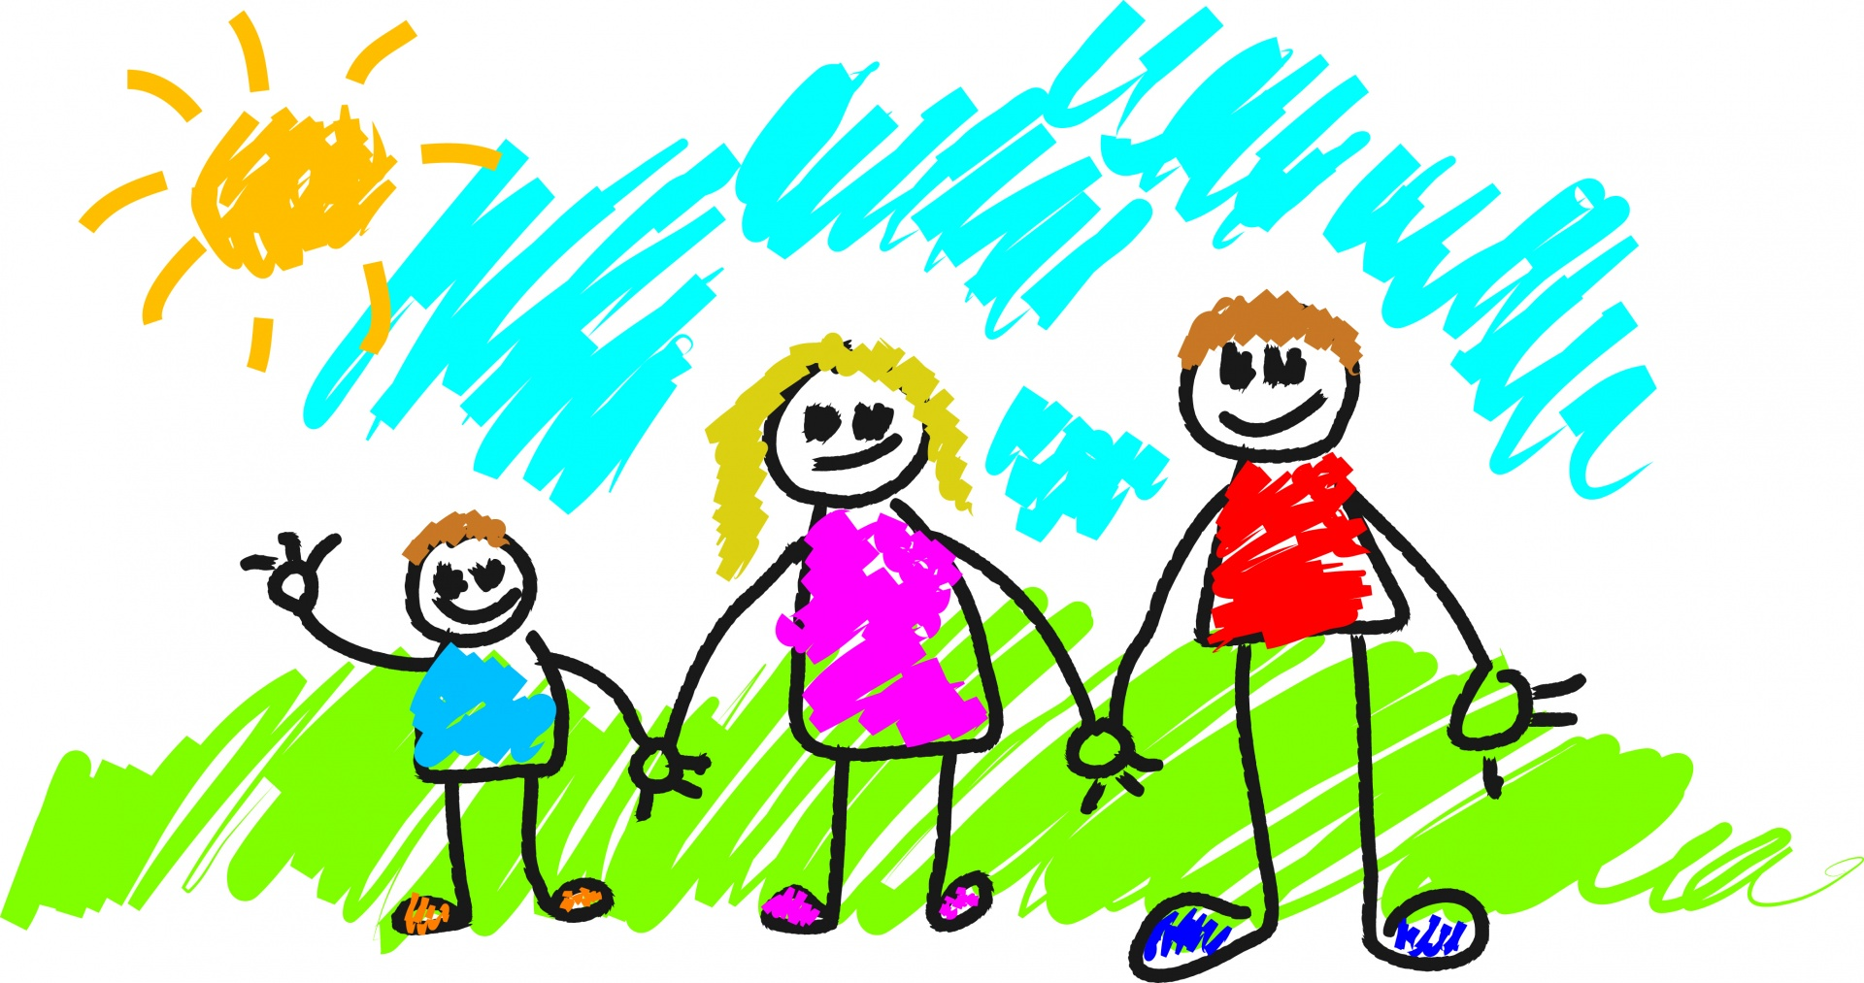
Marvellous Me!
This term our topic is titled Marvellous Me and is a celebration of who we are as individuals and will include learning about our families and popular families in stories.
Each week we will look at a different theme or story.
Week 1, 2 and 3- Will be very much settling in and getting to know the children and them getting to know us. We begin to establish the rules and routines within school.
Week 4 - We will be looking at our class identity and learning about acorns, and thinking about the seasonal changes which happen in the autumn.
Week 5 – We will look at popular stories with families in such as Titch, and Alfie and relate them to ourselves.
Week 6 - Harvest – we will look at farming, fruit, veg, and saying thank you for all that we have.
Week 7 - We will begin to get to know the family from the Oxford Reading Tree books.

