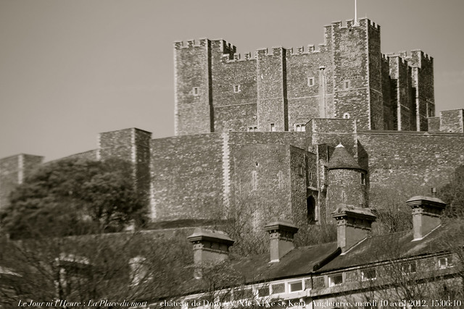
It’s the 12th December 1941, I woke up from the sound of cannons blasting away. The sound was so loud I nearly jumped out of bed. Every bang seemed louder and louder.
Today was my second day on the job, as I just got the job of the cannon master because the last one got shot and died recently. So now I’m in control of the main cannon and ten men for the other five cannons.

As I walked up the steep steps to the cannon there was suddenly a message that an enemy ship was coming in, I ordered cannon four to fire but the cannon ball missed so I ordered cannon three to fire and it hit! It was such an explosion I had to cover my eyes.

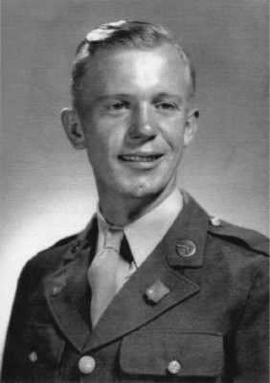
Everyone cheered with happiness which made me happy. Not only for the men but the whole county.
The only thing that would make me feel better is if this was a one time occurrence. However sadly it wasn’t, it happened twenty times on my shift.

This is my diary entry for today, hopefully I get to do one tomorrow.

Cannon Master Lucas Johnson.

