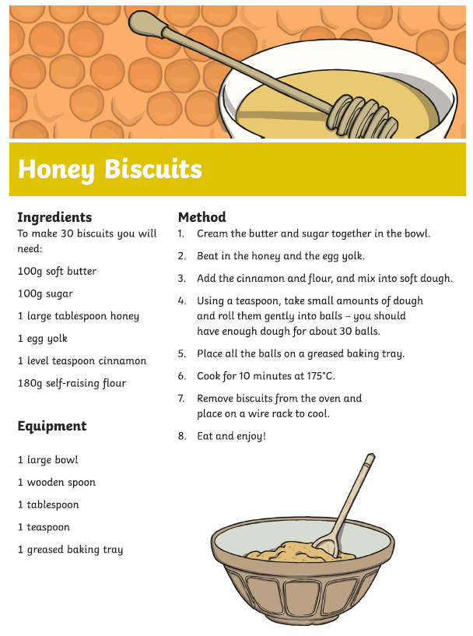
Rosh Hashanah Honey Biscuits

