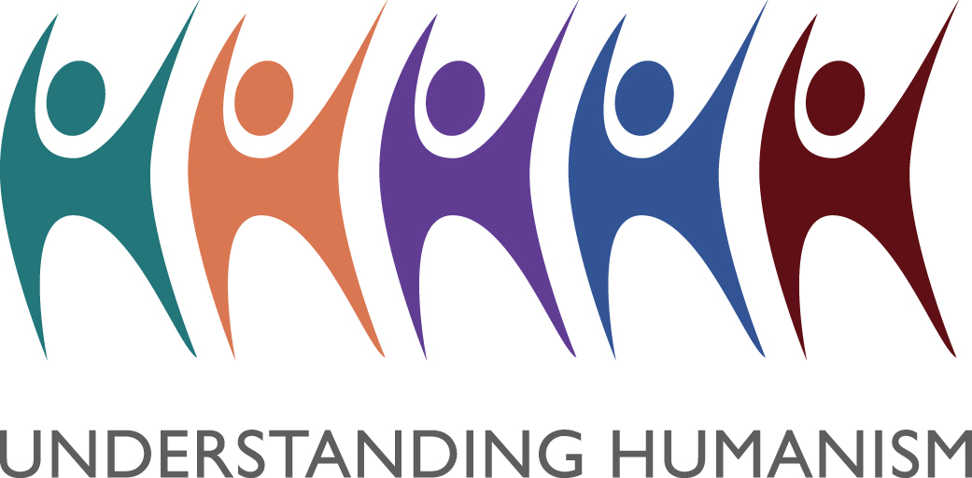

Naming Ceremonies Poems

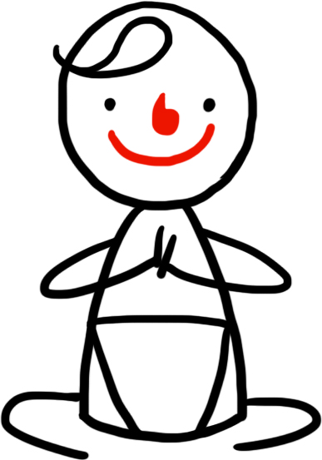
Take a look at the two poems about life and learning.

Can you write your own poem?
It could be about what is important in life.
Or it could be advice to parents or to a newborn baby.

I have seen a mother at a cot – so I know what love is
I have looked into the eyes of a child – so I know what faith is
I have seen a rainbow – so I know what beauty is
I have felt the pounding of the sea – so I know what power is
I have planted a tree – so I know what hope is
I have seen a chrysalis burst into life – so I know what mystery is
I have lost a friend – so I know what sorrow is
I have seen a stardecked sky – so I know what infinity is
I have seen and felt all these things – so I know what Life is
Anon

If children live with criticism they learn to condemn
If children live with hostility they learn how to fight
If children live with ridicule they learn to be shy
If children live with shame they learn to feel guilty
If children live with tolerance they learn to be patient
If children live with encouragement they learn to have confidence
If children live with praise they learn to appreciate
If children live with fairness they learn justice
If children live with security they learn to have faith
If children live with approval they learn to like themselves
If children live with love around them they learn to give love to the world

Children learn what they live, Dorothy Law Nolte

