Name.......................................................................... Date.........................................................

Oak Class Homework – 28th April 2017

SATs Revision for Grammar, Punctuation and Spelling

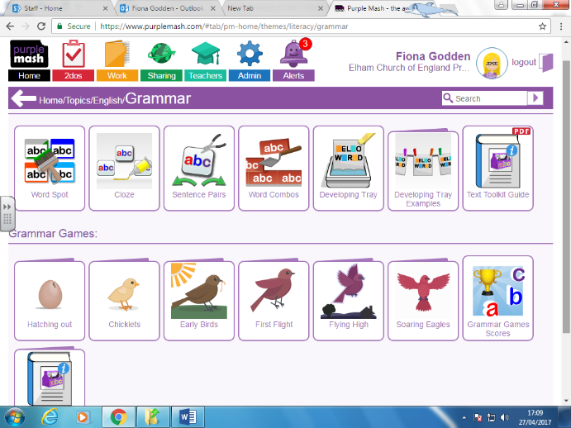
There are some great punctuation and grammar games on Purple Mash which I would like you to complete for this week’s homework.

They are all found in the ‘Flying High’ and ‘Soaring Eagles’ section of Topics/Literacy/Grammar.

I have set them all as 2Dos for you, so when you log in, please click on your Alerts icon to access them.

There are quite a few to play, so please try to do one or two a day. You can do them in any order, but focus on any areas which you are really unsure of first.

I will be able to see when you have completed each game!

You can log in to Purple Mash here: https://www.purplemash.com/sch/elham and your login is attached below.

Have fun!

Compete as many of them as you can by Friday 5th May.

