Name.......................................................................... Date.........................................................

Oak Class Homework – 31st March 2017

SATs Revision

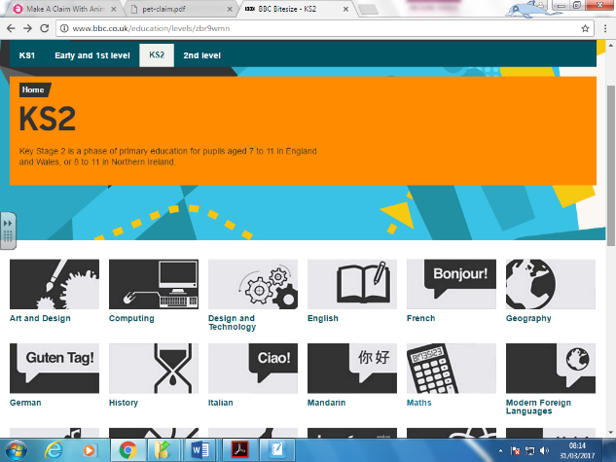
Over the Easter Break we would like you to do a little bit of SATs revision each day, particularly for Maths and GPS (Grammar, Punctuation and Spelling). Focus on any areas that you are still unsure of.

The BBC Bitesize website is very useful as well as Mathletics. Please work through the activities in Mathletics to revise areas you are not confident in.

BBC Bitesize
http://www.bbc.co.uk/education/levels/zbr9wmn (new site)

http://www.bbc.co.uk/bitesize/ks2/maths/ (old site)

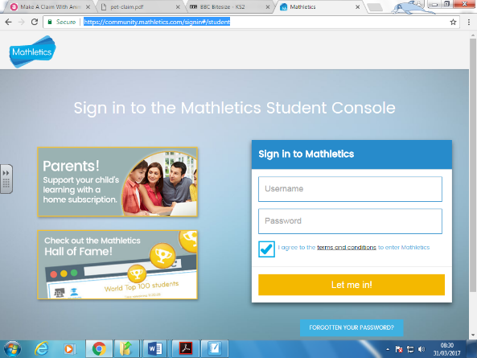
Mathletics
https://community.mathletics.com/signin#/student

If you want to try any old SATs papers, they are all available free on the website below. We would suggest that you start with the 2016 papers as these are based on the new Primary Curriculum.

https://www.sats-papers.co.uk/sats-papers-ks2

Have a great Easter and we will see you back in school on Tuesday 18th April.

