History of Computers Word search
Name: |  | Date:
Find the names of key people in computer history in the grid below. Once you have found the name, write what they did to help the progress of computers next to their name.
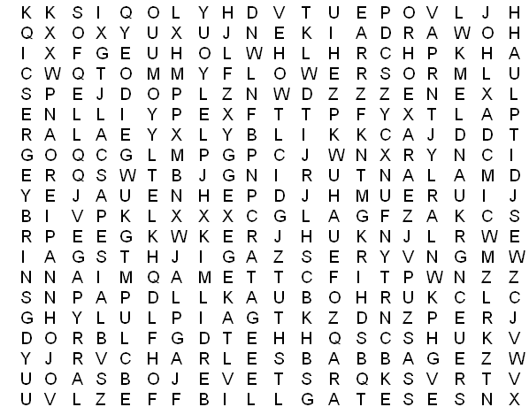
Important People in the History of Computing
Name | What did they do to help the progress of computers?
Alan Turing
Bill Gates
Blaise Pascal
Charles Babbage
Howard Aiken
Jack Kilby
John Napier
Lady Augusta Ada
Larry Page
Sergey Brin
Steve Jobs
Tommy Flowers

